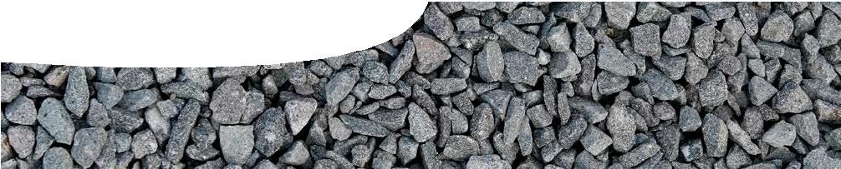
teacher guide
The Standard Model 4:
Quantum approach

Components

 | NAME | DESCRIPTION | AUDIENCE
 | Quantum approach  teacher guide | This guide contains notes for teachers on a quantum approach to understanding fundamental interactions. | teachers
 | A quantum view of interactions  presentation | This presentation describes interactions as exchange of virtual particles; introduces Feynman diagrams as tools to describe interactions; and explains a medical application in terms of underlying interactions. | students
 | Looking at interactions  fact sheet | This student worksheet contains questions about particle interactions. | students

Purpose
Students Elaborate on their knowledge of matter and forces by considering interactions between particles.

Outcomes
Students understand:
- what is meant by an interaction;
- that scientists use alternative models to represent natural phenomena;
- that quantum theory provides an explanation of force; and
- how particle interactions explain operation of a medical imaging technique.

Activity summary

ACTIVITY | POSSIBLE STRATEGY
Teacher steps through presentation, A quantum view of interactions. | class discussion
Students complete worksheet, Looking at interactions. | individual
Class discussion of points arising from presentation or worksheet. | whole class

Technical requirements
The teacher guide requires Adobe Reader (version 5 or later), which is a free download from www.adobe. com. The presentation is in Microsoft PowerPoint format. It is also available in PDF format.

Teacher notes

A quantum view of interactions
This presentation introduces students to the study of how matter particles interact.

SLIDES | CONTENT
1 – 2 | Introduction
3 | Quantum models of fundamental interactions are an alternative to the classical view of fields. The quantum view works well at short distance scales, where classical descriptions fail, and provides a natural mechanism of energy and momentum exchange through virtual particles.
4 | Interactions involve exchange of energy and momentum between particles, which can give rise to forces. For example, two positively-charged particles repel each other (exchange energy and momentum) through the electromagnetic interaction.  Three of the four fundamental interactions may also be described as binding interactions, as they hold particles together in bound states. Gravity binds matter together on the scale of Earth, the Solar System and galaxies. Electromagnetic interaction binds atomic nuclei and electrons, and also atoms into molecules. Strong interaction binds quarks together.  Although the weak nuclear interaction does not bind particles together it is involved in processes such as nuclear decay in which energy and momentum are exchanged between particles.
5 – 6 | Quantum theory provides a natural way to describe interactions between particles using the concept of ‘virtual particles’. Virtual particles carry properties like charge and momentum between interacting particles, but have only fleeting existence. Like much of quantum mechanics their description is based on mathematics rather than any easy analogy with the macroscopic world.
7 | Only simple Feynman diagrams are included in this presentation. Time is shown running vertically up the page/screen and space horizontally. Sometimes these are reversed.  Arrows on lines show the direction that particles move through time. Wavy lines indicate gauge bosons (eg photons) and their virtual equivalents.
8 – 11 | Using a single theory (QED) physicists can explain electromagnetic fields (virtual photons continually emitted and reabsorbed); electromagnetic interactions (exchange of virtual photons); and electromagnetic radiation (‘real’ photons).  Although the concepts behind QED may seem bizarre and complex, it is one of the best-tested theories in modern physics. Lande’s g-factor relates the magnetic moment of an electron to its spin. Without virtual photons it has a theoretical value of exactly 1. With virtual photons it has a theoretical value of 1.001 159 652 38 (±29). The experimentally measured value is 1.001 159 652 41  (±20).
12 | Quantum electrodynamics (QED) is a quantum explanation of electromagnetic interactions. Quantum chromodynamics (QCD) is a quantum explanation of the strong interaction.  A working quantum theory of gravity has not yet been developed. Much work is done by physicists to reconcile incompatible theories of gravity (general relativity) and the quantum world.
13 | The weak interaction involves exchange of energy and momentum. In radioactive beta-decay a neutron decays to a proton, electron and electron antineutrino. Energy and momentum of the neutron is transferred to the product particles.
14 – 16 | Conservation laws may be used to decide whether a proposed particle interaction is feasible. In all interactions properties such as electric charge, baryon number and lepton number must be preserved.
17 – 22 | PET scan imaging technology is used to illustrate particle interactions. Patient is administered the radioisotope 18F.  Protons in the F nucleus produce a positron and electron neutrino through β-plus decay (exchange of W+ boson — the weak interaction).  - Charge is conserved as a proton (charge +1) becomes a neutron (uncharged), positron (charge  +1) and neutrino (uncharged).  Note: students may query whether the oxygen species in this equation should be written as a negatively-charged ion (O–) in order to balance charge. Convention appears to be to ignore shell electrons in nuclear reactions as they play no role in nuclear processes. 18O8 can be thought of as representing an oxygen nucleus rather than oxygen atom or ion.  - To calculate lepton number look at nuclei only. There are no electrons in the F nucleus and none in the O nucleus. Lepton number of the positron is -1 as it’s an antilepton and +1 for the electron neutrino. So lepton number of zero is preserved.

SLIDES | CONTENT
- Baryon number of 18 is also preserved: 9 protons + 9 neutrons before decay; 8 protons + 10 neutrons after decay.
Positron and electron annihilate (matter-antimatter annihilation) to create two photons (gamma rays) through electromagnetic interaction.
- Charge is conserved (positron has charge +1 and electron has charge -1 so net charge is 0; photons are uncharged).
- Lepton number of zero (-1 for positron, +1 for electron) is preserved (zero for photons).
- Baryon number of zero is conserved.
- Two photons are emitted in opposite directions to preserve momentum. A simple way to explain this is to consider the case when net momentum of positron and electron is zero. If only one photon is produced it would have a momentum of zero, which is not possible. Two photons emitted in opposite directions can have a net momentum of zero.
23 – 26 | Why are proton-proton collisions in the LHC so complicated? Our view of protons as smooth billiard balls colliding isn’t always realistic.
 | - At the speed protons travel in the LHC it’s better to think of them as pancakes (flattened in the direction of travel by relativistic effects).
 | - Protons have internal structure, and it’s not simply represented by two up quarks and a down quark. Protons can be represented as a seething mass of countless virtual quark-antiquark pairs and virtual gluons, all moving around at close to the speed of light. Compare the mass of up quarks (4.6 MeV c-2) and down quarks (4.8 MeV c-2) with that of a proton (938 MeV c-2) to see that viewing a proton as three quarks is overly simplistic.
 | See profmattstrassler.com/articles-and-posts/largehadroncolliderfaq/whats-a-proton-anyway/ for a discussion of this idea.
 | The diagram below shows a representation of two protons colliding to produce showers of secondary particles. Without going into any detail it conveys the complexity of the processes that LHC scientists investigate.
 | Introduc?on
 | Typical proton=proton collision |  | Beam of partons  RadiaJon from incoming partons Primary hard scaKer  RadiaJon from outgoing partons HadronizaJon  MulJple Inter. / Underlying event
 | 8/30/11 | PIC 2011, R. Teuscher IPP/Toronto | 2
 | Teuschner, R. (2011). High ET Jet Physics. Paper presented at XXI Physics in Collision, 28 Aug – 1 Sep 2011, Vancouver, Canada. Retrieved 10 Nov 2014 from http://indico.cern.ch/event/117880/other-view
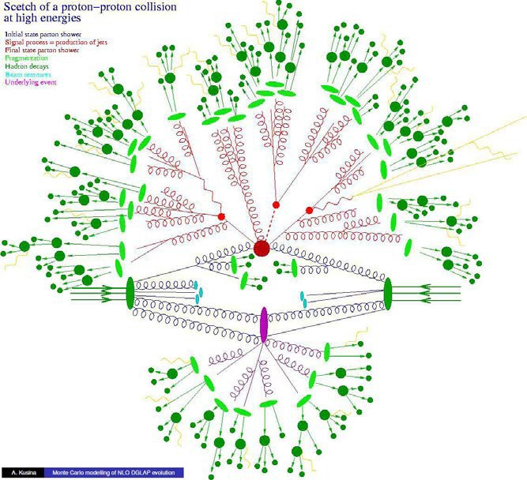

SLIDES | CONTENT
23 – 26 | Some details on collisions in the LHC:  - The LHC contains two beams of protons, travelling in circles in opposite directions.  - Each beam contains 2808 bunches of protons.  - Each bunch contains 100 000 000 000 protons.  - Bunches of protons in the two beams intersect every 25 ns.  - Most protons in the beams miss each other — only about 20 collisions occur for each bunch intersection.  - Even so that’s up to 800 000 000 collisions per second.  - Most of these collisions are uninteresting (they’re collisions in which protons do behave like billiard balls simply bouncing off each other). Of the 800 million collisions each second, data from about 500 are kept for analysis. These are interesting events where parts of one proton have interacted with parts of another.  - A 10 hour run of the machine produces about 18 000 000 ‘interesting’ collisions that require further analysis.

Acknowledgements
Thanks to Professor Ian McArthur (School of Physics, The University of Western Australia).
Designed and developed by the Centre for Learning Technology, The University of Western Australia.
Production team: Jenny Gull, Dan Hutton and Michael Wheatley.

SPICE resources and copyright
All SPICE resources are available from the Centre for Learning Technology at The University of Western Australia (“UWA”). Selected SPICE resources are available through the websites of Australian State and Territory Education Authorities.
Copyright of SPICE Resources belongs to The University of Western Australia unless otherwise indicated.
Teachers and students at Australian and New Zealand schools are granted permission to reproduce, edit, recompile and include in derivative works the resources subject to conditions detailed at spice.wa.edu.au/usage.
All questions involving copyright and use should be directed to SPICE at UWA.
Web: spice.wa.edu.au Email: spice@uwa.edu.au Phone: (08) 6488 3917
Centre for Learning Technology (M016) The University of Western Australia
35 Stirling Highway
Crawley WA 6009

Image credits

A quantum view of interactions
- ‘particle tracks blue’ by ntscforever (Ed Wilhelm). Used under licence. s286.photobucket.com/user/ ntscforever/media/ParticleTracks_B.jpg.html
- ‘Transaxial PET scan of human brain’ by Jens Maus. PD. commons.wikimedia.org/wiki/File:PET-image. jpg
- ‘PET detector system’ by Damato/Kjkolb. PD. commons.wikimedia.org/wiki/File:PET- detectorsystem_2.png
- ‘Event display of a H -> 4mu candidate (ATLAS- PHO-COLLAB-2012-008)’ by ATLAS collaboration.
Free for educational use. cdsweb.cern.ch/ record/1459496
- ‘Snooker balls’ by barfisch. CC-BY-SA-3.0. commons. wikimedia.org/wiki/File:Snooker_Touching_Ball_ Red.png

Associated SPICE resources
The Standard Model 4: Quantum approach may be used in conjunction with related SPICE resources to teach the topic of the Standard Model.

DESCRIPTION | LEARNING PURPOSE
The Standard Model (overview)
This learning pathway shows how a number of SPICE resources can be used in teaching students about the Standard Model.
The Standard Model 1: Big physics  Students watch a TED talk on the Large Hadron Collider. What do scientists hope to discover with this machine? | Engage
The Standard Model 2: Structure of matter  A series of presentations guide discussion of the fundamental building blocks of the Universe. | Explore
The Standard Model 3: Particle calculations  Students perform calculations using properties of fundamental particles. | Explain
The Standard Model 4: Quantum approach  A presentation introduces a quantum view of particle interactions. | Elaborate

