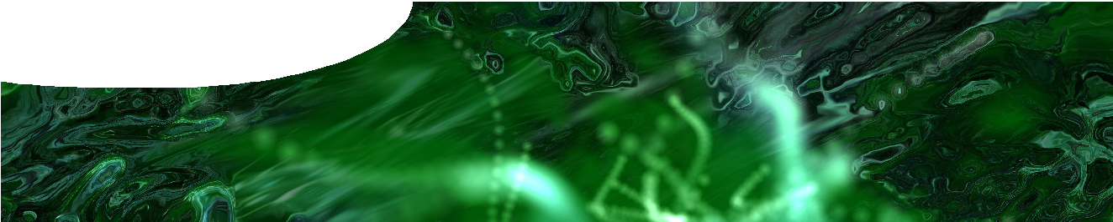
fact sheet
The Standard Model 2:
Glossary

antiparticle | Most particles have a matching antiparticle that has the same mass, but opposite electric charge. An electron’s antiparticle is a positron, which is identical to an electron except that its charge is +1 rather than -1.  Neutral particles also have antiparticles: the antiparticle of a neutron (which contains three quarks) is an antineutron that contains three antiquarks.  Particles and antiparticles annihilate each other when they come into contact, to produce other particles. For example an electron and positron annihilate to create two photons.
baryon | Baryons are composite particles that consist of three quarks (or three antiquarks). They include protons (two up quarks and a down quark) and neutrons (two down quarks and an up quark).  Particles made of quarks are known as hadrons. This includes baryons (containing three quarks) and mesons (containing a quark and antiquark).  The name ‘baryon’ is derived from the Greek word for ‘heavy’ (compare with lepton which means ‘light’).
boson | There are both fundamental and composite bosons, however only the five fundamental bosons are considered in this resource.  Four of the fundamental bosons are called gauge bosons. They are involved in the fundamental interactions: photon (electromagnetic interaction); W and Z bosons (weak interaction); and gluon (strong interaction).  The Higgs boson is the fifth fundamental boson. Other bosons, such as the graviton, have been proposed but not yet observed.
dark matter | Observations suggest that 84.5% of matter in the universe is not ordinary matter (protons, neutrons and electrons), but something else known as ‘dark matter’. It’s possible that dark matter involves particles outside those of the current Standard Model. Understanding dark matter is a major challenge for today’s physicists.
electron | Electrons are negatively-charged elementary particles. Their antiparticle, the positron, is positively-charged. Both are leptons (particles that do not interact by the strong interaction).
elementary particle | This is a term used for particles in the Standard Model: quarks, leptons, gauge bosons and Higgs boson. Although these particles are expected to have internal structure we are unable to resolve any internal structure with current particle accelerators.
fermion | Fermions form the family of particles that makes up most matter: including quarks, leptons and baryons. The other family is bosons.
hadron | Hadrons are composite particles made of quarks. There are two groups of hadrons: baryons (containing three quarks or three antiquarks); and mesons (containing a quark and an antiquark).  Quarks in hadrons are bound by the strong interaction.
lepton | Leptons are elementary particles. There are charged leptons (electron, positron) and neutral leptons (neutrinos). Leptons do not interact through the strong interaction, and do not form composite particles (unlike quarks). Leptons participate in the weak interaction.

meson | Mesons are composite particles made of quarks (hence they are hadrons). Unlike baryons, which consist of three quarks, mesons consist of a quark-antiquark pair. There are many different mesons, depending on the type of quark and antiquark, but all are unstable and quickly decay to other particles.
neutrino | Neutrinos are uncharged elementary particles. Because they are uncharged they do not participate in electromagnetic interactions, and as leptons they do not interact through the strong interaction either, so they barely interact with matter (through the weak interaction).  It was initially believed neutrinos are massless; there is now good evidence that they have a tiny rest mass.  Nuclear processes in the Sun produce large numbers of neutrinos, but most pass straight through Earth. About 65 billion neutrinos pass through each square centimetre of your skin per second!
neutron | Neutrons are composite particles made of two down quarks and an up quark. They are hadrons (particles made of quarks) and baryons (particles made of three quarks).  Neutrons and protons make up atomic nuclei, so neutrons are a major component of ‘ordinary’ matter. Although neutrons in atomic nuclei are generally stable, free neutrons (outside nuclei) decay with a half-life of about 10 minutes.  Neutrons in some nuclei are unstable and transform into a proton through radioactive beta decay (via the weak interaction).
pion | Pions (pi-meson or π-meson) are mesons that consist of one up or down quark, and one anti-up or anti-down quark. An up/anti-down pair is positively charged (π+); up/anti-up and down/anti-down pairs are both neutral (π0); and a down/anti-up pair is negatively- charged (π−).  Pions are created in particle accelerators, supernovae and cosmic ray collisions in the upper atmosphere. Charged pions decay with an average lifetime of 26 nanoseconds; neutral pions have an even shorter lifetime.
proton | Protons are composite particles that contain two up quarks and a down quark. They are hadrons (particles made of quarks) and baryons (particles made of three quarks).  Together with neutrons, protons make up atomic nuclei, so are a major component of ‘ordinary’ matter. Protons are stable (they do not decay) although it is sometimes possible to turn a proton into a neutron through electron capture, in an atomic nucleus.
quark | Quarks are elementary particles. They are not found in isolation, but are always bound in pairs (mesons) or triplets (baryons). More exotic combinations (tetraquarks and pentaquarks) have been proposed but not yet definitely observed.  There are six types of quark (up, down, charm, strange, top and bottom). Each type also has an antiparticle equivalent. Only up and down quarks exist commonly in nature. The other types may be made in particle accelerators, but quickly decay. The up quark has a charge of +2/3 and the down quark has a charge −1/3.
strong interaction | The strong interaction is one of four fundamental interactions. It is responsible for binding quarks to form hadrons and mesons, and, in residual form, for binding protons and neutrons in nuclei. The property that determines whether a particle interacts through the strong interaction is called colour charge. Quarks have colour charge; leptons don’t.  The strong interaction is mediated by exchange of virtual gluons.
weak interaction | The weak interaction is one of four fundamental interactions. Particles interact through the weak interaction by exchanging virtual W and Z bosons.  The weak interaction is involved in radioactive decay.  The weak interaction operates over an extremely short range. Since neutrinos can only interact via the weak interaction, they must get incredibly close to other particles to interact. This is why it is so hard to detect neutrinos.

