Part 1: How big is the Solar System?
The table below contains data on the size of the Sun and planets in the Solar System, and distances of planets from the Sun. As well as actual measurements, it contains scaled dimensions for a model in which 1 cm represents 100 000 km in the Solar System.
Using this information, collect everyday items of an appropriate size to represent objects in the Solar System, then devise a way to represent the scale of the Solar System. Hint: a school oval might be useful.
 | DIAMETER |  |  | DISTANCE FROM SUN
object | actual (km) | model (cm) | everyday item | actual (km) | model (m)
Sun | 1 400 000 | 14.00
Mercury | 5000 | 0.05 |  | 58 000 000 | 6
Venus | 12 000 | 0.12 |  | 110 000 000 | 11
Earth | 13 000 | 0.13 |  | 150 000 000 | 15
Mars | 7000 | 0.07 |  | 230 000 000 | 23
Jupiter | 143 000 | 1.43 |  | 780 000 000 | 78
Saturn | 120 000 | 1.20 |  | 1 400 000 000 | 140
Uranus | 51 000 | 0.51 |  | 2 900 000 000 | 290
Neptune | 49 000 | 0.49 |  | 4 500 000 000 | 450
Proxima Centauri (nearest star to Solar System) |  |  |  | 4 x 10¹³ | 4 000 000

Questions
- How does this model help you understand the size of the Solar System?

- What problems are there with a simple model like this?

- Where should you send a class volunteer to represent the nearest star, Proxima Centauri?

Part 2: Universal tours
Your mission: Travel from Earth to the edge of our Solar System, then to some of our galactic neighbours, and finally deep into the Universe. Record distances as you travel.
UNITS FOR MEASURING ASTRONOMICAL DISTANCES
unit | definition | distance (km)
astronomical unit (AU) | average distance between the Earth and Sun | 150 million kilometres  150 000 000 km  1.5 X 10⁸ km
light-year | distance light travels in one year | 10 trillion kilometres  10 000 000 000 000 km  10¹³ km
parsec | distance to an object which displays a parallax angle of one arcsecond | 31 trillion kilometres  31 000 000 000 000 km  3.1 X 10¹³ km

First stop: exploring our Solar System
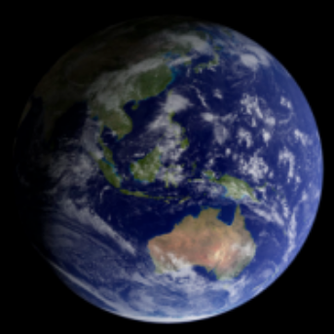
image: NASA
- Your first destination is Saturn, 9.539 AU from the Sun. How far is this in kilometres?

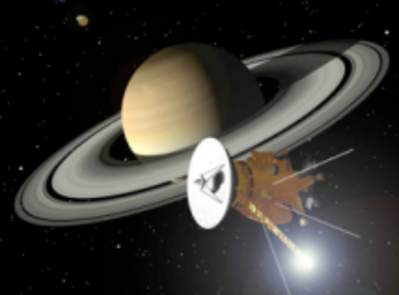
The Cassini/Huygens space probe took seven years to reach Saturn, travelling at a maximum speed of 44 km s⁻¹.
image: NASA/JPL

- What measurement technique can be used to establish distances to planets in the Solar System?

Moving beyond the Solar System
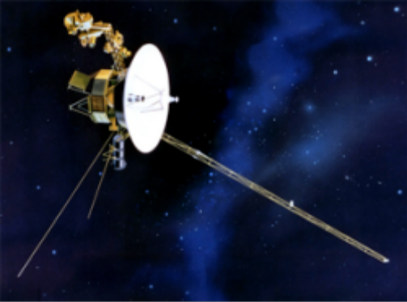
Extragalactic traveller, space probe Voyager I, was launched in 1977. It is now 113.158 AU from the Sun, at the edge of the Solar System.
image: NASA/JPL

- Our galaxy, the Milky Way, is 100 000 light-years across and the Sun is 25 000 light years from the centre. How long would it take you to travel from Earth to the outer rim of the Milky Way if you were travelling at the speed of light?

- If you wanted to travel to a neighbouring star, which one would be quicker to get to, the brightest star in our galaxy, Sirius, which is 8.5 million light-years away, or Proxima Centauri, 1.29 parsecs away? Show how you arrived at your answer.

Navigating the Local Group
The Local Group is our local space neighbourhood. This includes the Milky Way along with 30 other galaxies. Places you could stop at include the Large and Small Magellanic Clouds and Andromeda galaxy.
- The Large Magellanic Cloud is 163 000 light years from the Milky Way, and the Small Magellanic Cloud 12 007 580 277 AU. Which is closest to our own galaxy? Show your working.

- Some scientists predict that spacecraft powered by fusion technology will be capable of reaching speeds of 10% of the speed of light. How many years would it take the spacecraft to reach the Alpha Centauri star system, 4.36 light-years away?

- At 10% of the speed of light, how many years would it take to reach the Large Magellanic Cloud?

Exploring the Universe
- You have discovered a new galaxy, and want to work out if it is possible to travel to it. You note distinctive, regular pulsations in the brightness of certain stars in this galaxy. What type of stars are these, and how can they help establish distance to this galaxy?

- What is the name given to a celestial object with a known brightness, used to establish distances in astronomy?

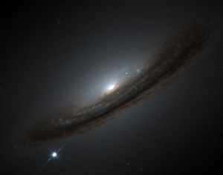
supernova 1994D
image: High-Z Supernova Search Team/ HST/NASA
Reaching the Limits
- A new supernova event has been discovered and imaged by ground-based telescopes. Astronomers believe this event can be used to measure distance to the host galaxy. What type of supernova is this called?

- What methods can astronomers use to establish distance to a galaxy where a supernova event occurs?

- Why is the study of supernovae remnants important to our understanding of the Universe?

Congratulations – mission complete
It’s time to travel the 13 billion light-years back home …

