Use this worksheet with the learning object Take it for a drive and the fact sheet Renewable energy vehicle to learn more about energy transformations in an electric vehicle.

Introducing the electric car dashboard
Open the learning object. Play the first 10 seconds. On the screen, you’ll see the electric car idling at a red light. Pause the learning object at 0:10.
- Look at the dashboard (at 0:10). Record the level of charge in the battery and what level you see on the energy use arrow.

Play the next 21 seconds and pause at 0:31. You will see the vehicle accelerate as the traffic lights turn green. Now, answer the following questions:
- Look at the dashboard (at 0:31). Record level of charge in the battery, speed the car travels, and the level you see on the energy use arrow.

- Describe what you see happening to the energy use arrow in the interval: 0:10 to 0:31.

- Describe how change in the energy use arrow relates to how the car’s driven.

Introducing the graph
This graph shows energy use data from the electric car journey in the learning object.
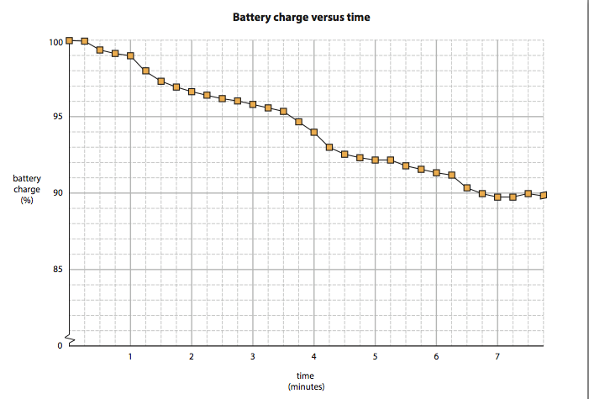
This graph shows how battery charge changes over the length of the drive.
- Look at the time interval 0:00 to 1:00 on the graph. How much does the battery charge change during this time?

- Look at the time interval 0:15 to 0:30 on the graph and learning object.
a. How much does battery charge change during this interval?

b. What activity uses most energy in this interval? (hint: What happens in the car journey when the energy use arrow goes into the red bars?)

- Look at the time interval 1:00 to 1:15 on the graph and learning object. Explain, with reference to the graph and the learning object, what happens during this interval.

Tracking energy transformations during the drive
Watch the remainder of the learning object, Take it for a drive. Then, answer the following questions using the learning object and the graph.
- Explain the overall shape of the graph. What does it show?

- Complete this table to show which activity uses most energy in each given time interval, and the percentage decrease in battery charge.
MARKER  (on video) | TIME INTERVAL | ACTIVITY THAT USES MOST ENERGY  (watch the learning object) | DECREASE IN BATTERY CHARGE (%)  (use the graph)
A | 0:15 – 0:30
B | 1:00 – 1:15
D | 3:30 – 3:45
E | 3:45 – 4:05
F | 5:15 – 5:30
H | 6:15 – 6:30
- When stationary at traffic lights (0:10), the energy use arrow on the car’s dashboard indicates the electric vehicle continues to use energy.
a. What could be using energy within the car at this point?

b. Draw an energy flow diagram to show energy transformations that occur when the vehicle stops.

- Watch these two segments on the learning object: marker B (1:00 to 1:15) and marker G (5:40 to 6:15).
a. Explain why energy use by the electric car is greater when it accelerates hard up a hill than when it drives at a constant speed on a flat road.

b. Draw an energy flow diagram to represent energy transformations when a car accelerates uphill.

- Watch the learning object from 1:42 to 2:00, where the electric car travels at a constant speed of 60 km/h, then answer the following questions.
a. Explain what’s happening to energy use during this time interval.

b. List two other accessories that greatly increase energy use when driving the electric car.

c. Draw an energy flow diagram to represent energy transformations when radio and lights are on in an electric vehicle.

- The air-conditioner is turned on twice during the drive, once for cooling (marker D, 3:33) and once for heating (6:24).
a. What effect does turning on the air-conditioner have on energy use in the electric car?

b. Draw an energy flow diagram to represent energy transformations when the heater is on in an electric vehicle.

c. A traditional combustion engine vehicle loses energy as heat. This is used to heat the inside of the car. Draw an energy flow diagram to represent energy transformations when the heater is on in a combustion engine car.

- Describe conditions where the electric car drives efficiently. Then identify a section of the learning object that illustrates this.

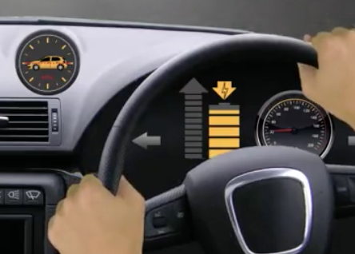
- Watch the journey from 7:00 to 7:30 (marker I), then answer the following questions.
a. Explain what happens when the car dashboard looks like this (7:20). The Renewable Energy Vehicle fact sheet will help you.

b. How does the graph help to explain your answer to part a, above?

c. Draw an energy flow diagram to represent energy transformations when an electric vehicle brakes.

- Driving in a city often means frequent braking to slow down for traffic, give-way signs, pedestrians and cyclists. Can you think of a reason why electric cars have an advantage over combustion engine cars when driving in a city? Use the Renewable energy vehicle fact sheet, graph and learning object, to help you explain why this may be true.

- The regenerative braking arrow lights up multiple times during the journey. However, there’s only one time interval on the graph where we see an increase in battery charge (7:15 to 7:30). With reference to energy, can you explain why this might be?

