Part 1: Quotes
Six members of the Kimberley community have provided their opinion about the impact cane toads are having upon the community or environment. Try to guess who made which quote by drawing lines to connect quote and community member.
… so we take them out toad busting and they love it, they love camping out, they love to see the animals and also catching toad.” | 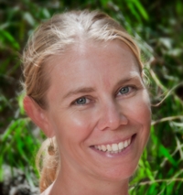 | Corrin  Department of Environment and Conservation
… the disheartening thing is that the thought of the impact is something you just don’t want to think about … | 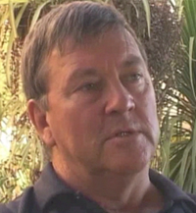 | Jeff  Triple-J tours
… do our very best to keep you out of our deadly West … | 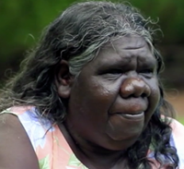 | Ju Ju  Aboriginal Elder
I think toads are going to have a huge impact on the product we can offer people … | 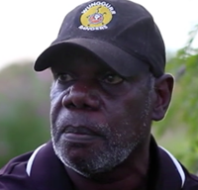 | Kevin  Wunggurr ranger
Maybe that there’s not as many wildlife and a lot of tourists might not come here as much because a lot of tourists come to see the wildlife. | 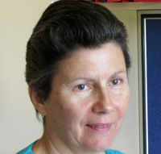 | Dianne  community member
If the toad is going to go throughout the Kimberley, there is nothing left for our youngsters and their youngsters to hunt … | 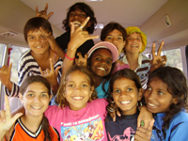 | young Kimberley Toad Busters

Part 2: Listen
- Listen to the audio recordings of the people. Were you surprised by who any of the quotes belonged to? Explain.

- What impact are cane toads having on the traditional Aboriginal lifestyle?

- Do cane toads affect everyone in the same way? Explain.

- Which of the people interviewed do you think has been, or will be, the most impacted upon by cane toads? Why?

- If cane toads continue to spread to the southwest corner of West Australia, what would be the impact of their presence on those communities?

