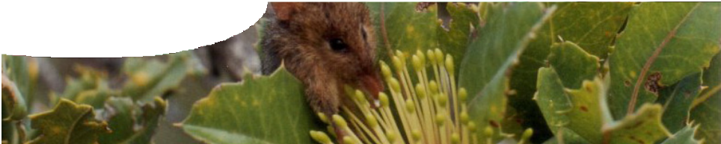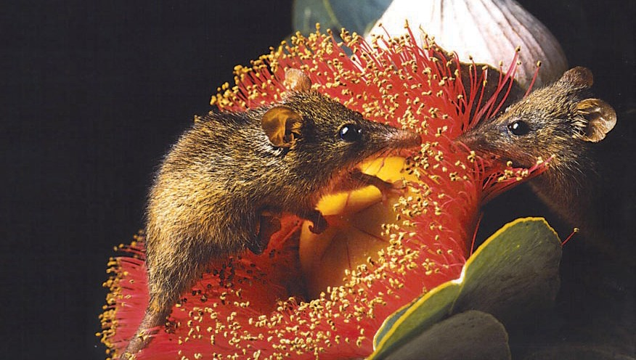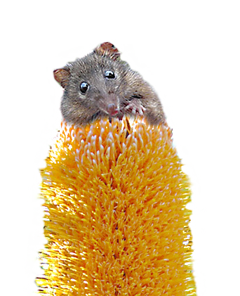
worksheet
Investigating energy intake
What do honey possums, nectar and radioisotopes have in
common? Let’s find out …
Johnathan Blair / Nation Geographic Stock, used under licence

Protecting the honey possum means protecting its habitat.

Scientists can estimate the area of habitat required to sustain a healthy population of honey possums by establishing their daily energy requirements.
Finding out how much food a honey possum needs is no mean feat – scientists conduct research in the field using some very special techniques.
Traditionally, scientists have measured the basal metabolic rate (BMR) of an animal. This is performed in a laboratory and provides information about an animal’s energy expenditure when at rest. Subjecting animals such as the honey possum to laboratory

procedures can cause extreme stress and even death. This means data gathered may be scientifically invalid. Studying animals in
their natural habitat avoids these problems. It also provides information about their energy
requirements during normal daily activity.
Field metabolic rate (FMR) is the amount of energy a free-living animal expends during normal daily activity. If an animal’s FMR is calculated it is possible to estimate daily food intake. Measuring
an animal’s FMR also presents challenges. Using traditional laboratory equipment in the field

isn’t practical, so FMR is measured indirectly. This involves measuring metabolic by-products, or gas output, by sampling the blood of free-living animals, such as the honey possum. One such field technique is the doubly-labelled water method. This has been successfully used with honey possums.
So how does measuring the metabolic by-products of honey possums help determine daily energy expenditure?
Let’s start by looking at what’s going on in the cell.

What is cellular respiration?

Energy is required by all organisms for growth, repair
The equation for respiration is:

and reproduction. This energy
C6H12O6
+ 6O₂
→
6CO₂
+ 6H₂O + energy

is produced during the process of cellular respiration. Cellular respiration occurs within the mitochondria of each and every cell. It is an oxidative process, which means it requires oxygen.
Glucose molecules are oxidised to carbon dioxide (CO2) and water (H2O). Energy is released and subsequently stored within ATP (adenosine triphosphate) molecules for later use.
glucose oxygen carbon dioxide water as ATP

CO2 and H2O are by-products of this process. These molecules leave the cell and diffuse into the bloodstream. The end point of this journey occurs when CO2 diffuses from the bloodstream into the air spaces of the lungs. CO2 (and some H2O, as vapour) is then expired into the external environment.
Measuring gas inputs and outputs provides an indirect measure of metabolism.

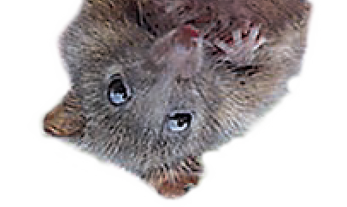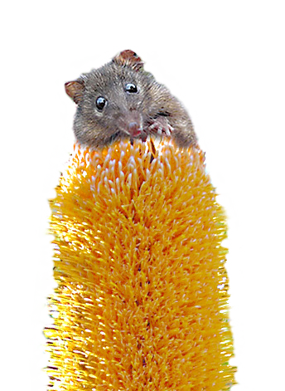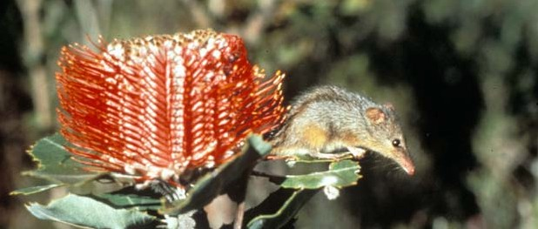

Calculating energy expenditure

Energy expenditure can be determined by measuring the carbon dioxide produced (litres per day) from blood samples of free-living animals. The amount of CO2 produced by an animal depends on its diet. An animal that metabolises protein produces more CO2 than one that metabolises carbohydrates. Nectar, the main food source of honey possums, is pure carbohydrate.
Scientists know that for every litre (L) of CO2 produced during the metabolism of carbohydrate, 20.8 kilojoules (kJ) of energy is expended. This is a standard value for the metabolism of carbohydrates in all animals.
With this information, it is possible to calculate the daily energy expenditure, or field metabolic rate (FMR), of the honey possum using the following formula:
FMR (kJ day-1) = CO2 produced (L) x 20.8
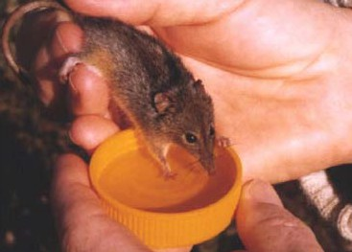

Question 1: What is the FMR of a honey possum that produces 0.73 L of CO2 per day?

Question 2: If the amount of CO2 produced varies with the type of food metabolised, what else may vary?

Research scientists have identified plants from which honey possums source nectar (see ‘Nectar as fuel’ on page 4). The energy content (in kJ) of nectar from each plant has also been determined. With this information, and the calculated FMR, it is possible to estimate the number of flowers/inflorescences a possum visits daily.

Question 3: A captured honey possum is found to feed exclusively on Banksia coccinea. If its FMR is 15.2 kJ day-1, how many inflorescences did it visit?

Question 4: A researcher determines the average FMR of a honey possum is 2.7 times greater than its BMR. Suggest reasons for this.

Question 5: What biotic and abiotic factors might affect the FMR of a honey possum?

Field research has revealed the average honey possum consumes 6 -7 mL of nectar each day. For a 9 g possum, this amounts to almost 70 % of its own body mass. That’s a huge amount of food!

Question 6: What might be implications of such large food requirements for honey possum survival?

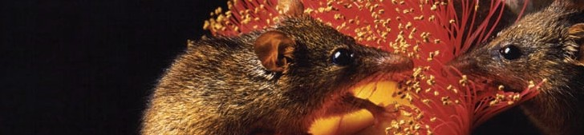
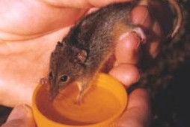

Johnathan Blair / Nation Geographic Stock, used under licence

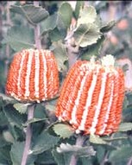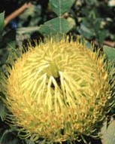Banksia baxteri
NePremciumtar

$
small tree 1.7–4 m
0.08 kJ
per inflorescence

Banksia coccinea
small tree 1–8 m
0.096 kJ
per inflorescence

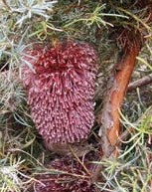
Banksia nutans
shrub 0.3–1.3 m
0.733 kJ
per inflorescence
Banksia baueri
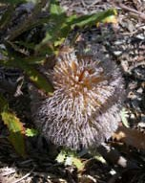
bushy shrub 0.5–2 m
0.08 kJ
per inflorescence

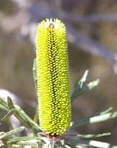
Banksia attenuata
small tree 0.4–10 m
0.078 kJ
per inflorescence

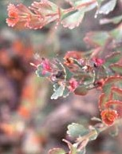
Adenanthos cuneatus
spreading shrub 0.3–4 m
0.029 kJ
per inflorescence

Different flowers produce nectar in different volumes. The energy content (kJ) of this nectar is highly variable.
So do animals favour one type of flower over another? And if so, how do we find out?

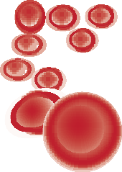Like getting blood from a possum

Research scientists use a special technique called infraorbital sinus bleeding to take blood samples from the tiny and sensitive honey possum.
Blood is taken from a sinus behind the eye! This sounds gruesome but actually causes little or no distress to the animal due to the lack of nerve endings in this area. A 25 µL microcapillary tube is inserted gently between the eyeball and eye socket, into the sinus. The tube fills through capillary action and is then removed. The pressure of the eyeball returning into place stops any further blood flow. This technique is widely used with other animals, including reptiles.

Scientists find out which plants the honey possum prefers by taking samples of pollen stuck to their noses and whiskers. The pollen is classified to reveal its source.
The honey possum’s favourite meals, and the amount of energy (kJ) available from nectar per inflorescence (a group of flowers on a single stem or branch) is shown above.

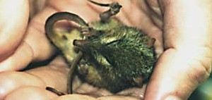
Talking about torpor
Torpor, or heterothermy, is a behavioural and physiological state of inactivity and reduced metabolic rate. It is triggered by environmental stimuli including temperature, food or water. Physiological changes occur in body temperature, metabolism and water balance. Torpor might last for a few hours or even several days.
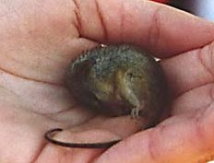
The honey possum displays shallow daily torpor. During these periods, body temperature can fall from 35 °C to as low
as 5 °C, and metabolic rates can fall to 10–60% of normal values.
Researchers often find honey possums in torpor after a lengthy stay in a pitfall trap.

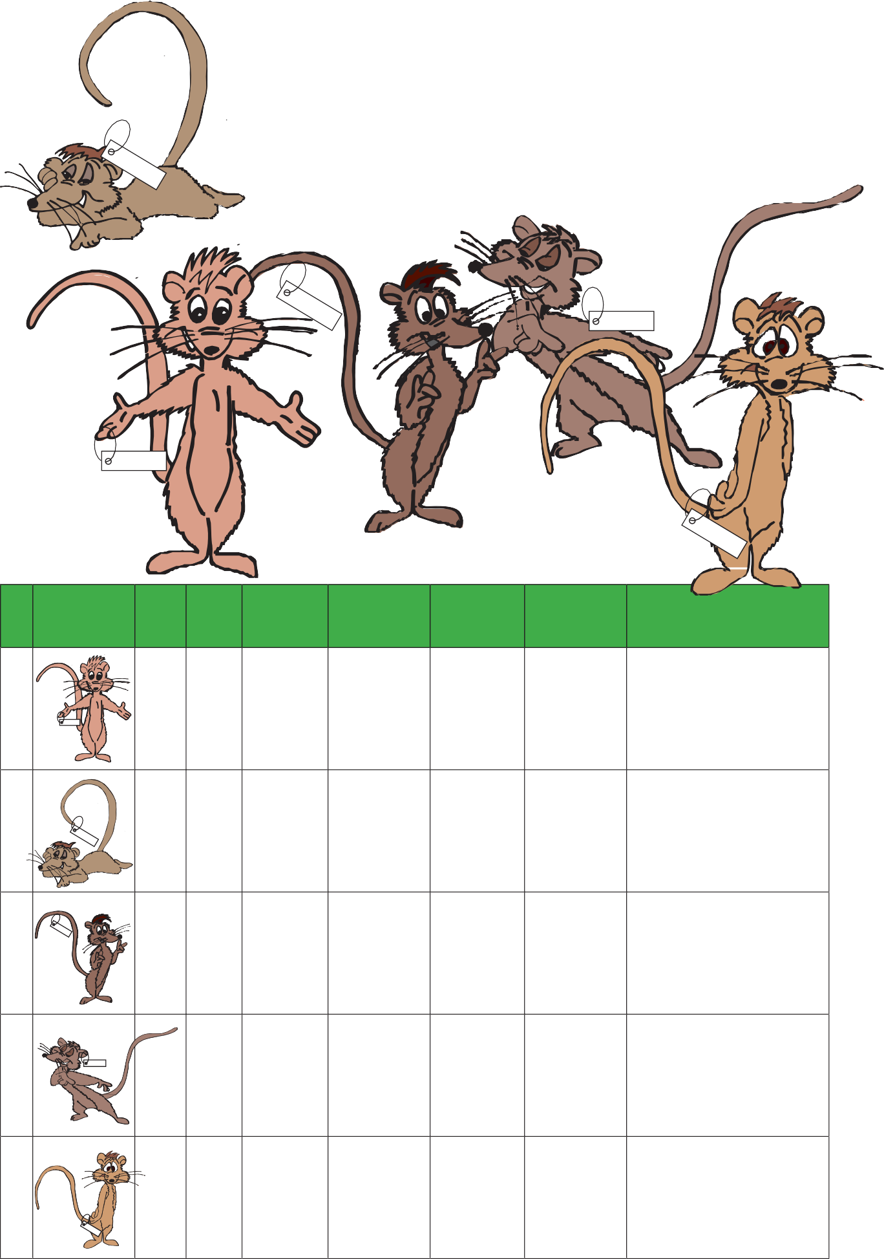

A tale of five possums
During a field trip, research scientists collected data (including blood samples) from five honey possums, from various study sites. By analysing these blood samples they can calculate CO2 production. These results, and other data regarding the possums, are recorded in the table below.

4 Nova

1 Barry

Subject |  |  | Sex | Mass (g) | Length (cm) | Food source | Estimated time in trap (hrs) | CO2 /L  per day | FMR
1 | 1 Barry |  | M | 10.2 | 8.3 | Banksia nutans | 2 | 1.58
2 |  |  | M | 8.6 | 7.9 | Adenanthos cuneatus | 0.5 | 1.76
3 |  |  | M | 8.4 | 7.6 | Banksia baxteri | 1 | 1.62
4 |  | 4 Nova | M | 6.8 | 6.6 | Banksia baueri | 4 | 1.41
5 |  |  | M | 9.1 | 8.1 | Banksia coccinea | 8 | 0.73

Question 7: Calculate the FMR in kilojoules per day (kJ day-1) for each honey possum using the information provided. (Remember the standard conversion factor for metabolism of carbohydrate is 20.8 kJ)

Question 8: Calculate how many inflorescences each honey possum visited to meet its energy needs. Round values to the nearest whole number.

Question 9: Construct a bar graph that displays information regarding:
- FMR (kJ day-1) for each honey possum, and
- the number of inflorescences visited daily by each honey possum.

Question 10: What do you notice about the approximate number of inflorescences each honey possum visited?

Question 11: Comment on similarities and differences in the data for the five honey possums.

Question 12: Explain how the food source of each honey possum might influence energy expenditure.

Question 13: Data obtained for individual ‘five’ are different from the other honey possums. Discuss.

Question 14: All animals in this study are male. Using your background knowledge, explain how data might be affected by adding females to the sample.

The equation for cellular respiration is as follows:
energy
(as ATP)
+
water
(6H2O)
+
carbon dioxide
(6CO2)
oxygen
(6O2)
+
glucose
(C6H12O6)

The cellular journey of these molecules is represented below:
CELL
OUT
IN

Question 15: Using the honey possum as your reference, complete the following table:

Molecule | Where does it come from? | Where does it go?
glucose
oxygen
carbon dioxide
water

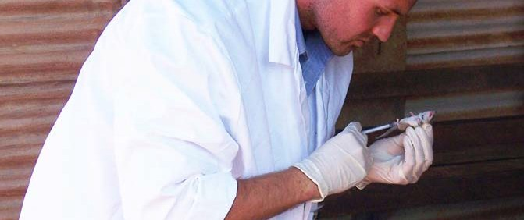Measuring respiration with doubly-labelled water

What is doubly-labelled water?
Doubly-labelled water (DLW) is water that contains the radioisotopes heavy oxygen (18O) and tritium (3H). These isotopes act as molecular labels which allow scientists to measure changes in their concentration, over time. These isotopes occur naturally and have no adverse effects on subjects. 18O is stable and 3H, whilst radioactive, is used in such small amounts it is harmless. A solution of doubly-labelled water contains isotopes 3H2O and H2180.
The doubly-labelled water method is a field technique commonly used to measure the field metabolic rate of free-living animals such as mammals, birds, reptiles and even humans. Scientists find this method particularly effective with honey possums as they do not drink water. As no further dilution of the isotopes can occur within body water, the method can be used to provide an accurate measure of CO2 production.
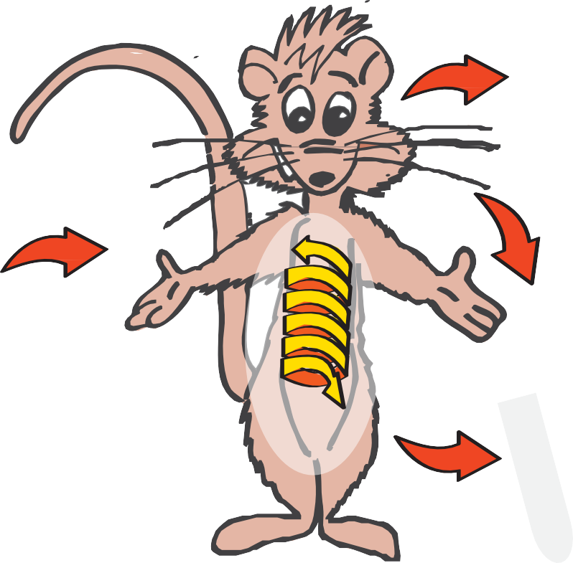Doubly-labelled water and the honey possum
CO2 released with breath, including 18O

DLW is introduced, including 18O and 3H

In the field, captured honey possums are injected with a solution of DLW. They are left to rest in a suspended calico bag for two hours. This allows the isotopes to equilibrate, or mix
evenly, within water in the body. A very small drop of blood is taken before the honey possum is given a feed of honey and water and released at the site of its capture.

DLW mixes with water in the body

H2O lost as sweat and urine, including
18O and 3H

blood sample taken and measured for
18O and 3H

The tricky part comes next – recapturing the same honey possums. This is one of the most difficult aspects of field research because it relies mainly on luck!
Recapture rates are low, around 4%, and recapture must occur quickly, within 36–48 hours.

This is because honey possums lose water rapidly, and after 48 hours the isotopes will be completely washed out of the body. Upon recapture, a second blood sample is taken. All collected blood samples are sent for analysis.

What is being measured, and why?
The DLW method is effective because it is based on our understanding of biochemical processes that occur during cellular respiration.
3H and 18O injected into a honey possum mix with body water, including blood. CO2 produced by cellular respiration is transported, through the bloodstream, to the lungs. During this process a series of reactions result in 18O mixing with CO2. This is important because it means that any CO2 exhaled from the lungs will also have 18O mixed with it.
As the honey possum breathes out CO2, the concentration of 18O in the blood steadily decreases. By measuring the concentration of 18O that remains in the blood, scientists can estimate the amount of CO2 produced. There’s a complication though, because 18O isn’t just lost through CO2 – it’s also lost in water as urine, sweat and vapour.
That’s where 3H comes in. This radioisotope is only lost through water – there’s no hydrogen in CO2. By measuring the decrease in concentration of 3H in blood, scientists can estimate the amount of water lost by the animal.
Once that’s known, it’s possible to work out how much of the decrease in 18O is due to water-loss, and how much is due to CO2 production. Now we have the figure we need – the amount of CO2 produced by the animal between release and recapture.

Question 16: Why is it important to wait for DLW to mix with body water?

Question 17: Why is the DLW method used?

Question 18: The DLW method has been used in animals as small as insects and as large as seals. It is also used in humans. However, this method is not suitable for tropical animals. Why?

Question 19: Why wouldn’t the DLW method be used in amphibians?

Question 20: The use of the DLW method has important implications for honey possum conservation. Discuss.

