
worksheet

Influenza – an evolving problem!


any vaccinations provide immunity for a number of years. Some even protect you for life.
M
So why do doctors recommend that you get an influenza vaccination each year?
Well, your immune system has a memory of past infections; some memory is long-lived and prevents you from catching a disease more than once.
If reinfected by a pathogen that has previously made you ill, your immune system will usually act quickly to attack it, often preventing onset of any major symptoms. However, the immune memory, whilst effective, is specific, so changes
that occur to pathogens over time may make them unrecognisable to your immune system.
Influenza is a virus that multiplies quickly and is prone to replication errors or mutations in its RNA sequence.

If mutations occur in the segment that codes for two surface proteins (H and N) on the virus, then your existing antibodies may not recognise the virus and will not bind to it. Thus the virus will more easily infect your cells.
Changes that occur to influenza viruses occur rapidly as they move around the world. Strains that develop in a local population one year may be different from those found the following year. This explains why doctors recommend some people should be vaccinated for influenza every year.
Each year a panel of scientists reviews influenza strains currently infecting people around the world, then makes recommendations for strains that should be included in vaccines.


neuraminidase (N) haemagglutinin (H)

RNA

structure of influenza A virus

The Influenza Research Database (IRD)
Sometimes, when you go to the doctor with influenza-like symptoms, a sample of mucus or blood may be taken and sent away for testing. This is done to determine exactly what’s making you ill, so you can be treated
appropriately. Sometimes this information may be added to a database (without your identifying details) to allow scientists to keep track of strains of viruses and bacteria present in populations. Over time, these data build a picture about what is happening to pathogen populations around the world.
The Influenza Research Database contains information about many different strains of influenza, from many different populations. In this activity you will focus on influenza virus H1N1 which caused the swine ‘flu pandemic in humans in 2009. You will see how this strain of influenza was different from those in previous years. You’ll compare strains, using bioinformatics tools such as multiple sequence alignment and phylogenetic trees, to examine how mutations change the relatedness of some strains of influenza.
To use the database follow the steps below. Screenshots are provided to help you navigate the website.
Before you start
Check that the browser you are using supports Java by going to http://www.java.com/testjava/ More information is available in the teachers guide (Technical requirements).

Overview of database use

Ⓕ Visualise mutations using a phylogenetic tree.
Investigate mutations (nucleotide differences) between aligned segments.
Ⓔ
Ⓓ Align segment sequences.
Ⓒ Find information about the virus strain, H1N1.
Search for sequence segments of H1N1.
Ⓑ
Go to http://fludb.org, log-in and get a workbench space. You need a workbench space to store your searches.
Ⓐ

Ⓐ Register for a workbench
The workbench enables you to save searches and recall data. To produce a meaningful phylogenetic tree you may need to run several searches and save your data as you go. To register for a workbench, select Register for a workbench and follow the instructions. There are also various tutorials about the IRD that you can access from the blue banner, by selecting Support.
Record your login details as you register for a workbench. Login details required: email address and password.

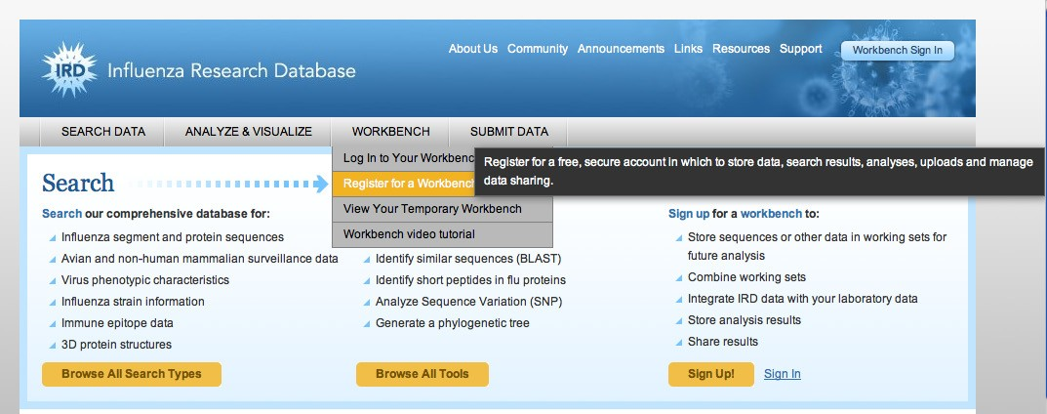
Ⓑ Search for H1N1
From the grey navigation bar roll over SEARCH DATA, then Search Sequences and select Nucleotide Sequences.
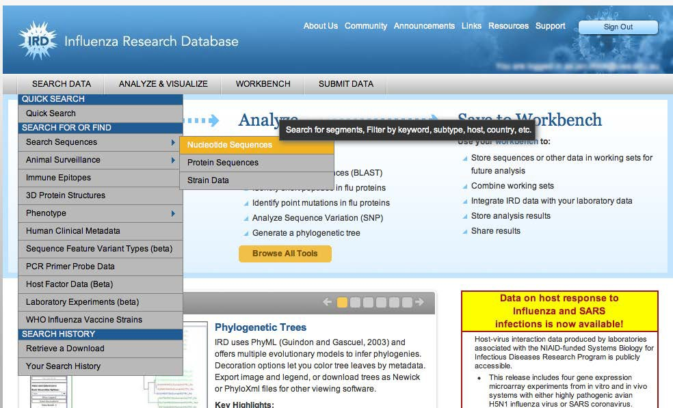

Nucleotide sequence search
Select or enter the following settings:

VIRUS TYPE A
SELECT SEGMENTS 4 HA
SUB TYPE H1N1
HOST Human
GEOGRAPHIC GROUPING Oceania
COUNTRY Australia
Leave the other fields (STRAIN NAME and DATE RANGE) blank.
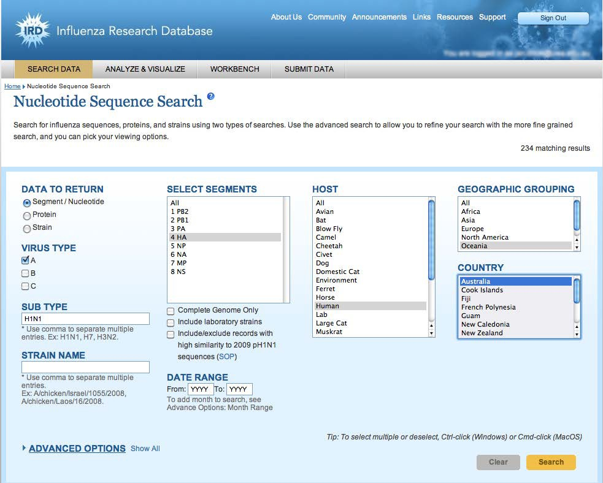

Select Search.
You’re searching for H1N1 influenza viruses in Australia, a common type of influenza that affects humans and the one responsible for the global ‘swine flu’ outbreak. You’ll get a list of many strains!
Note: Your results may differ from the screenshots that appear in this worksheet as the database is constantly updated.

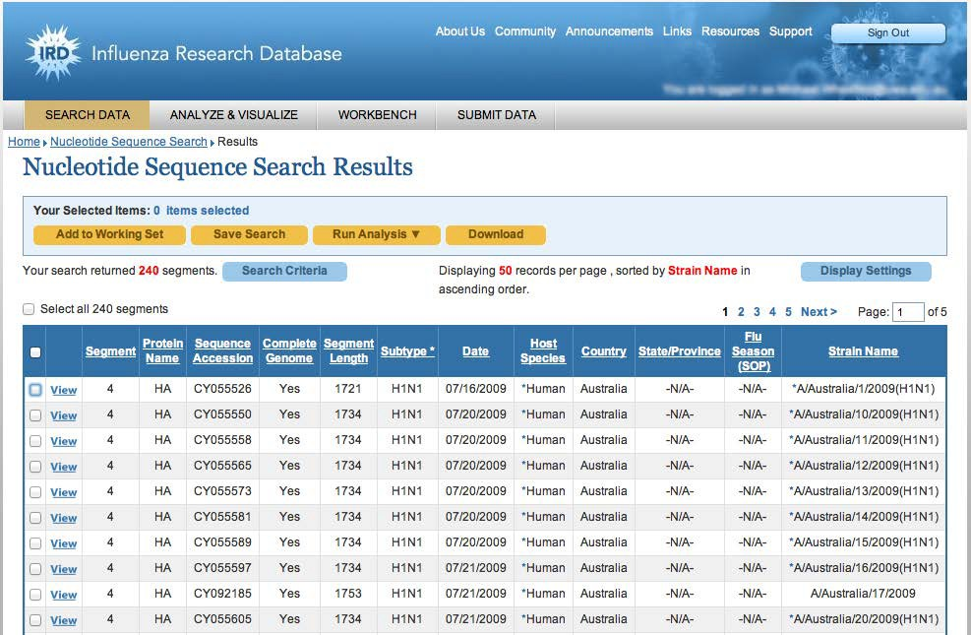

Ⓒ Segment information
When samples are collected from people, additional information is gathered to build up a profile of how a virus is establishing itself in a population. Select View for one segment to view details of the strain.
Using strain and segment/protein information provided for your selected segment, answer the questions on the next page. There’s a lot of information so you’ll need to search carefully, and scroll down the page.

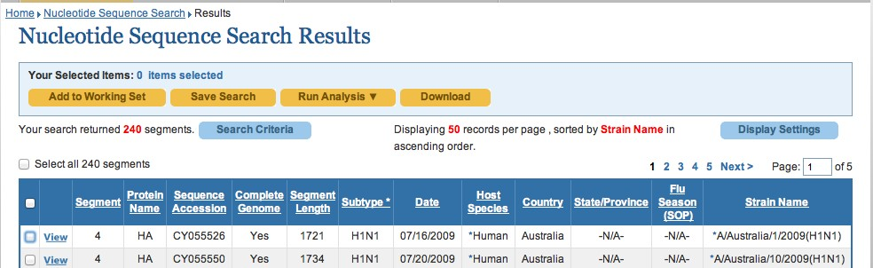

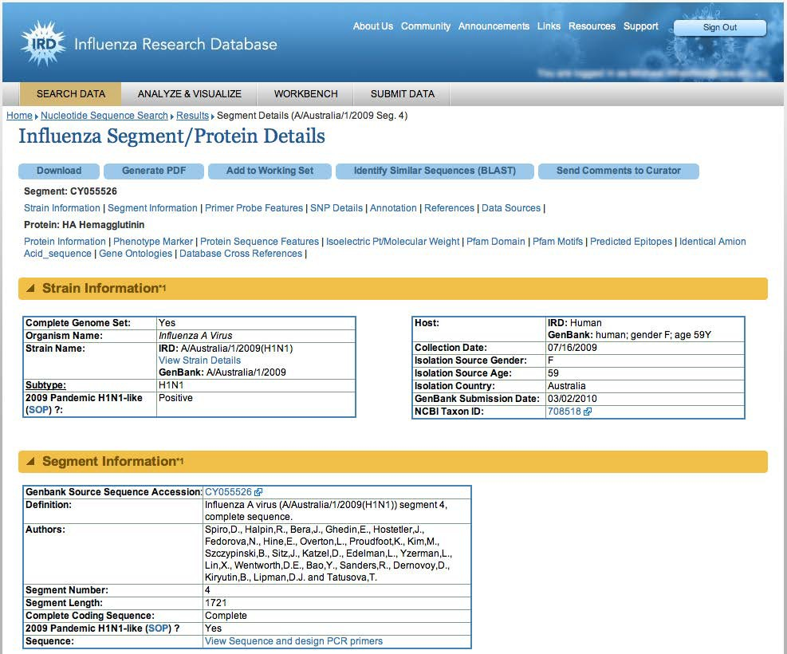


- Complete the following details:
Name of the strain (look under the yellow banner - Strain Information): .......................................
Isolation year:..................................................................................................................................
Age and gender of the individual (look under the box Host): ..........................................................
How long is the segment? (yellow banner Segment Information): ................................................
How many amino acids does it encode? (scroll down to Segment Annotation – protein length)
.......................................................................................................................................................
- What does H1N1 refer to?
.......................................................................................................................................................
3. Your search has yielded hundreds of strains. In terms of virus evolution, explain this.
.............................................................................................................................................................................
.............................................................................................................................................................................

View sequence
Stay on the current page (Influenza Segment / Protein Details).
Some collected samples are sequenced, which means that genetic material is analysed and nucleotide order determined. This precise analysis enables comparison of strains to determine where mutations have occurred.
Under Segment Information select View Sequence and design PCR primers to retrieve the sequence.
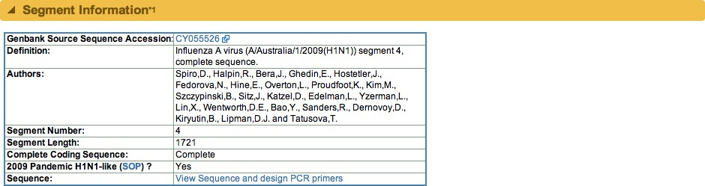
You should get a large table of nucleotides showing your results. This is just a portion of the whole strain; it may be the beginning, middle or end of a viral sequence.
An example of a genomic sequence follows on the next page.

- What do letters in the sequence represent?

.............................................................................................................................................................................
.............................................................................................................................................................................
- Why is the order of letters important?
.............................................................................................................................................................................
.............................................................................................................................................................................

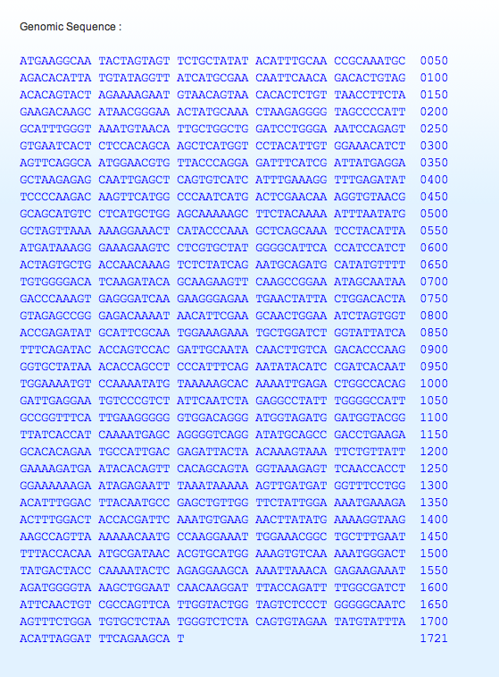

Perth H1N1 pandemic 2009
Search for H1N1 viruses identified in Perth.
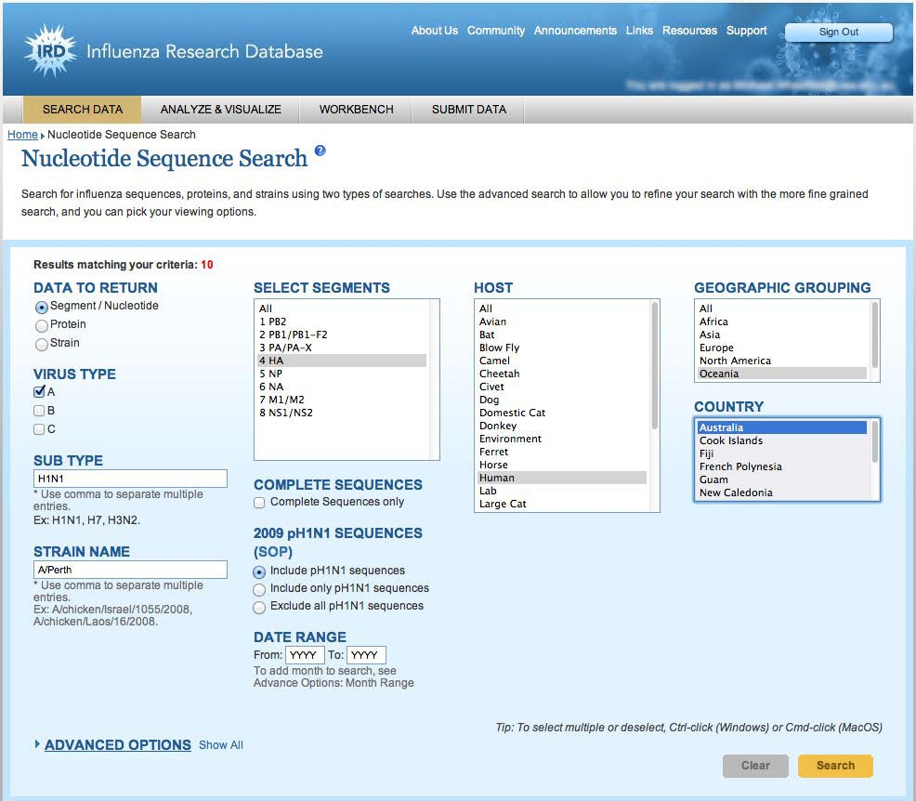To do this, return to the HOME page and repeat your search, only this time specify STRAIN NAME as A/Perth. This should yield ten segments, from 2006 onwards (remember to specify SUB TYPE as H1N1).

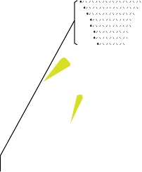The diagram on the right shows the convention for naming human influenza strains.
haemagglutinin (H)

RNA neuraminidase (N)
A/Australia/16/2009(H1N1)

virus
geographic
strain
year of
virus

type
region
number isolation
subtype

Save this search to your workbench by selecting Select all 10 segments, then Add to Working Set. You will be prompted for a name for this set: you may want to call it ‘Perth H1N1’.
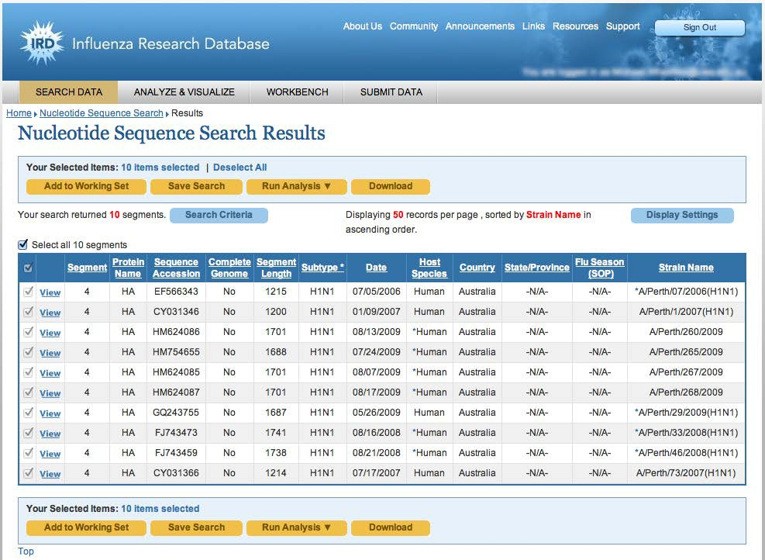

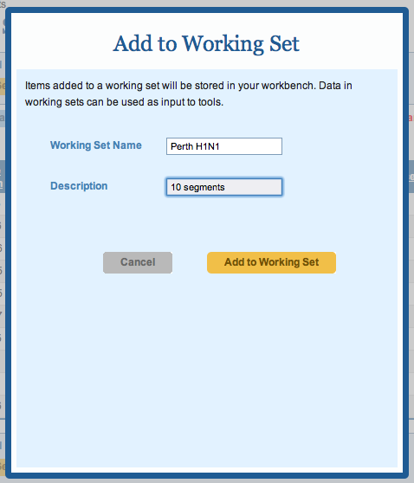

After naming the working set, select Add to Working Set, then Close.
These strains were identified through blood and mucus samples from influenza patients. It is possible to find out more information about strains by looking at segment details.
Look specifically at segment details for the strain A/Perth/265/2009 and complete question 6. Remember to select View and scroll through information provided.

6. Add information from the database for strain A/ Perth/265/2009 to the table below.
When was this virus collected? ................................................................
What was the age and gender of the individual? ......................................
At what location was the specimen collected? ..........................................
(see GenBank header notes)
How long is the protein that this sequence encodes? ................................

Ⓓ Analyse sequences
Go back to Results (use the ‘breadcrumbs’ toolbar, under dropdown menus).
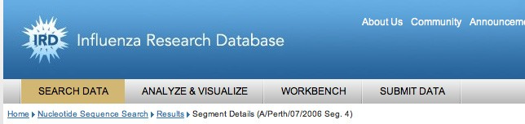
breadcrumbs

Examine Perth strains more closely, by performing a multiple sequence alignment. To do this, select Select all 10 segments, then Run Analysis, then Align Sequences (MSA). This will place sequences in rows. At certain positions mutations (nucleotide differences) will be visible.
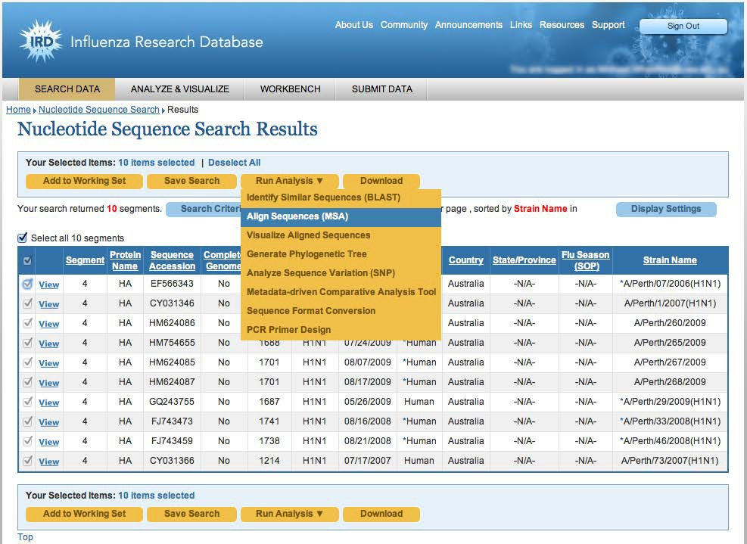

A window will pop up, select Nucleic Acid (Segment), then Continue.

On the next screen, without changing any parameters, select Run.
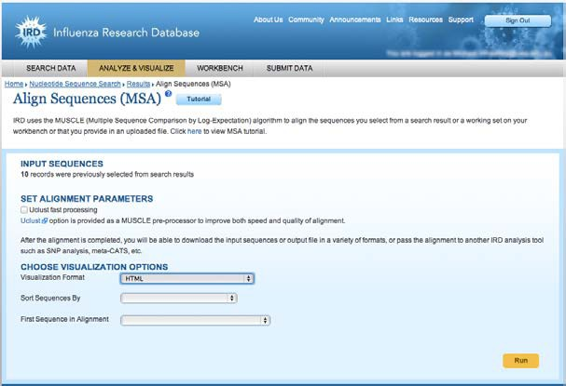
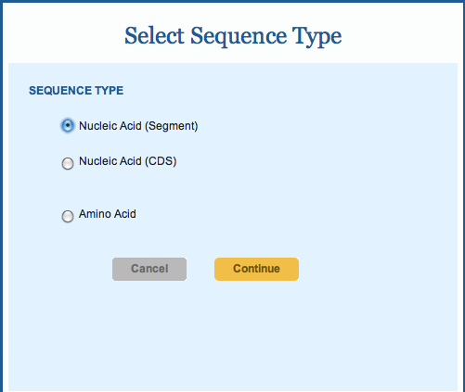

It takes some time for the analysis to run; a message is displayed while it is processing.

Ⓔ Compare sequences
Once the analysis finishes, roll over the blue Run Analysis button and select Visualise Aligned
Sequences from the dropdown menu.
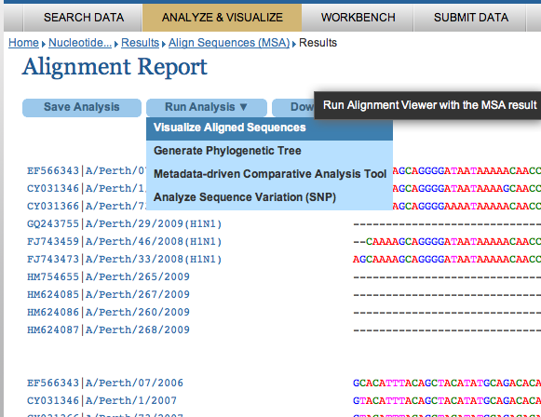

Customise LABEL SEQUENCE BY in the alignment: select Custom, and underneath it, a submenu will appear, select Strain Name and SubType, then select Run.
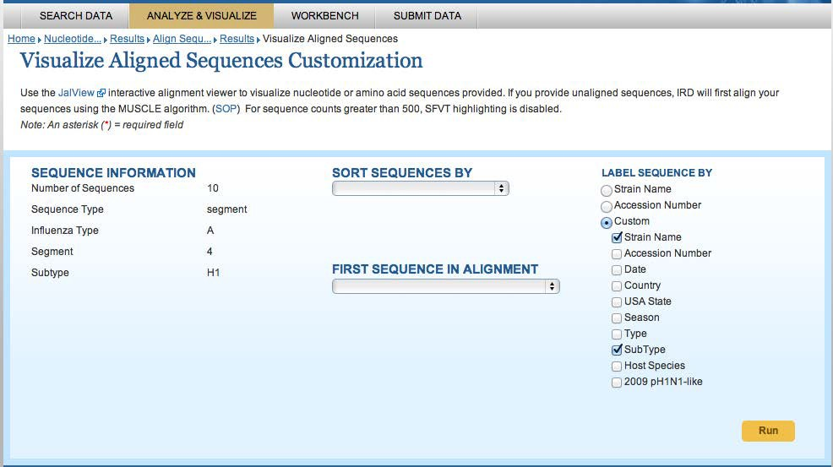

You can now see the visually aligned sequences.
Note: You may need to ‘allow’ a Java applet to run in order to display aligned sequences. A blank space on the page or ‘missing plug-in’ message may indicate problems with the installation of Java or its security settings on your computer.
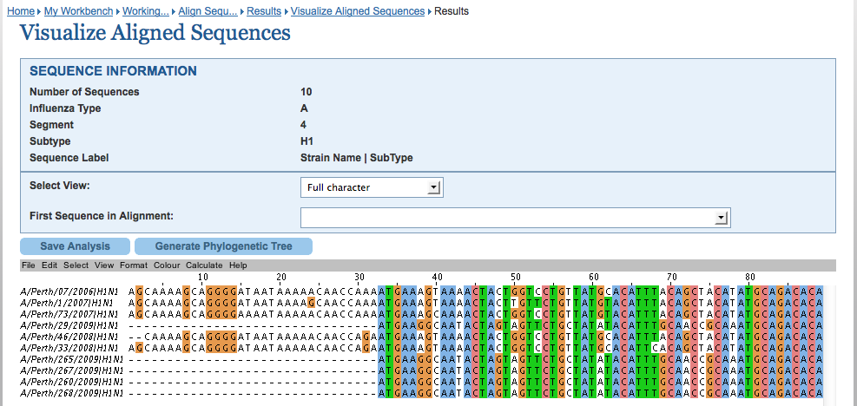

Scroll left and right to look at the full alignment. Solid columns of colour (including white) indicate each sequence that has the same nucleotide, in a particular position. Colour changes indicate where mutations have occurred.
7. What do you think dashes in the sequence mean?
............................................................................................................................................................................
............................................................................................................................................................................

From these sequences it’s possible to determine the degree of alignment. 100% means there are no mutations between strains (perfect alignment).

Select two 2009 sequences from Perth by clicking on them (eg 265/2009 and 267/2009).
Note: to select sequences that are not adjacent, on a Mac, hold down the control key. For those that are adjacent, hold down the shift key, as you select them.
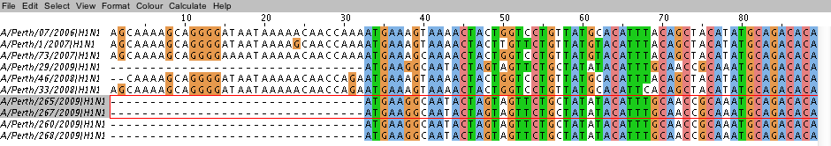

From the grey submenu bar select Calculate, then Pairwise Alignments… (from the dropdown menu).
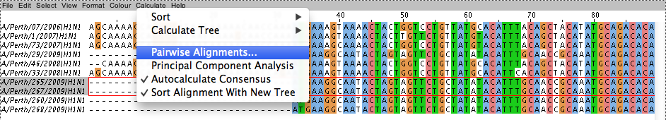

A separate page will pop up, scroll down it to find Percentage ID.
These sequences are 99.82% similar (you may get a different value, depending on the sequences you choose). Close the window.

Now select sequences from two different years, eg 268/2009 and 1/2007. These sequences are 75.56% similar. Select sequences from 2006 and 2008 (eg 07/2006 and 46/2008). They are 97.04% similar.

- Complete this table based on your calculations

Table 1: Percentage similarity between strains

Strain/year
 | 29/2009 | 265/2009 | 268/2009 | 1/2007 | 07/2006
29/2009 | - | - | - | - | -
265/2009 | 99.59 | - | - | - | -
268/2009 | 99.76 | 99.82 | - | - | -
1/2007 | 75.58 | 75.64 | 75.56 | - | -
07/2006 | 75.67 |  |  | 96.33 | -
46/2008 | 76.72

- Using percentage similarity data (table 1), explain how closely related these strains are:
a) 2009 strains; and
............................................................................................................................................................................
............................................................................................................................................................................

b) 2006, 2007 and 2008 strains.
............................................................................................................................................................................
............................................................................................................................................................................

- How do 2009 viruses compare to other viruses in Table 1?
............................................................................................................................................................................
............................................................................................................................................................................
............................................................................................................................................................................

Ⓕ Phylogenetic trees
The database can be used to create a phylogenetic tree that shows how H1N1 strains from Perth are related to each other, and how they diverge over time. To create a meaningful phylogenetic tree you must choose an
outgroup. This is a strain that shares a common ancestor with Perth H1N1 strains, but is genetically distinct from them.
Return to Nucleotide Sequence Search and search for a 2005 H1N1 strain from China as your outgroup (set
Date Range as 2005 – 2005).

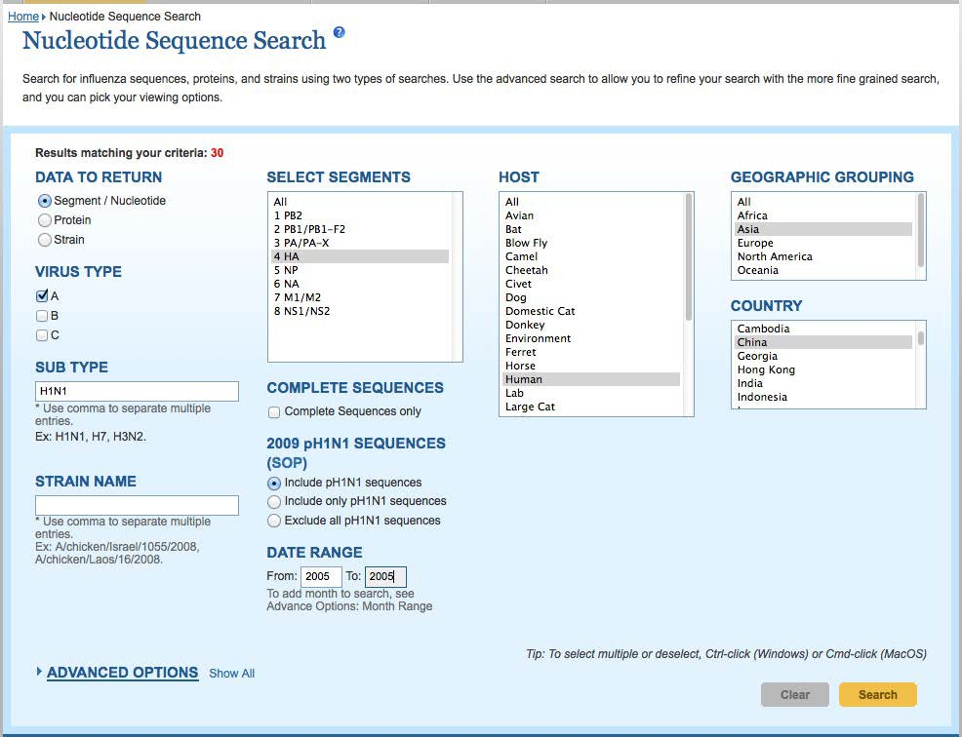

Your search will find a number of sequences. Select a sequence, then select Add to Working Set.
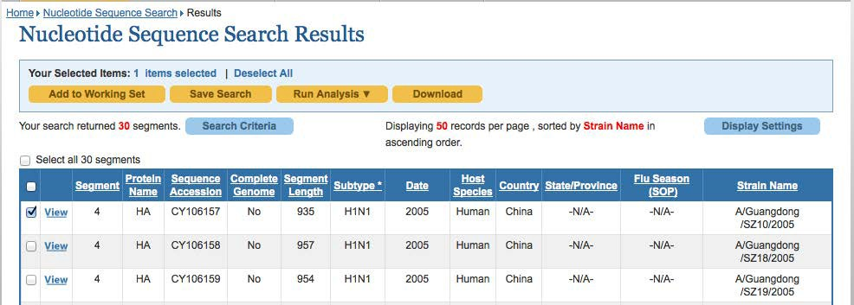

Add the selected strain to your working set (Perth H1N1, or whatever you chose to name it), select Add to Working Set, then Close.

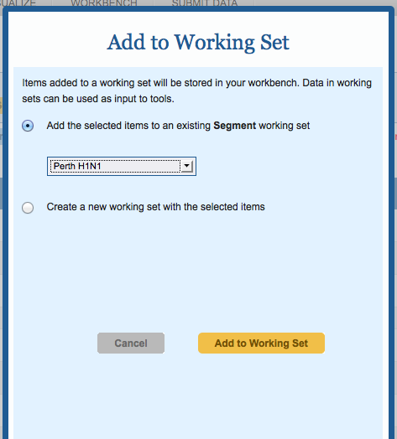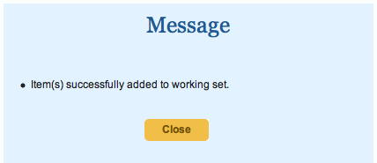

Under WORKBENCH select View Your Workbench, select the Perth H1N1 working set, then select View. Once this working set is displayed, select all strains (there should be 11).
Select Run Analysis then Generate Phylogenetic Tree. This will take some time.

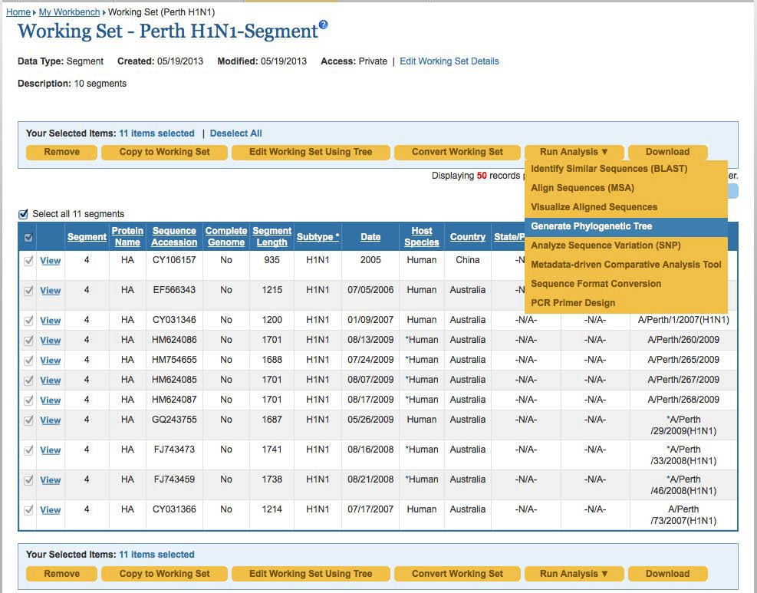

On the Generate Phylogenetic Tree page, select Quick Tree, then Specify custom format of tip label. Select Strain Name, Date and Country, then Build Tree.
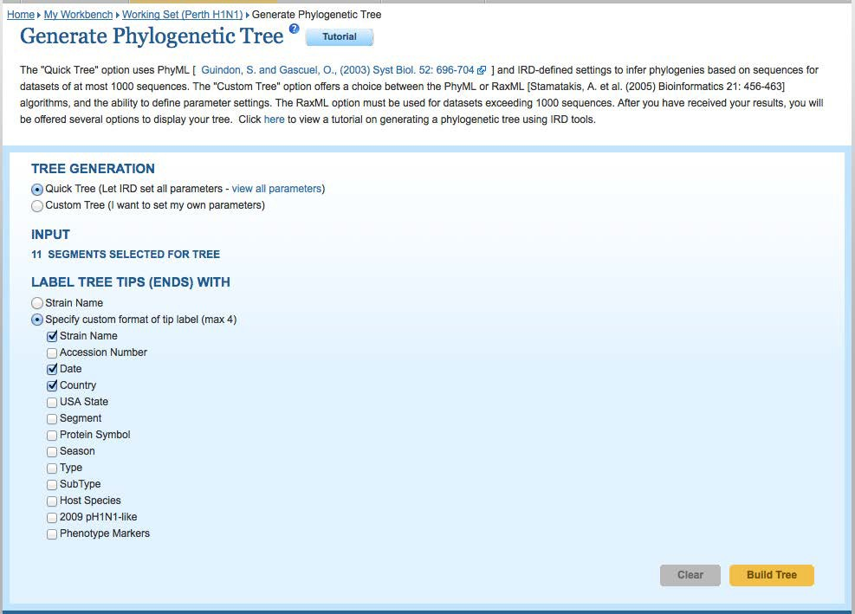

View tree
Once the analysis is complete, select View Tree (note: this will launch a Java applet, Archaeopterxy Phylogenetic Tree Viewer — you should ‘allow’ this applet to run).
The China outgroup should be the ‘root’ of the tree, that is, a strain that branches off the main trunk almost immediately. If your outgroup is not the root of the tree then, under DISPLAY OPTIONS, select Show Nodes. Select a node (the small black square) near the outgroup segment (China 2005) to re-root the tree. (The cursor turns to a cross when you run your mouse over a node.)
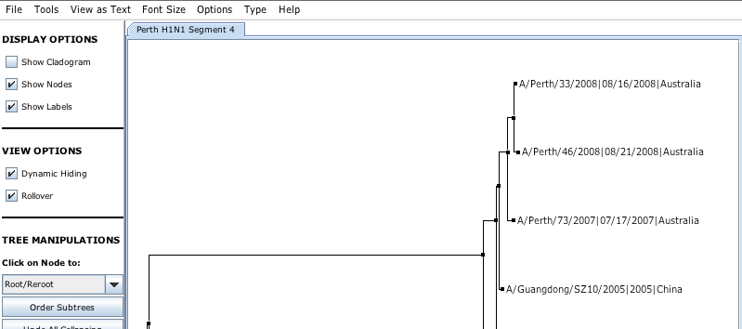

Under TREE DECORATIONS, select Year from the drop-down menu Basic Decoration Options. From the Options menu bar (at top of page) you can also display Branch Length Values.
The tree below uses an outgroup H1N1 from China, 2005. You can clearly see two distinct groups (called clades). The 2006, 2007 and 2008 segments are slightly different, however there’s a major change for 2009. The 2009 strains clearly show the swine ‘flu epidemic.

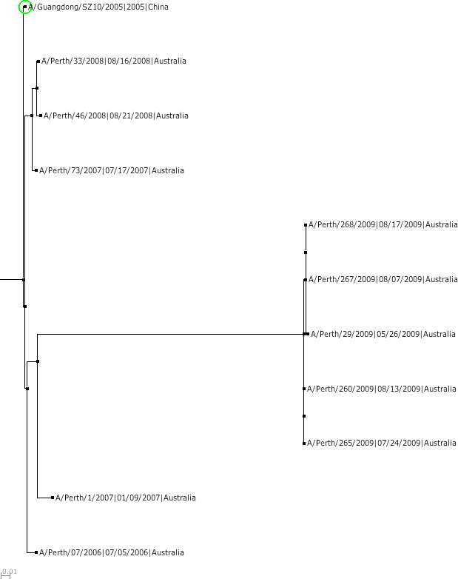

- A/Perth 2006-2007 strains have a small number of mutations. What evolutionary process accounts for these differences?
...................................................................................................................................................................
...................................................................................................................................................................
...................................................................................................................................................................
...................................................................................................................................................................

- In these sequences it appears that a number of mutations appeared in 2009. Can you describe what occurred in terms of antigenic shift?
...................................................................................................................................................................
...................................................................................................................................................................

- How closely does the outgroup (China, 2005) relate to Perth strains of H1N1? Consider: A/Perth/07/2006; A/Perth/46/2008 and A/Perth/265/2009.
...................................................................................................................................................................
...................................................................................................................................................................
...................................................................................................................................................................
- In addition to yearly influenza vaccinations, a vaccine was offered in 2009 for swine influenza. Why do you think this was necessary?
...................................................................................................................................................................
...................................................................................................................................................................
...................................................................................................................................................................
- Look at different lengths of horizontal lines on the tree. What information can be gained from the length of horizontal branches?
...................................................................................................................................................................
...................................................................................................................................................................
...................................................................................................................................................................

Under DISPLAY OPTIONS, select Show Cladogram.
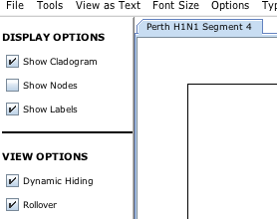

16. The cladogram looks quite different to the phylogenetic tree. What sort of information does a cladogram show?
............................................................................................................................................................................
............................................................................................................................................................................
17. What information does a phylogenetic tree show that is not shown by a cladogram?
............................................................................................................................................................................
............................................................................................................................................................................
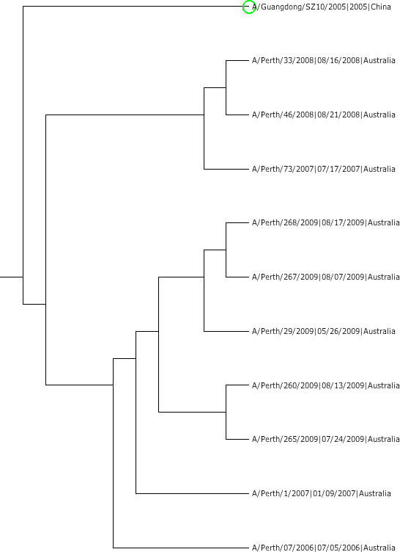
phylogenetic tree (left) and cladogram (right) for the same dataset

Other trees to create using the IRD
- Compare the same subtype H1N1, from different regions, across one year.
- Compare different human influenza viruses, eg H1N1 and H3N2 subtypes.
- Create a tree using segment 6, or NA. This segment of RNA codes for neuraminidase protein, another important protein on the surface of influenza virus. Does it suggest a similar pattern of evolutionary relationships?
- H5N1 is an avian (bird) flu virus that has caused outbreaks in domestic poultry in parts of Asia and the Middle East. This virus can also jump from birds to other species, including humans. Use the Influenza Research Database to investigate occurrence of H5N1 in China in 2007. Is there any evidence to indicate how humans might have contracted the virus? (Note: include host species in your tree label. To root your tree, add a single occurrence of human H3N2 flu to your dataset. When you process this dataset you may get a warning that you are working with two different subtypes (H5N1 and H3N2) but this will not be a problem here.)

Reference: US Dept of Health & Human Services. (n.d.). H5N1 Avian Flu (H5N1 Bird Flu). Retrieved 21 May 2013 from http:// www.flu.gov/about_the_flu/h5n1/

