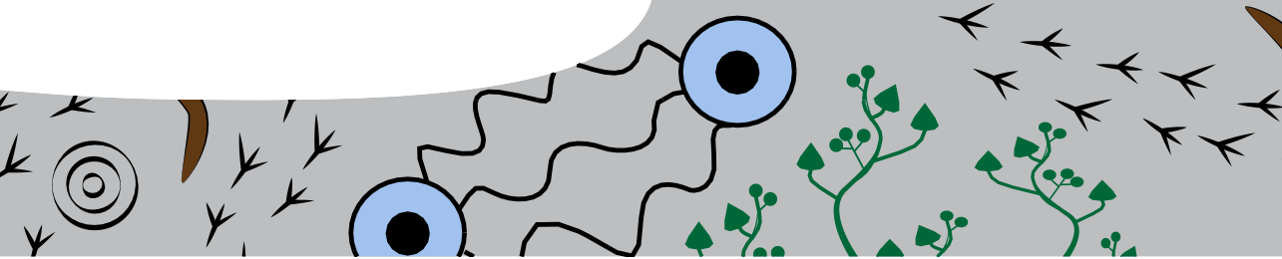
worksheet
Imagine, plan, create

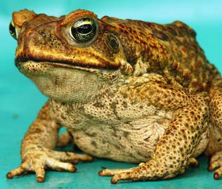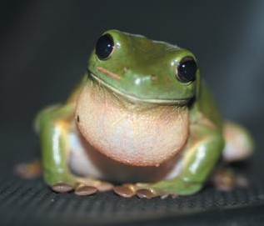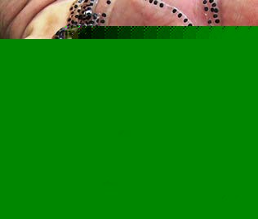

Image from Kimberley Toad Busters Green Tree Frog by Stephen Michael Barnett,
CC-BY 2.0
Image from Kimberley Toad Busters

You’ve probably noticed these images are all from our feeding relationships’ study? Think about it for a minute – and discuss in groups:
- What part of your study interested you most? Why?
- What surprised you? Why?
- What concerned you? Why?

Your task
Choose and present a scenario of your choice, about feeding relationships in the Kimberley, and create a painting/artwork using Aboriginal art techniques. You may create your own symbols to tell the story behind your painting, and also choose some symbols used by Aboriginal people, from a selection that anyone is permitted to use. Other symbols are sacred and may only be used by the Aboriginal group of people to whom they belong.

How do you know about Aboriginal art? Check it out, of course.

Here are some guidelines to help you do just that.
Study examples of Aboriginal art, and familiarise yourself with techniques used and meanings of/stories behind the artworks. You may like to do this with a partner so you can discuss information you discover. As you go, you may each draw up a chart of symbols anyone may use, for you to refer to later.
To do this research, you need to find Aboriginal artworks that tell stories. Many art galleries sell Aboriginal artworks and display images of these works on their websites. Images are sometimes accompanied by synopses (summaries) of stories they tell.
Search ‘Aboriginal artworks’ on the Internet to bring up a selection of galleries. Other search phrases to try include: ‘Aboriginal art and meanings’ or ‘Images of Aboriginal art and meanings’.
This should show a wide range of artworks, and symbols used when creating paintings, and their meanings.

Other websites that provide information include:
- Aboriginal art online is helpful as it includes descriptions of stories behind artworks displayed: http://www. aboriginalartonline.com/aboriginalpainting/ then select ‘Kimberley’.

- Select ‘Symbols’ from the same website to identify and discuss symbols, and what they represent.

- Central art – Aboriginal art store provides a general, detailed introduction to Aboriginal art and its meanings and includes stories told by some of the paintings. It’s a commercial site so paintings will change, but it’s a worthwhile source of information (http://www.aboriginalartstore.com.au). Also check the section ‘Art & Culture – Aboriginal Symbols Glossary.
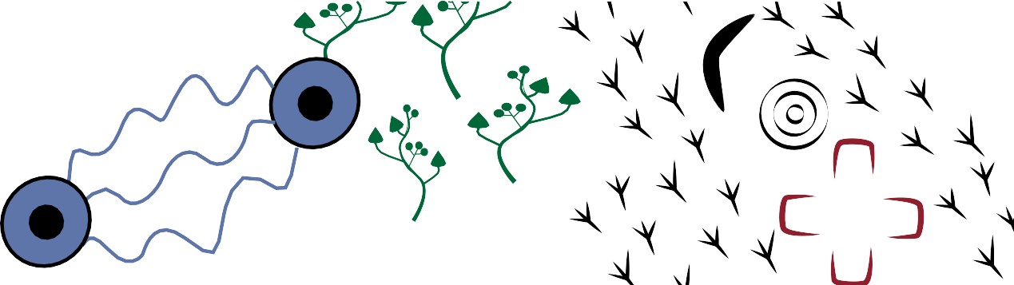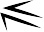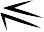

Procedure for creating artwork
Now, think of a scenario, about feeding relationships in the Kimberley, of which you’d like to paint a picture. There are many things that may interest you. Here are some ideas:
- catching cane toads,
- ways to control cane toads,
- identifying cane toads;
- cane toad life cycle;
- how cane toads’ arrival affects other animals in the food chain;
- a food chain in the Kimberley;
- cane toads’ path to the Kimberley;
- cane toads’ effects on water-life in a lake; or
- choose your own scenario.
Each person must decide on a scenario and create their own artwork.

When you’ve chosen your scenario, follow these steps:
- Write draft description/story of your scenario.
- Read. If more than one paragraph, write brief summary. Summary may look something like this:
Cane toads’ eggs and tadpoles are in a pool near a river, lined with trees. Water beetles and goannas eat eggs and tadpoles, and die. Crows eat toads, and die.
- Decide which story elements to paint.
Eg In the above scenario, elements might be: cane toads’ eggs; their tadpoles; pool; river; beetles; goannas; birds …
- Draw table, and enter elements.

ELEMENTS TO DRAW |  | LITERAL SYMBOLS | IMAGINATIVE SYMBOLS
cane toad eggs
cane toad tadpoles
pool
river

- 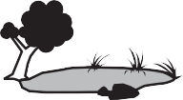Create symbols for elements of your story, on the chart. Symbols must relate to animals, places, effects … in it.
Under heading: ‘LITERAL SYMBOLS’ draw realistic symbols for each element (eg like those in real life: crosswalk signs; symbols to show male or female toilets …).
Under heading: ‘IMAGINATIVE SYMBOLS’ draw abstract symbols suggesting each element (eg like badges for makes of cars; logos for banks …).
- Check your list of symbols used in Aboriginal art, that you may use.
Eg for places (rivers …), landforms (hills …); indicating movement in a particular direction; and so on.
- Decide on which symbols and colours you’ll use for each element – choose a different colour for each symbol, and for backgrounds, but do not use the ochre colours often used in Aboriginal sacred paintings.
- Plan layout and placement of elements so they tell your story.
- Draft painting, using pencil/charcoal.
- Paint your picture, including your description summary (pasted on back); or you may prefer to choose from media other than paint, or even use multimedia.

