Watch the animation Gene regulation and answer the following questions.

Gene expression and regulation
- What is gene expression?

- What is gene regulation?

- Name three things gene regulation allows cells to do.

Gene regulation and cell differentiation
- Your skin cell and nerve cells have the same DNA but the structure and function of these cells are different. Explain why these cells differ.
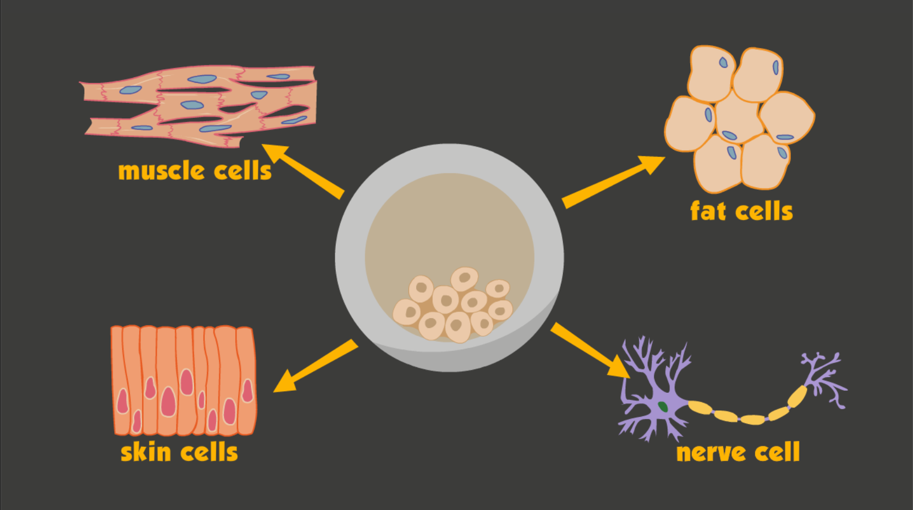

- Which cell type below expresses the gene that codes for the protein myosin?
(myosin is a protein responsible for muscle contraction)
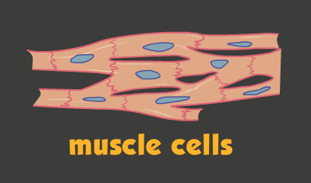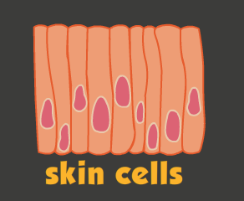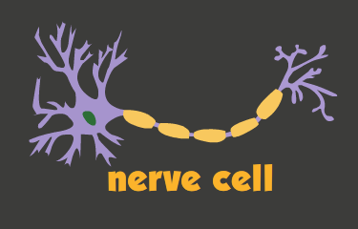
☐ ☐ ☐
- Housekeeping genes are found in most cells. Products of these genes are essential for basic cell functioning, such as cellular respiration. Are housekeeping genes always expressed, never expressed, or sometimes expressed?

- What triggers gene expression?

- In eukaryotic cells the default position of most genes is ‘off’, (they’re not expressed). Explain why.
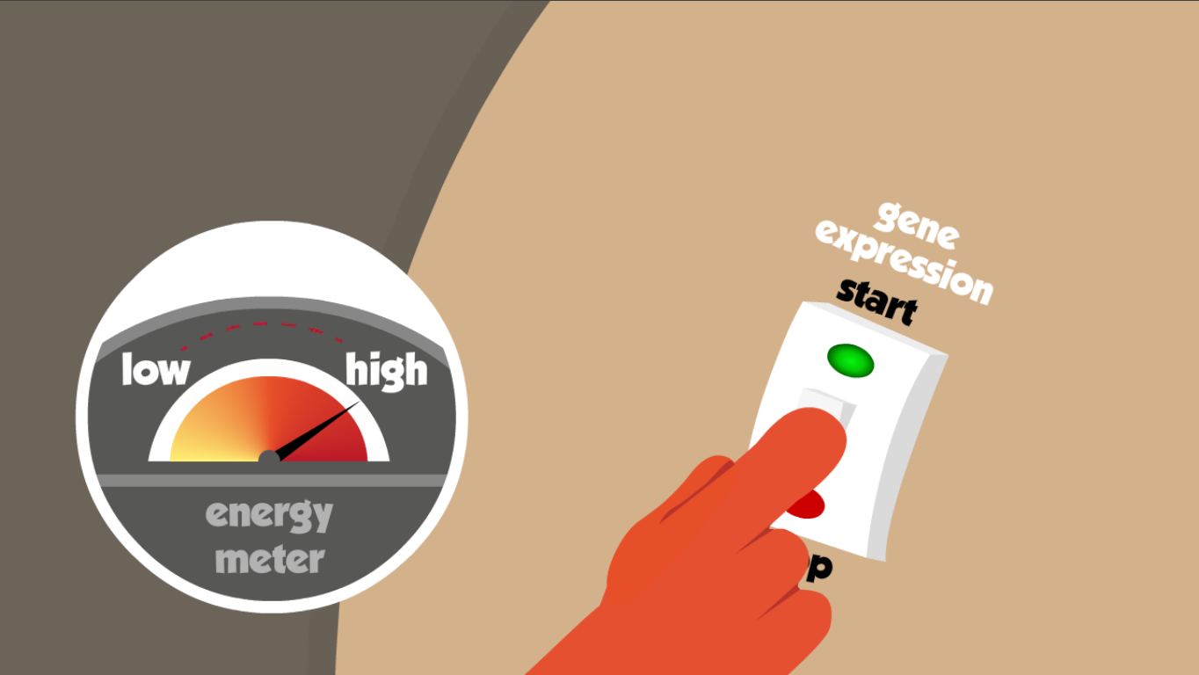

Transcription regulation
- The diagram below shows the first stage of transcription: initiation. The assembled molecules and nucleotide sequences form a transcription initiation complex. List the molecules involved and their role in this process.
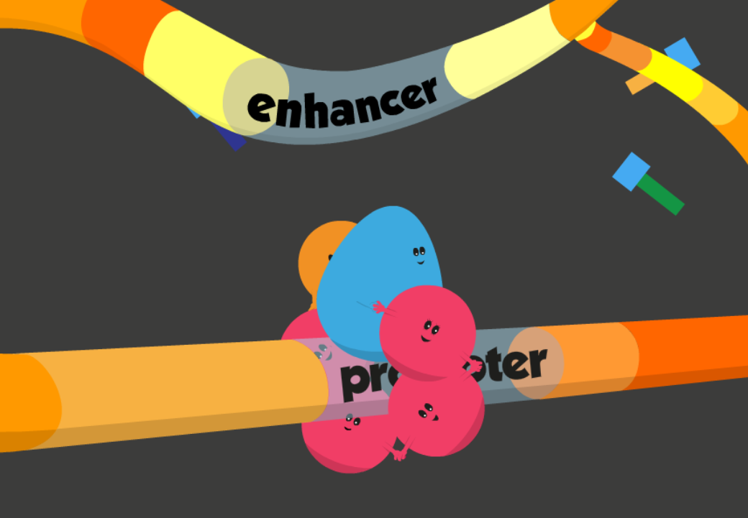

- Transcription involves three main stages: initiation, elongation, and termination. Label the diagrams below with the correct stage and name highlighted molecules.
stage: | 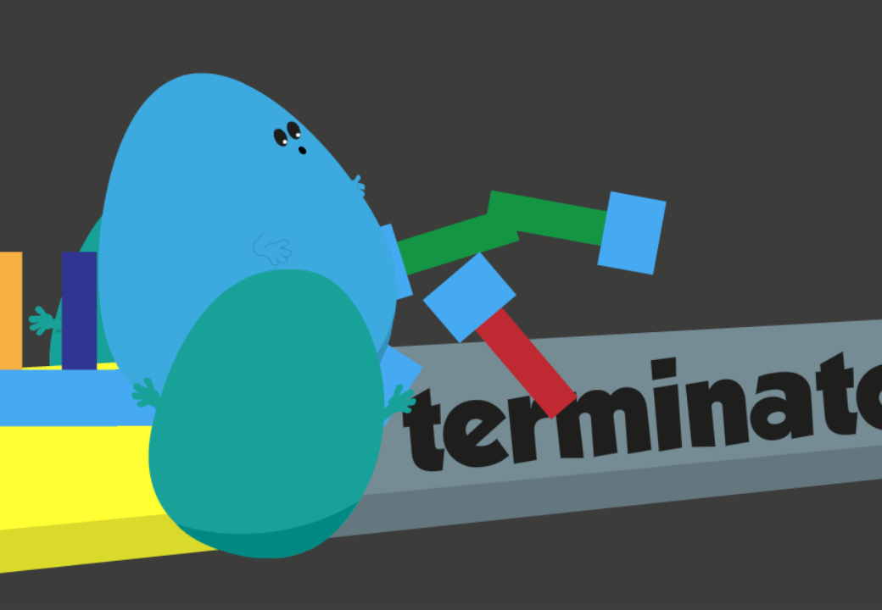
stage: | 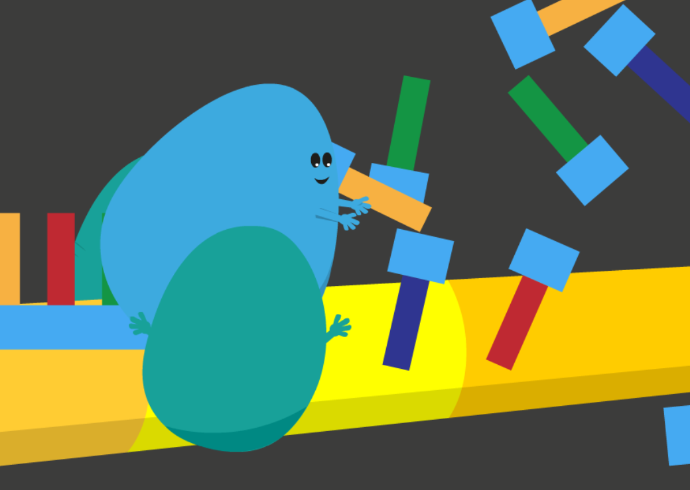

- What is a transcription factor, and what is its role in gene expression?

- What do regulating proteins recognise along sequences of DNA/RNA?

Splicing
- What is splicing? Why is it important?
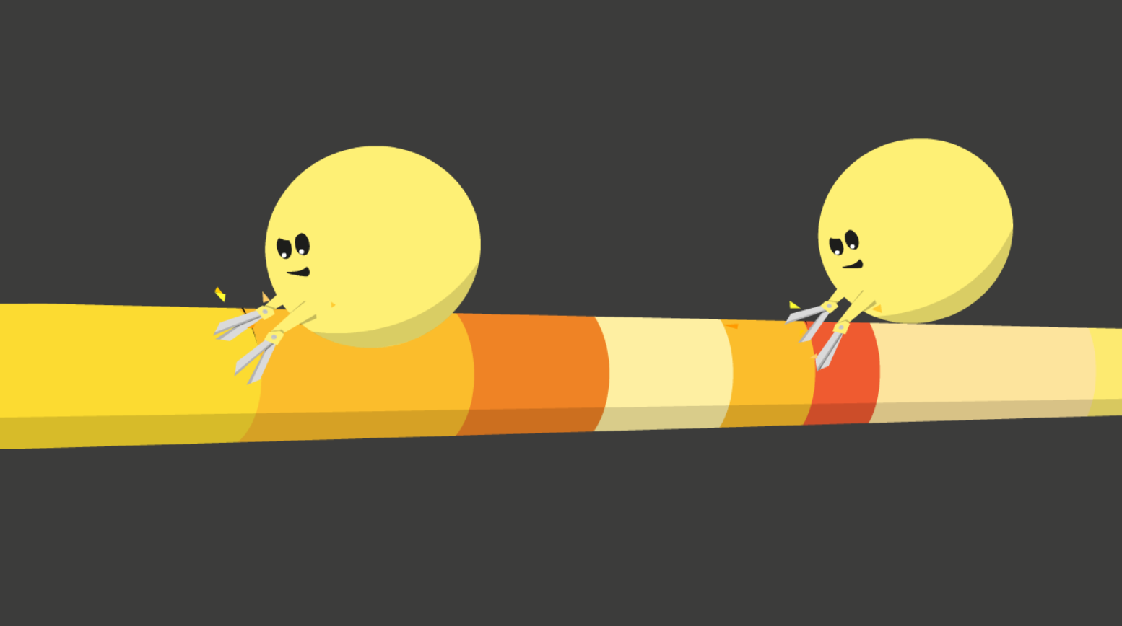

- Alternative splicing results in a single gene making a variety of protein products. This increases cellular efficiency, as less genetic material is required to code for the thousands of proteins cells need. Use the image below to explain the process of alternative splicing.
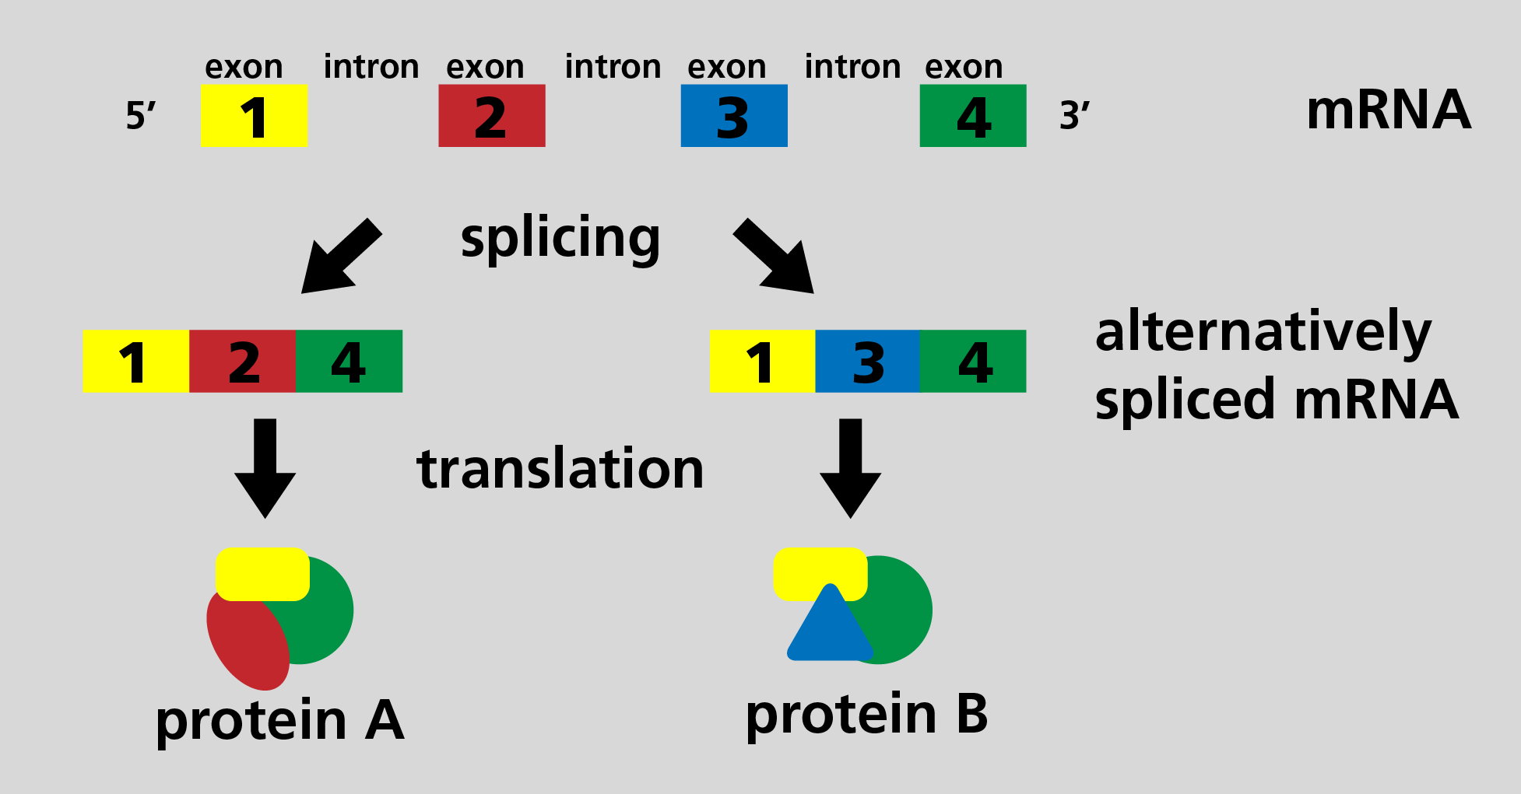

Translation regulation
- The diagram below shows the first stage of translation: initiation. The assembled molecules and nucleotide sequences are essential for translation initiation. List the molecules involved and their role in this process.
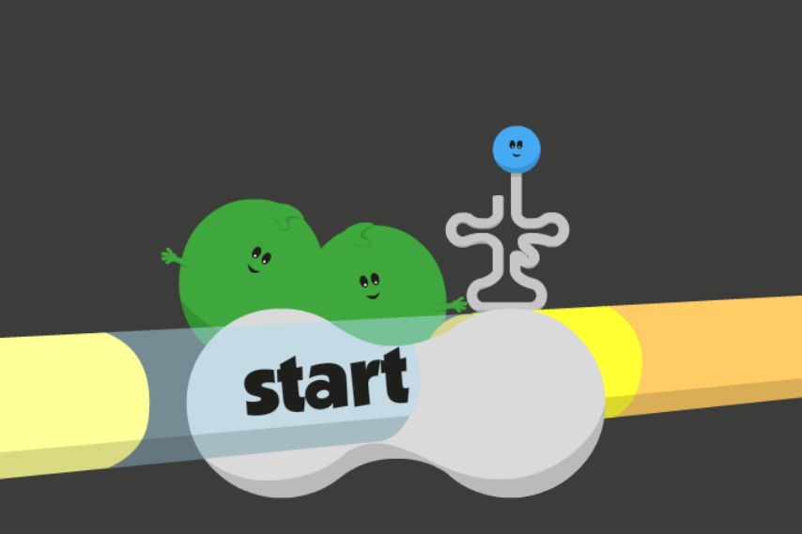

- Translation involves three main stages: initiation, elongation, and termination. Label the diagrams below with the correct stage and name highlighted molecules.
stage: | 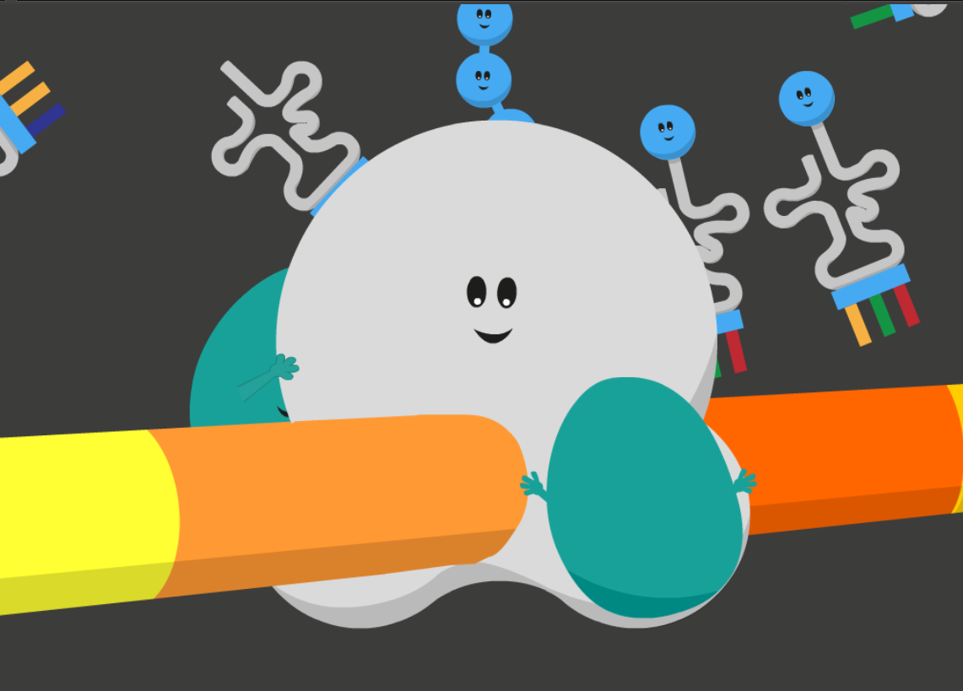
stage: | 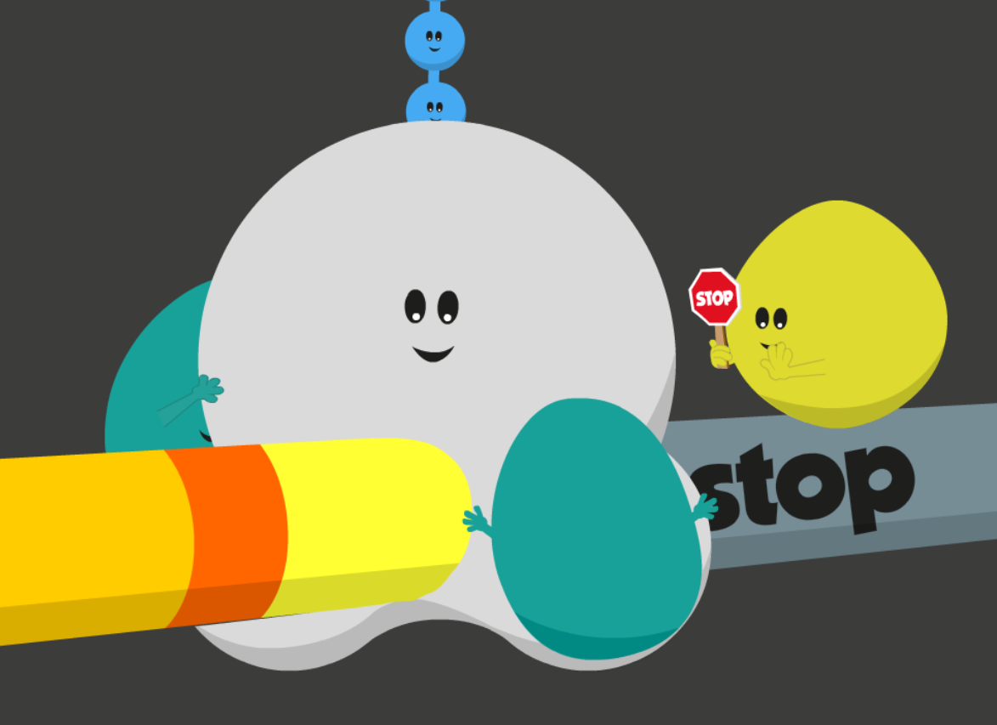

Mutations and gene expression
- DNA mutations can result in altered gene expression patterns. Mistakes in DNA nucleotide sequences can be transcribed and translated, resulting in mutated or faulty protein products.
This diagram shows a mutated protein involved in a cell-signalling pathway that triggers gene expression. Describe what might happen to expression of this gene as a result of this mutation.
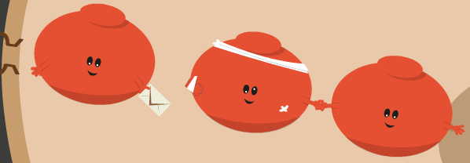

- Mutations in gene regulating molecules and sequences can also disrupt gene expression.
The diagram below shows a mutation in the promoter region of a gene, which has resulted in a change to the nucleotide sequence. Describe what might happen to expression of this gene as a result of this mutation.
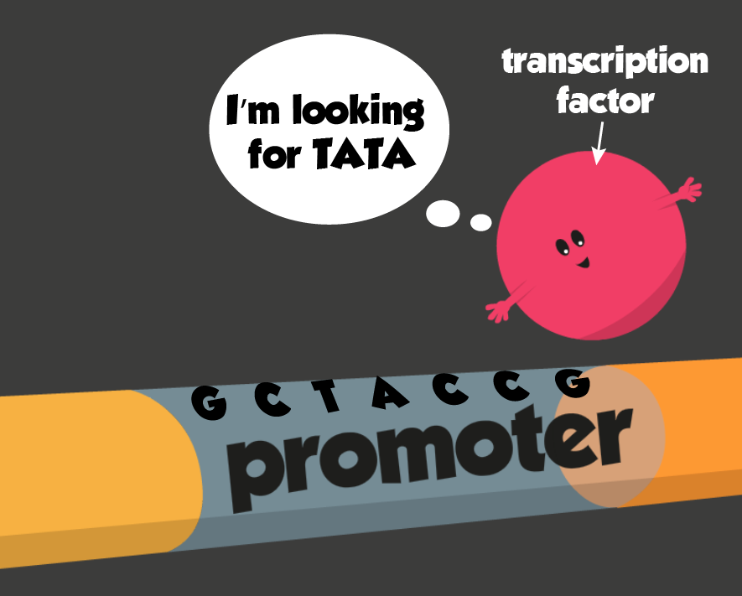

- If gene regulation breaks down within cells due to DNA mutations or production of faulty proteins, this can result in diseases, such as cancer. Cancer is characterised by continual cell division and growth. Consider what you’ve learned about regulation of gene expression, and describe what may be happening within a cell that’s become cancerous.

