Part 1: Electrostatic powder-coating
Powder-coating transforms a wide range of metal objects. These include white goods, metal chairs and tables, car parts, steel pergola frames and so on. Although the ideal finish is smooth and shiny, it is always a problem to prevent powder forming unsightly ‘blobs’ on the coating. Electrostatics provides an answer. How does it work?
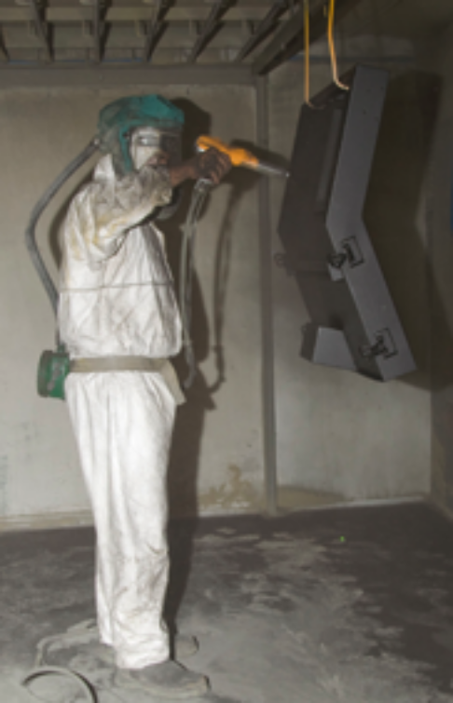
An electrostatic powder spray system is a highly efficient technology for applying powder. The process involves forcing powder through a spray gun barrel where it rubs against the internal surface. This rubbing causes powder particles to pick up additional electrons and become negatively-charged. The object to be coated is grounded. The charge difference between powder and object attracts powder to the object giving it a more even coat as well as increasing the percentage of powder that sticks to the object. It also means that powder covers hard-to-reach-areas.
Powder particles that pass the object can be attracted and deposited on its back. This phenomenon is known as ‘wrap’. As the coating is deposited on an object being treated, charge dissipates through the ground and returns to the power source, completing the circuit.
Finally, to properly attach the powder, the object is baked.
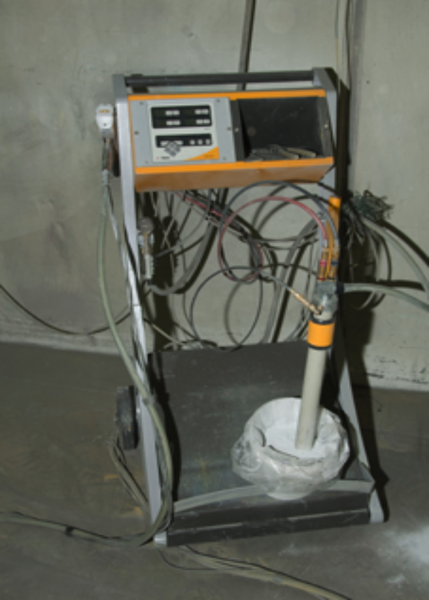
Electrostatic powder-coating is often used on white goods, automobile parts and aluminium extrusions.
The typical transfer efficiency of the system (powder to gun to object) is 75%, although it is possible to achieve nearly 100% use of the coating with some systems, through recycling of powder overspray.
As electrostatic powder spray systems operate at high voltages (from 30 to 150 kV) safety of operators is a high priority. For instance, all items, including the operator, must be grounded. Ungrounded items should be removed. Operators should never wear rubber or cork-soled shoes.

Photographs by Paul Ricketts, with thanks to Camboon Powder Coaters, Malaga.

Questions
- What is meant by the term ‘grounded’?

- Why does an item being powder-coated need to be grounded?

- Would it matter if some powder particles being sprayed were positively-charged and some were negatively-charged? Explain your answer.

- Why isn’t electrostatic powder-coating used when spraying items made of plastic?

- The passage mentions metal furniture and steel pergola frames as examples where electrostatic powder-coating is particularly effective. Why are these two items regarded as being suitable to be powder-coated?

- Use text and images in this worksheet to draw a diagram, in the space provided on the next page, that illustrates how electrostatic powder-coating may operate. Be sure to show the item to be sprayed, grounding device, powder gun and particles of powder. Label the diagram.
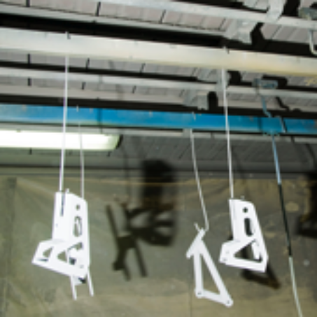
powder gun items ready to be coated
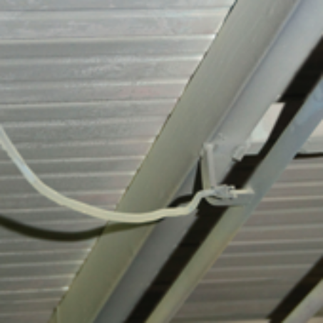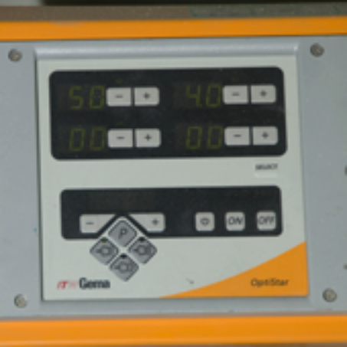
earth connection to the shed voltage control panel

Part 2: Types of lightning
Lightning is an atmospheric discharge of electricity. It usually occurs during thunderstorms and sometimes during volcanic eruptions and dust storms. The principal cause of lightning is separation of electrical charges within thunderclouds, but scientists still debate exactly how lightning forms. Theories have variously suggested wind, humidity, friction, atmospheric pressure and accumulation of charged solar particles have a role.
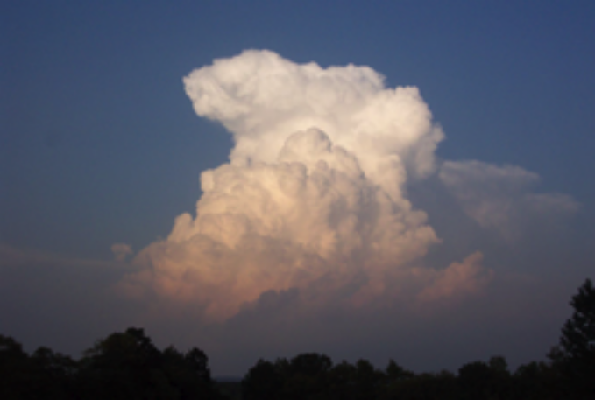
Updraft in a thunderstorm creates an anvil or thunderhead cloud.
photo: George Lioio, used under licence from stock.xchng

One common theory is based on the way warm, moist air moves rapidly upwards and cools to between -10 and -20 °C as a thunderstorm develops. Collisions in this updraft result in electrostatic charging of ice and water particles.
Light, positively-charged ice crystals rise, while a heavier, negatively-charged water-ice mixture falls to the cloud base. Charges build up until charge difference is so great that discharge occurs through lightning.

Intracloud and cloud-to-cloud

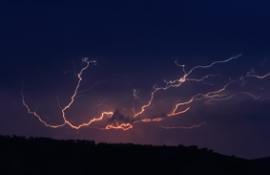
cloud to cloud lightning strike, March 2007, Swifts Creek
photo: Fir0002/Flagstaffotos, GFDL, en.wikipedia.org/wiki/File:Cloud_to_cloud_lightning_strike.jpg
Lightning discharges may occur between areas of cloud that have different charges, without contacting the ground. These occur frequently in ice-laden ‘anvil’ clouds that form in the upper parts of thunderstorms. An anvil shape is formed when rising air in thunderstorms expands and spreads out as it bumps up against the bottom of the stratosphere. Positive charge accumulates in upper parts of the anvil leaving the lower part of the cloud negative. When the charge difference between adjacent clouds reaches a certain level, a lightning discharge occurs. This type of lightning can be observed from great distances at night. It is sometimes called ‘heat lightning’ or ‘sheet lightning’ and the observer may see only a flash of light without thunder.

Cloud to ground
As thunderclouds move over the land surface, an equal but opposite charge is induced in the ground below. The induced ground charge follows the cloud movement.
As charge difference between cloud and ground increases, a discharge path starts to form from a negatively-charged region in a thundercloud. This ionised channel in the air is called a leader. It may take various forms, but a negatively-charged ‘stepped leader’ proceeds generally downward in a number of quick jumps, each up to 50 m long.
Along the way, a stepped leader may branch into many paths. It takes a leader a comparatively long time (hundreds of milliseconds) to approach the ground. This initial phase involves a relatively small electric current (tens or hundreds of amperes), and the leader is almost invisible compared to the subsequent lightning channel.
When the leader approaches the ground, opposite charges on the ground enhance the electric field. This effect is greatest on trees and tall buildings. If the electric field is strong enough, a discharge can develop from these points. This ionised channel of air is called a positive streamer. If negative leader and positive streamer connect, a hotter, high-current return stroke may form. This produces a bright flash and thunder that we associate with lightning.

Bolt from the blue
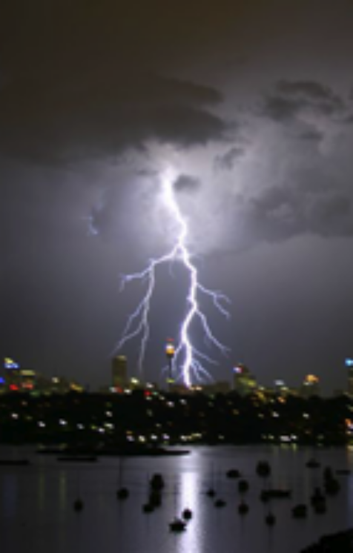
Storm over Sydney
photo: Peter Aloisio,
used under licence from stock.xchng
‘It hit me like a bolt-from-the-blue!’ This saying originates from a type of lightning that appears when skies are clear or just slightly cloudy. Such lightning can strike a long distance from an actual thunderstorm.
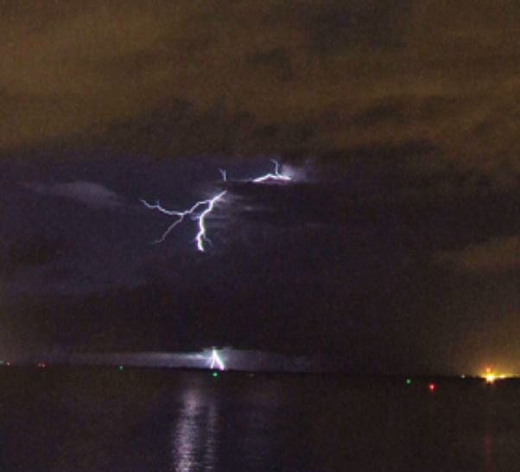
Lightning strikes southwest of Darwin, NT
photo: Bidgee, CC-BY-3.0,
en.wikipedia.org/wiki/File:Anvil-to-ground_lightning.jpg

In the case of bolt-from-the-blue lightning, positive charges that rise to the top of a thunderstorm begin to spread out in the anvil. Eventually, charge difference between the positively-charged thunderstorm anvil and negatively-charged surface of the Earth becomes overwhelmingly large. A bolt of lightning develops from the top of the thunderstorm, sideways from the cloud, then down to the ground to minimise this charge difference.
Such a lightning bolt is very dangerous because it must travel such a long distance, sometimes well away from the cloud formation. These bolts carry an extremely large electrical current of up to
300 000 amperes.
This type of lightning, which is also called positive lightning, probably makes up less than 5% of all lightning strikes.

Questions
- Use the preceding descriptions of different types of lightning to complete the cartoons that follow. Your drawings should show how areas of positive and negative charge accumulate, where lightning strikes occur, and how charge flows during a strike.

- Show how intracloud or cloud-to-cloud lightning develops in the following cartoon sequence.
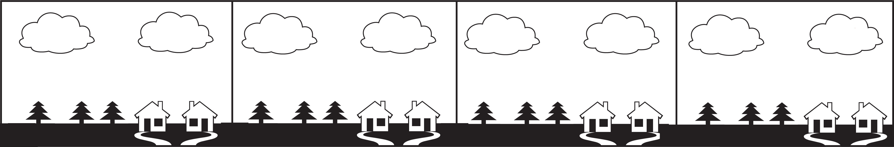

- Show how cloud-to-ground lightning develops in the following cartoon sequence.
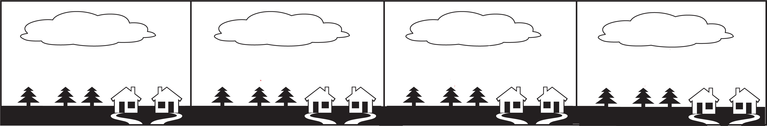

- Show how ‘bolt-from-the-blue’ lightning develops in the following cartoon sequence.


