The learning object, Looking at bushfires, contains information about effects of bushfires on plants and animals in three Western Australian regions: the Kimberley, Western Desert and South West. Use information in the learning object to answer the following questions.

Part 1: Effects of bushfire

Kimberley
- Watch the video on the Fire in the Kimberley page then go to the Kimberley quadrat page. This page simulates effects of low and high intensity bushfires on common Kimberley savannah plants and animals. Which plants provide most fuel for the bushfire?

- Look at the plant distribution four years after the bushfire. Which plant shows most variation in the way it recovers after low intensity fires, compared with high intensity fires?

- Look at the effect of fire on fauna in the Kimberley study site, after 12 years. Does the intensity of a bushfire change the way bandicoots and native mice are affected? Why is this?

- The Kimberley region has frequent large bushfires. This is partly because spear grass grows quickly and provides a massive fuel load, so fires spread fast and are more intense in dry months.
a) Over a 12-year timespan, what is unusual about recovery of spear grass from low intensity fire compared to high intensity fire?

b) Low intensity fires take place during or at the end of the wet season (summer) in the Kimberley, while high intensity fires occur during the dry season (winter). Spear grass grows from seed produced at the end of the wet season. Does this explain the answer for a), above? Give reasons for your answer.

c) How might this affect fire management strategies?

Western Desert
- Watch the video on the Fire in the Western Desert page then go to the Western Desert quadrat page. Which plants provide most fuel for the bushfire?

- One way to describe biodiversity is the variety of species in an ecosystem. Based on the quadrat data, which study site has the greater plant biodiversity: the Kimberley or Western Desert site?

- Fire in the Western Desert affects the central military dragon and central netted dragon differently. Look at the data and predict what kinds of habitats or conditions each might prefer.

- The bush tomato is an important food source for Martu people, traditional owners of the Western Desert region. Describe bush tomatoes’ pattern of regrowth after low intensity and high intensity fire.

- The bush tomato is a small shrub that produces seed after 1 – 3 years, resprouts after fire and has a life span of about 30 years. Why does it grow back so strongly after an intense fire?

- Traditionally Martu people managed their land in the Western Desert with fire. They lit low intensity fires, at regular time intervals.
a) Explain how this benefitted the people.

b) How did it benefit the ecosystem?

c) Why didn’t they light high intensity fires?

South West
- Watch the video on the Fire in the South West page then go to the South West quadrat page. What plants provide most fuel for the bushfire?

- Which plants in the South West study site take longest to recover from a high intensity fire?

- Why might frequent intense fires endanger these plant species?

- Which type of fires benefit quokkas and honey possums?

- Quokkas prefer to eat fresh green shoots that sprout soon after a fire. They also need thick vegetation for protection from predators and weather. Honey possums live on nectar from flowers of mature trees and shrubs. Explain why quokka numbers gradually decrease after a low intensity fire, while honey possum numbers increase steadily and remain relatively high.

Part 2: Patch burning
Part 2 of the learning object simulates effects of regular bushfires, at different time intervals, on plants and animals in the three study sites. You can study patches that are: rarely burnt, occasionally burnt or frequently burnt.
Use the Patch burning and Effects of patch burning pages, for each study site, to answer the following questions.

Kimberley
- Cypress pines are said to be at risk of extinction due to frequent fires in the late dry season in the Kimberley (about every two to three years).
a) Does the patch burning data support this? Explain how.

b) Cypress pines have thin bark and grow from seeds of mature trees, whereas bloodwoods resprout after fire. Use this information to explain why frequent fires endanger cypress pines.

c) How could a patch burning strategy be used to prevent extinction of cypress pines?

d) How might patch burning help to maintain biodiversity (plants and animals) in the Kimberley?

Western Desert
- The following questions look at how fire frequency affects plants in the Western Desert.
a) What differences are there between frequently and rarely burnt patches?

b) Which patches show the greatest plant biodiversity? Why is this?

c) How might patch burning be an advantage to people living on the land?

d) Some animals prefer areas where vegetation is frequently burnt; some prefer unburnt areas; others have no preference. How might patch burning be an advantage to animals?

South West
- The following questions look at how fire frequency affects flora in the South West.
a) Give examples of plants that benefit from frequent burning.

b) Give examples of plants that benefit from rarely being burnt.

c) Are there any plants that tolerate a variety of burning conditions? Explain.

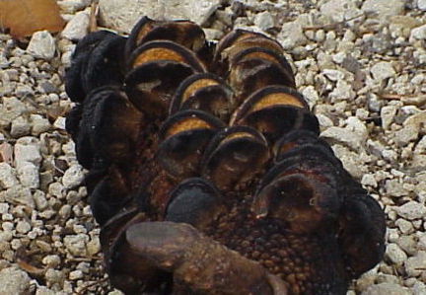
- Oak-leaved banksia (Banksia quercifolia) does not resprout after fire. It only grows from seeds. These are contained in tough capsules, only opened by fire. After a fire passes through an area, capsules open and release seeds onto ground that has just been fertilised by ash, increasing their chances of survival.

Banksia serrata with partially opened capsules
Kurt Stueber (GFDL/GNU)
a) Using the patch burning data to describe how frequent fires affect oak-leaved banksia.

b) Oak-leaved banksia trees start producing seed when they are about six years old. They have a life span of about 30 years. What type of fire management practice do you think would best ensure survival of oak-leaved banksia?

Thinking about patch burning
If patch burning is to be used as a land management strategy, careful planning is needed to decide on which patches to burn and when to burn them. Consider the two scenarios below:
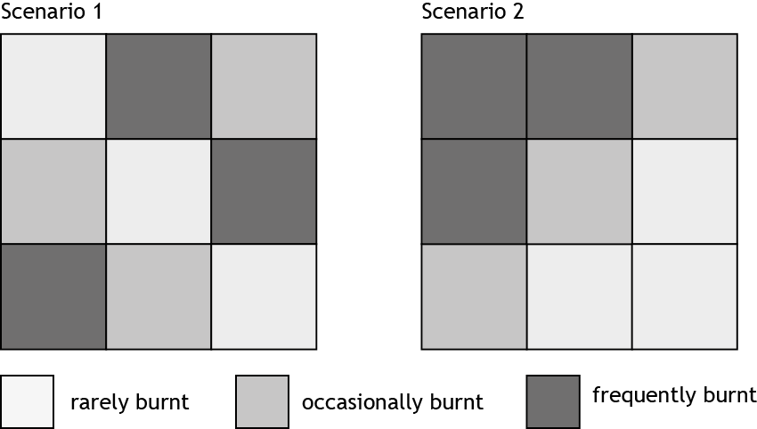
In scenario 1, frequently burnt and infrequently burnt patches are spread around, but in scenario 2 they’re clustered together.
- Which scenario would be preferable if a sudden lightning strike caused a wildfire? Explain.

- Is patch burning the best fire strategy for all three areas studied? Explain.

- Explain why intervals between frequent burning are different for the South West compared with the Kimberley or Western Desert regions.

Summary
‘Bushfires reduce biodiversity’
‘Bushfires maintain biodiversity’
- Describe situations where these statements might be true.

- Experts who manage bushfire-prone landscapes develop fire management plans. Many factors need to be considered and guiding principles have been established in Western Australia to develop plans. Explain why the factors below (based on fire management in the WA rangelands) are important in developing a regional fire management plan.
climate (annual weather patterns)
presence of natural resources (eg bush foods, tourism sites)
presence of communities, farms
animals and plants in the area
Aboriginal knowledge, past practices
scientific research into plant and animal populations
size and intensity of fires
frequency of fires
patch burning: size and connections between patches
stakeholders (Government, fire and emergency services, land care groups, lobby groups)
presence of endangered or significant species
long term climate predictions (climate change)
budget (cost and availability of staff and equipment)

