Worksheet answers
- Graph data from Table 1, either on graph paper below or use a spreadsheet. Plot ‘year’ on the x-axis and ‘sea surface temperature’ on the y-axis. Plan to extend the x-axis to the year 2100 and the y-axis to 35 °C in a later activity.
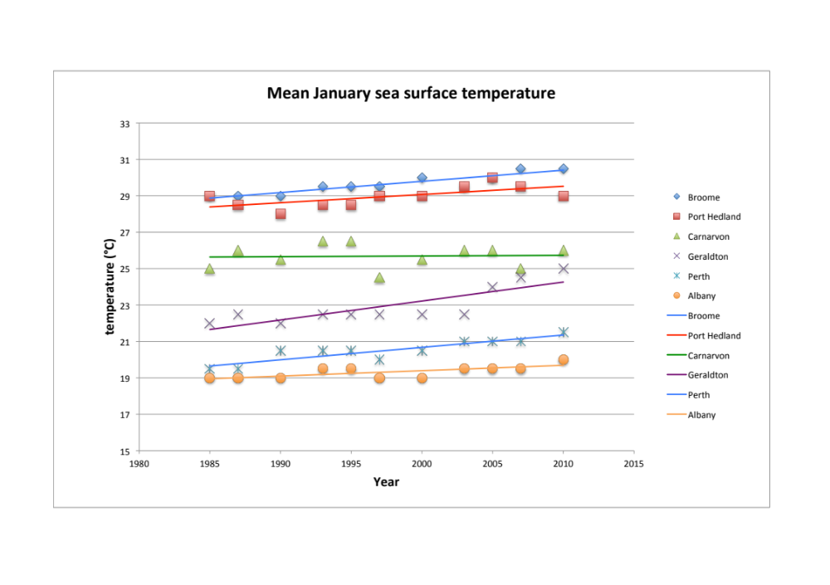
Figure 2: mean January sea surface temperatures for Western Australian towns
- Do you think there is any relationship between sea surface temperature and global mean surface temperatures? Explain your answer.
Answers will vary.
- Extract data from Figure 3 to complete Table 2 below. Note there is an upper and lower limit to each scenario.
 | 2020 | 2040 | 2060 | 2080 | 2100
Scenario 1  upper limit | 1.1 | 1.9 | 3.3 | 4.6 | 6.0
Scenario 1  lower limit | 1.1 | 1.5 | 2.6 | 3.5 | 4.4
Scenario 2  upper limit | 1.0 | 1.8 | 2.0 | 1.9 | 1.8
Scenario 2  lower limit | 0.9 | 1.5 | 1.4 | 1.3 | 1.1
Table 2. Projected mean global surface warming (°C)
- Use data in Table 2, and the January sea surface temperature graph you produced for Figure 3, to predict how sea surface temperature might change up to 2100. You will need to plot points based on estimated sea surface temperature increases for each town. Discuss with other members of your group which scenario to use, whether to use the upper or lower limit, and the shape of the trend line between 2010 and 2100.
- Draw trend lines for each of the six coastal towns through to 2100.
Depending on the scenario students choose to extrapolate to the year 2100, graphs will resemble the graph below. In each case, a trend of increasing sea surface temperature for towns is predicted.
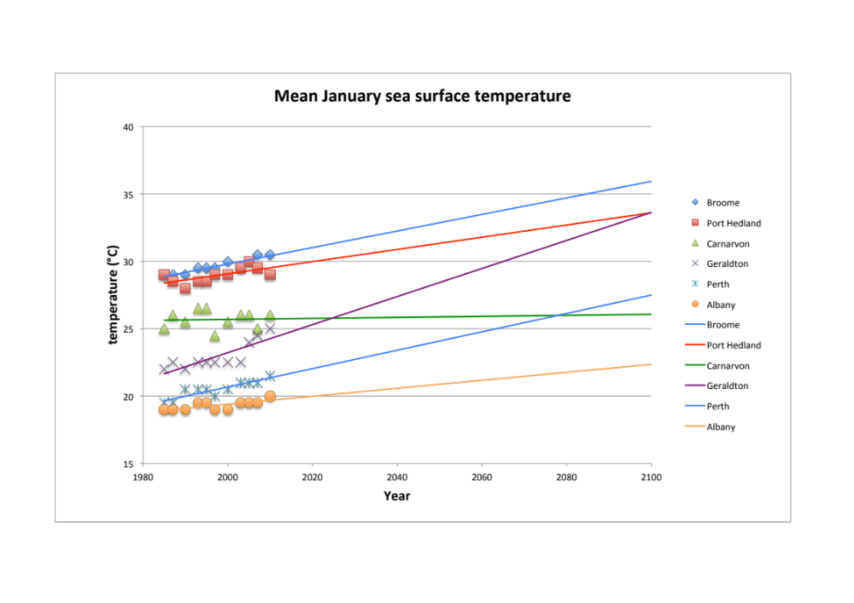
- As sea surface temperature is an important factor in the formation of tropical cyclones you may now use your own graph to make predictions about future tropical cyclone activity for each of the six towns.
- How would you expect tropical cyclone activity to affect Western Australian towns over the next 90 years? Explain your answer.
The most likely response is that more towns further south will experience formation of cyclones and hence the frequency will generally increase.
Additional information: There may be a variety of answers to this question, depending on which scenarios students choose to extend their graphs. A class discussion would be useful so that students can justify why they chose particular data points. If sea surface temperatures (SST) greater than 26.5 °C are more widely spread there is a greater chance that the area in which tropical cyclones form will increase. However, there are other factors that influence cyclone formation. These include degree of atmospheric instability and humidity level.
- Use your forecast to predict in what year cyclones might form regularly off the coast of Geraldton.
This could happen by 2055, if SST forecasts are correct.
- Projected sea surface temperature data on your graph are based on observations recorded between 1985 and 2010. What do you think about using this range of data to make predictions through to 2100? What changes (if any) in data range would you suggest?
A larger data range, both in terms of time and geographical distribution, would be preferable to make better predictions.
- How did projected global warming data affect your predictions for sea surface temperature and predicted cyclone activity for WA coastal towns?
If global temperatures rise then it follows that SST will also rise, so it is likely that more cyclones will form further south along the West Australian coast.
- Scientists believe a sea surface temperature of at least 26 °C is necessary to support formation of tropical cyclones. What other factors influence formation of tropical cyclones?
Other factors that influence tropical cyclones include: presence of low-pressure areas; and increased effect of the Earth’s rotation that causes winds to spiral.
- What factor(s) might contribute to differences between your answers to questions 5 and 6 and those of other students?
Data may be manipulated differently due to use of different assumptions about the degree of global warming, and different groups may graph this differently. This would lead to alternative views about cyclone activity for WA coastal towns.
- The exercise you have undertaken in graphing and extrapolating data is a form of modelling. What is the major limitation of your model in predicting future tropical cyclone activity?
Data used for this model has only come from one source. The more limited the data, the less precise any predictions based upon it.
- In reality, meteorologists use a number of models to predict severe weather events such as tropical cyclones. What is an advantage of using multiple models to predict events?
Meteorologists use a wide range of data, gathered by different methods and manipulated in different ways, thereby representing several different approaches to weather modelling. By comparing output from multiple models meteorologists can make better predictions about future weather patterns.
- ‘Hindcasting’ is a tool used by climate modellers. Research hindcasting and describe how it assists in predicting future events?
Hindcasting applies the current predictive model to previous events and examines how well the model output matches the historical data. For example, a model predicting cyclone activity into the future could be used to ‘predict’ cyclone activity over the past 25 years and examined to see how well it matches what actually happened.

