

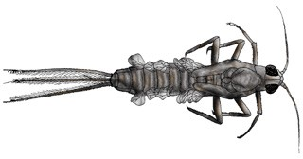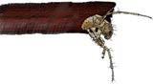

mayfly nymph 9

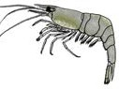
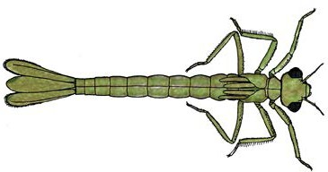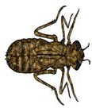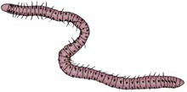
ast1416 | Identification key (fact sheet)
© The University of Western Australia 2015 version 1.0
page 1
3
3
3
Invertebrate size ( )
average actual size unless stated otherwise

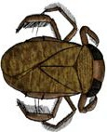water boatman
2
developed for the Department of Education WA for conditions of use see spice.wa.edu.au/usage
Licensed for NEALS

(black back)
predacious diving beetle
(back legs move at
2
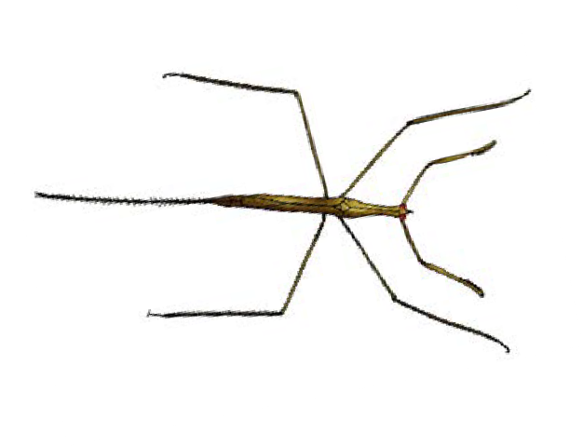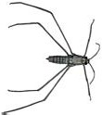same time)
1/3 actual size
1
needle bug
(quite large)
3

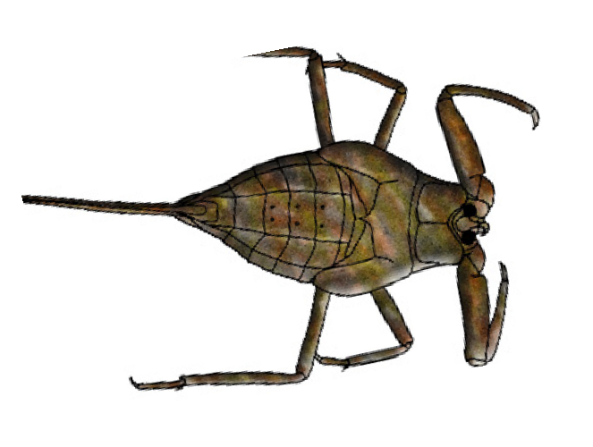water scorpion

1/3 actual size
1

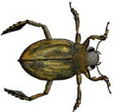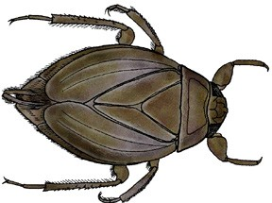giant water bug
1/2 actual size

segmented worm
not rated very sensitive sensitive tolerant
very tolerant
5 4
3 1
Pollution sensitivity
NR

10 8
7 6
1
2

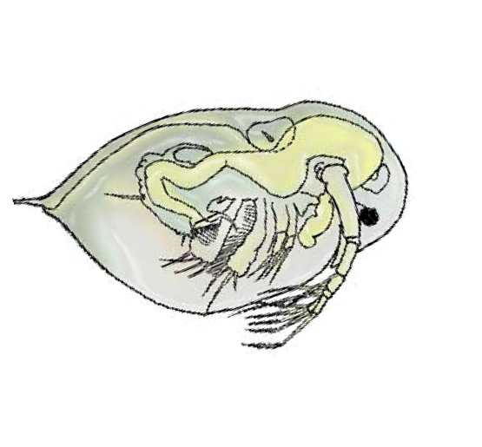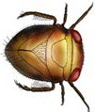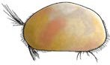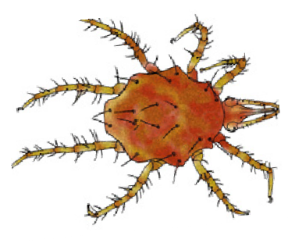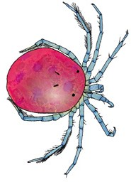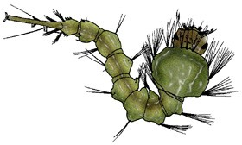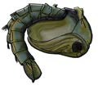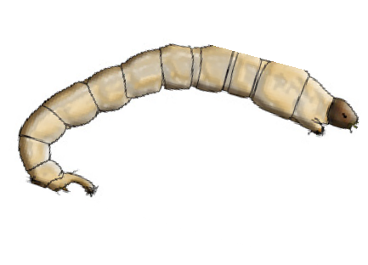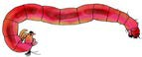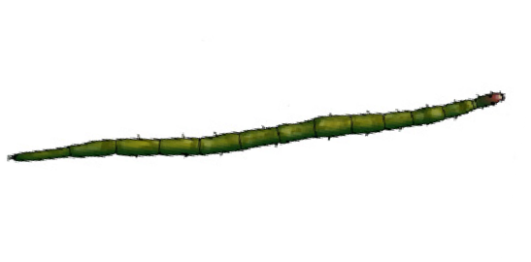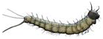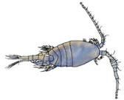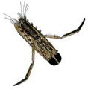 back swimmer
Which critter did you catch?
Circle what you found.

pygmy back
copepod _{NR}
(jerky movement)
swimmer
2
(poor swimmer)
caddisfly larva
(in tube or case)
8
mosquito 1
larva
mosquito pupa
1
water mites 7
water flea _{NR}
(jerky movement)
seed shrimp _{NR}
1/2 actual size
freshwater shrimp
dragonfly nymph
damselfly nymph
non-biting midge larva
3
biting midge 4
larva
(swims on back)

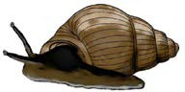
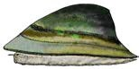water strider 4
3

gilled snail
freshwater limpet 4
(single shell)
pea shell 5
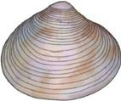(double shell)
Adapted with permission from NRM Education, Natural Resources – Adelaide and Mt Lofty Ranges. All images on this ID Key are adapted by Steve Walker (2006) from the B&W images in ‘Critter Catalogue: a guide to the aquatic invertebrates of South Australian inland waters (2004 EPA)’ except for the Crawling Water Beetle (Steve Walker 2006).’

