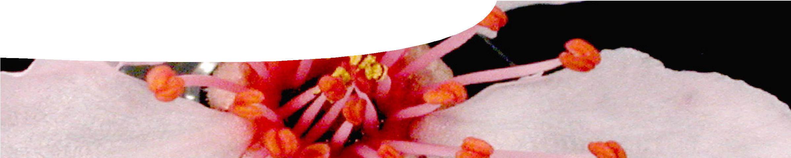
background sheet
What is pollen?

All about pollen
Pollen is essential for sexual reproduction of flowering plants and plants that produce cones. Each pollen grain contains male gametes necessary for fertilisation. The scientific study of living and fossilised pollen grains is known as palynology.

The formation of pollen
The male part of flowering plants is the stamen. This consists of an anther supported by a single stalk, the filament. The anther usually contains four pollen sacs which are responsible for producing pollen grains.
Each pollen grain is a single cell containing two male gametes. Once mature, the anther splits open and pollen is released. Both male gametes are involved in fertilisation, resulting in formation of a zygote and an endosperm. This process of double fertilisation is unique to flowering plants.

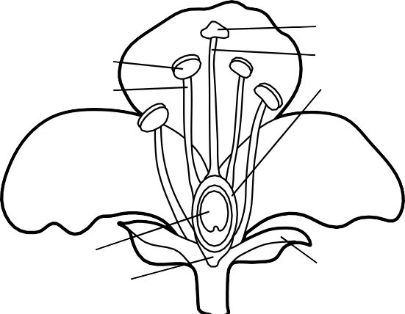
}
Pollination vectors include wind, living organisms and water. Flower structures and pollen grains are generally adapted to the type of pollinating vector active in pollination.

Wind pollination is common amongst grasses. Grass pollen is light, dry and released in large quantities. Pollen grains are often structurally modified to assist in airborne transportation. Pollination by living vectors is often more complex, involving a long association between plant and vector in which co-adaptations have evolved. Insects are the most common pollinators of plants, but living pollinators also include mammals, birds and, in some instances, reptiles.

Pollen and allergies
Pollen produced by plants is often associated with hayfever or ‘seasonal allergic rhinitis’. One in five Australians suffer from hayfever. An allergen is a substance that causes an allergic reaction.
In affected individuals the immune system will

stamen

anther filament

petal

ovule receptacle
stigma
style carpel ovary
{

sepal

recognise an allergen as potentially harmful and initiate a defensive response by releasing a number of chemicals, including histamines. Histamines cause common hayfever symptoms such as itchy and irritated eyes, sinus congestion, a runny nose and
general or localised itching. In Australia, pollen types responsible for hayfever tend to be of northern hemisphere origin. They include grasses, weeds and deciduous trees. Generally Australian native grasses and trees are considered to produce pollen that is far less allergenic than exotic northern hemisphere

Pollination
The transport of pollen from stamen to stigma is referred to as pollination. Self-pollination occurs when pollen grains are transferred from anther to stigma on the same flower, or an adjacent flower on the same plant. Cross-pollination occurs when pollen grains are deposited on stigma of a different plant of the same species.

Flowering plants and gymnosperms rely on external agents or vectors for dispersal of pollen.
species.

The unique pollen grain
A pollen grain comprises a tough outer wall which is largely made of an unusual substance known
as sporopollenin. The remarkable feature of sporopollenin is its chemical stability. The pollen grain wall is highly resistant to environmental damage and may even survive in sedimentary rocks for many millions of years. The outer wall of the pollen grain is often elaborately decorated and may be punctuated with small openings called apertures.

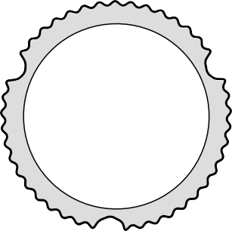A pollen grain may also have an interior wall, the intine, made predominantly of cellulose, and constructively similar to other plant cells.

pore
thickening
The following characteristics are useful in the identification of pollen types:

- size
- shape
- number of apertures
- surface texture

nucleoli
of cellulose

For example, the pollen grains illustrated below

intine exine

Classifying pollen
Pollen classification is based on structural features. Pollen grains display remarkable variation in size, shape, number of apertures and surface texture.
These distinctive characteristics make it possible to identify and classify a plant at family and genus level, and often even species level.

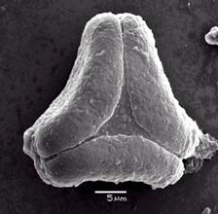
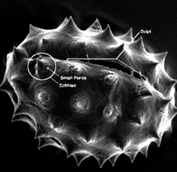
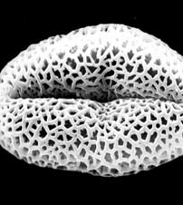
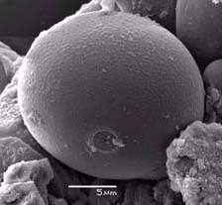
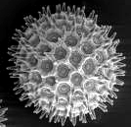
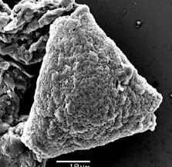

both belong to the genus Adenanthos, but represent two different species: Adenanthos obovatus and Adenanthos meisneri. The two pollen grains are distinguishable on the basis of structural differences such as shape, size, number of pores and surface structure.

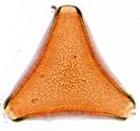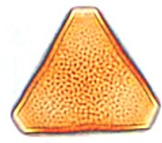

Size
Pollen grains are measured in micrometers (also called microns) and denoted by the symbol µm. There are 1000 µm in 1 mm.

Pollen grains show considerable variation in size, from the tiny forget-me-not with a diameter of 6 µm to the impressive 100 µm of the birch tree. Most pollen grains are 10–70 µm in diameter. A mere pinch of pollen may contain thousands of individual grains. Pollen size is often directly related to the pollination agent. The smallest pollen grains tend to be wind dispersed, while those carried by living organisms or in water are often larger.

Shape
Most pollen grains are spherical, ovoid, triangular or disc-shaped. There are numerous variations on these basic geometric themes, such as elongated and flattened. The following guide aids in the identification of common pollen grain shapes:

ovoid spheroidal triangular

Apertures
Apertures occur in the pollen grain wall and it is from these that male gametes escape during
pollination. There are two observable types: pores, which are circular in appearance, and colpi, which take the form of elongated furrows. A pollen grain may have numerous apertures, and sometimes pores and colpi occur together.

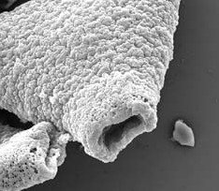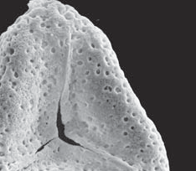
pore
colpi

Surface texture
The surface appearance of pollen types is incredibly diverse. The outer wall (exine) is often flamboyantly sculpted and varies considerably between species. It is thought to play an important role in species-specific recognition systems between pollen grain and stigma that facilitate germination.

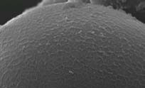
The following guide aids in the identification of different surface textures:

psilate
smooth

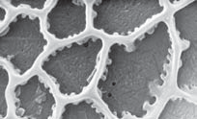
reticulate
net-like

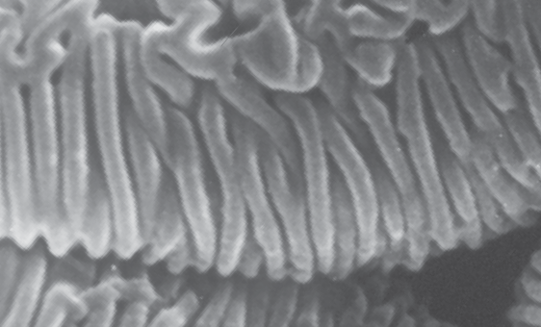
striate
roughly parallel patterns

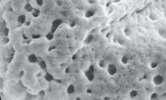
rugulate
irregular patterns

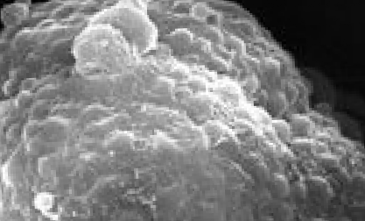
verrucate
surface bumps

Using a dichotomous key to identify pollen
A dichotomous key is a method of identification. It is used in biology to help identify organisms. Dichotomous means ‘divided into two parts’.

A dichotomous key presents information in couplets, which are two statements about a particular organism. By selecting the best option for a particular organism, the key directs users to another statement. Working through a dichotomous key, statements become more and more specific until the organism is identified/named. For example:
1. pollen grain triangular go to 2
- pollen grain ovoid go to 3
- pollen grain diameter >33 µm Adenanthos obovatus
- pollen grain diameter ≤33 µm go to 4
- etc

A dichotomous key can also be represented visually. For example:
pollen grain triangular
pollen grain triangular
pollen grain ovoid
pollen diameter
> 33 µm
pollen diameter
! 33 "m
Adenanthos obovatus

References
Charles, M. and Craigie, R. (2008). Methods and Theory in Quaternary Palynology. Retrieved June 25, 2008 from http://www.shef.ac.uk/archaeology/ env-arch-economy/palynology
Hoen, P. (1999). Glossary of Pollen and Spore Terminology. Retrieved June 25, 2008 from http://www.bio.uu.nl/~palaeo/glossary/glos-int.htm
Edlund, A., Swanson. R., and Preuss, D. (2004). Pollen and Stigma Structure and Function: The Role of Diversity in Pollination. Plant Cell 16: S84-S97; Retrieved June 27, 2008 from http://www.plantcell.org/cgi/content/full/16/ suppl_1/S84
Derksen, J. and Pierson, J. (2008). Pollen. Retrieved June 27, 2008 from http:// www.vcbio.science.ru.nl/en/virtuallessons/pollenintro/
Australasian Society of Clinical Immunology and Allergy (2001). Pollen allergy.
Retrieved June 30, 2008 from http://www.allergy.org.au/content/view/132/1/

