background sheet
What is nuclear radiation?

Nuclear radiation (also called ionising radiation) is energy released as high-speed charged particles or electromagnetic waves. Radiation can come from many sources, both natural and manufactured. All living things are constantly exposed to low doses of radiation from rocks, sunlight and cosmic rays.

Types of nuclear radiation
This background sheet considers three types of radiation; α-particles, β-particles, and γ-rays. Their properties are summarised in Table 1.

PROPERTY | α-PARTICLE | β-PARTICLE | γ-RAY
nature | helium nucleus | fast electron | electromagnetic radiation
charge | positive | negative | neutral
rest mass | 6.4 x 10-27 kg | 9.1 x 10-31 kg | no mass
velocity (c = velocity of light) | ~ 0.06 c | up to 0.98 c | 1 c
energy | ~ 6 MeV | ~ 1 MeV | ~ 0.1 MeV
penetration | ~ 5 cm air | ~ 500 cm air  ~ 0.1 cm aluminium | ~ 4 cm lead reduces intensity by 90%
path through matter | straight | tortuous | straight
Table 1: properties of radiation

α-particles are the most energetic form of radioactive decay and have the greatest mass of the three types. They are helium nuclei containing two protons and two neutrons.
Because of their large mass they travel relatively slowly (about 6% of the speed of light) but their high energy produces considerable ionisation. This means that they lose their energy over a short distance and do not penetrate far into matter; a piece of paper will block the radiation. An α-particle loses some of its energy each time it ionises another molecule.
β-particles are very fast electrons, moving at up to 98% of the speed of light. They have a low mass, so, in spite of their high velocities, they have less energy than α-particles.
β-particles are emitted by nuclei that have too many neutrons to be stable. These nuclei attain a more stable state (i e lower energy state) when a neutron changes into a proton and electron. The electron is immediately emitted from the nucleus as a β-particle. The proton remains in the nucleus leading to an overall increase in the number of protons in the nucleus and formation of a different element.
γ-rays are electromagnetic radiation of very high frequency. Other parts of the electromagnetic spectrum include X-rays, ultraviolet, visible, infrared, microwave and radio waves.
γ-rays have a wavelength between 4 x 10-10 and 5 x 10-13 m.
The intensity (I)of emitted electromagnetic radiation decreases with distance (d) from the source in an inverse square relation:
1
I ∝
d 2

Measuring radiation
The curie (Ci) was an early unit used to measure amounts of radioactivity. This originally defined as the radiation emitted by one gram of radium-226. It is now defined as:
1 curie = 3.7 x 1010 radioactive decays per second.
In the International System of Units (SI) the curie has been replaced by the becquerel (Bq).
1 becquerel = 1 radioactive decay per second

= 2.703 x 10-11 Ci

More on beta decay
Beta decay is explained through the weak nuclear interaction. This is one of four fundamental interactions (or forces) recognised by physicists, together with gravitational, electromagnetic and strong nuclear interactions.
The Feynman diagram in Figure 1 shows a neutron decaying through the process of β– decay.

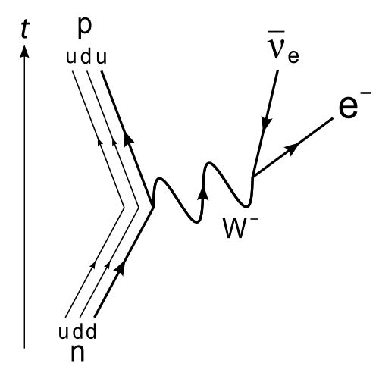
Figure 1: β– decay of a neutron to a proton For a neutron to become a proton one of its
down quarks turns into an up quark, by emitting a W– boson. This particle, which only exists for a tiny fraction of a second, carries the weak nuclear force (analogous to the way photons carry the
electromagnetic force). The W– boson in turn decays into an electron and electron antineutrino, which are ejected from the nucleus.
Table 2 demonstrates how this interaction preserves charge, baryon and lepton number. A related process, β+ decay, involves decay of a proton into neutron with emission of a positron and electron neutrino.

 | before | during | after
particles | n | p, W– | p, e–, νe
charge | 0 | +1, -1 | +1, -1, 0
baryon number | 1 | 1, 0 | 1, 0, 0
lepton number | 0 | 0, 0 | 0, 1, -1
Table 2: Preservation of charge, baryon and lepton number during β– decay.
e
+
11
23
Mg → Na + e + ν
e
−
7
14
C → N + e + ν
14
6
23
12
Examples of β– (14C) decay and β+ (23Mg) decay

Personal exposure to radiation
Amount and duration of exposure are taken into account when looking at personal exposure to radiation. Exposure to small amounts of low-energy radioactivity over a long time can be less harmful than a short, high-energy burst.
The amount of ionising radiation or ‘absorbed dose’ received by a person is measured by the energy (E) absorbed in body tissue (of mass M) in units of joules per kilogram (J kg-1). It is usually expressed in the special SI unit of grays (Gy) where 1 Gy = 1 J kg-1.
Absorbed dose = E / M
However, different types of radiation have different biological effects, even when absorbed dose is
the same. Radiation that gets into the body causes ionisation events. The number of ionisation events caused by a given absorbed dose depends on the radiation type. Beta and gamma radiation cause fewer events than heavy alpha particles.
When assessing biological effects this needs to be taken into account. A form of weighting or ‘quality factor’ is used that provides a measurement of biological effects. The special SI unit of sievert (Sv) is used for absorbed doses that have been adjusted in this way. This is also called the ‘dose equivalent’.
1 Sv = absorbed dose (Gy) x quality factor

RADIATION TYPE | QUALITY FACTOR
X and γ-rays | ~ 1
β-particles | ~ 1
α-particles | up to 20
Table 3: quality factors for different types of radiation
Radioactivity with higher ionisation energy (such as alpha particles) has high quality factor (up to 20). Beta and gamma radiation, which are not strongly ionising, have a quality factor of 1. Regardless of the type of radiation, one sievert of radiation causes the same biological effect.

RADIOACTIVITY LEVELS OF SOME COMMON SUBSTANCES
an adult human (70 kg) | 7000 Bq
coffee (1 kg) | 1000 Bq
granite (1 kg) | 1000 Bq
superphosphate fertiliser (1 kg) | 5000 Bq
the air in a 100 m2 Australian home (radon) | 3000 Bq
a household smoke detector (americium) | 30 000 Bq
uranium (1 kg) | 25 000 000 Bq
Table 4: radioactivity levels of some common substances

