START HERE
- Does it have legs?
YES go to 3
NO go to 2
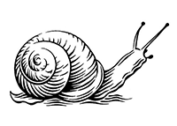
- Does it have a shell?
YES It is a SNAIL
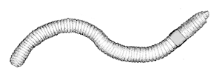
NO It is an EARTHWORM

- How many legs does it have?
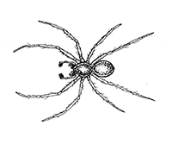
6 LEGS go to 4
8 LEGS It is a SPIDER
LOTS OF LEGS go to 9

- Does it have wings?
YES go to 5
NO go to 7

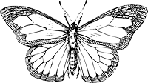
- Are the wings coloured or white?
YES It is a BUTTERFLY or MOTH
NO go to 6

- How many wings does it have?
2 WINGS go to 8
4 WINGS go to 12

- Is its body divided into parts?
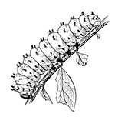
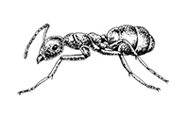
YES It is an ANT or TERMITE
NO It is a CATERPILLAR

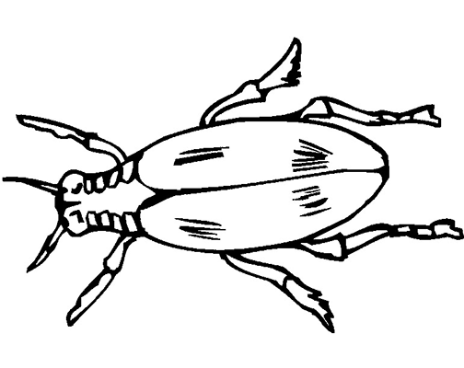
- Does it have hard covers over its wings?
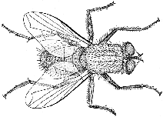
YES It is a BEETLE
NO It is a WASP, BEE or FLY

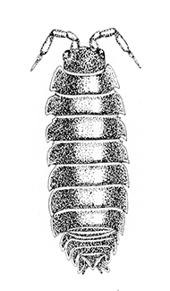
- Does it have lots of legs and curl up into a ball?
YES It’s a SLATER (also called a WOODLOUSE)
NO go to 10

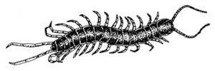
- Does it have nearly 100 legs?
YES It is a CENTIPEDE
NO go to 11

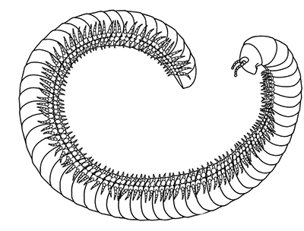
- Does it have lots and lots of legs?
YES It is a MILLIPEDE
NO I’m not sure what you have found.
Maybe your teacher knows.
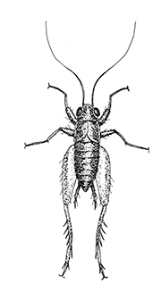
- Are the wings folded back?
YES It is a GRASSHOPPER
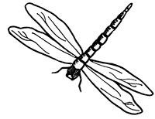
NO It is a DRAGONFLY

