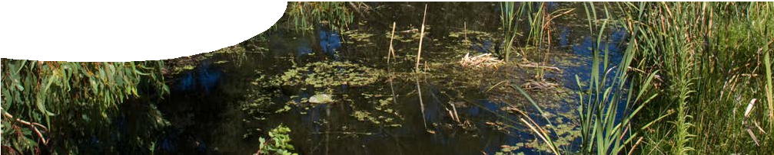
fact sheet
Wetlands

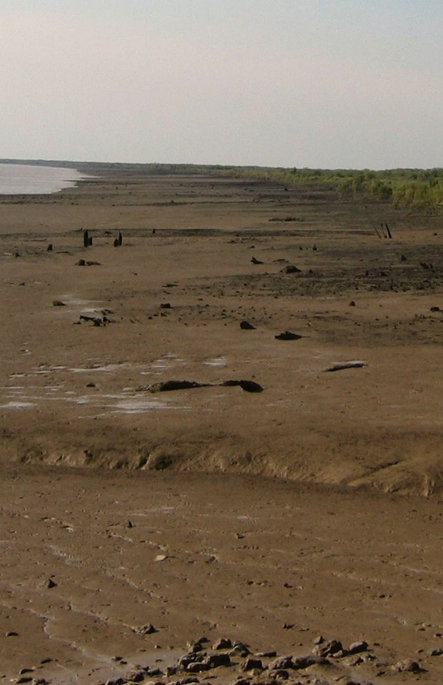Wetland habitats are low lying and permanently or periodically inundated with water. Wetland habitats are diverse, and include marine and brackish areas.
Australia has many different types of wetland environment. Inland wetlands include marshes, peat- lands, floodplains, rivers and lakes. Coastal wetlands include salt marshes, mangroves and seagrass.
Wetlands have a significance that extends across national borders. An international treaty that provides
a framework for cooperation in conservation and wise use of wetlands was signed in 1971 in Ramsar, Iran. In 2008, the Ramsar list of wetlands of international importance included over 1800 wetland sites.
Australian wetlands are found mostly near the coast. Australia is so dry that many wetlands are dry for part of the year or even several years.

Natural flood management
Wetlands generally occur in physical depressions in the landscape. They act as reservoirs for water as well as environmental sponges. They soak up excess groundwater from rainfall, stormwater or tidal surges, purify water, trap sediments and nutrients,
and slowly release them back into the environment.
Wetlands also act as flood control by holding back excess water so that other areas do not get flooded, thereby reducing the impact on plants and animals.
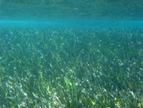
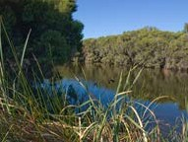
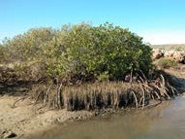
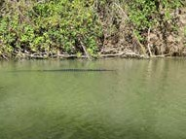
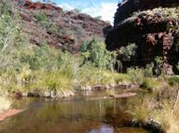
Wetlands are found all over the world, from the cold tundra of the north and south to the hot steamy jungles of the equator.

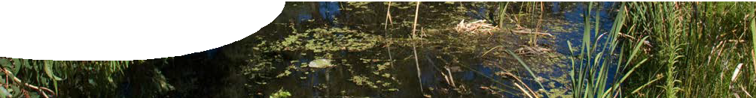
fact sheet
Wetlands

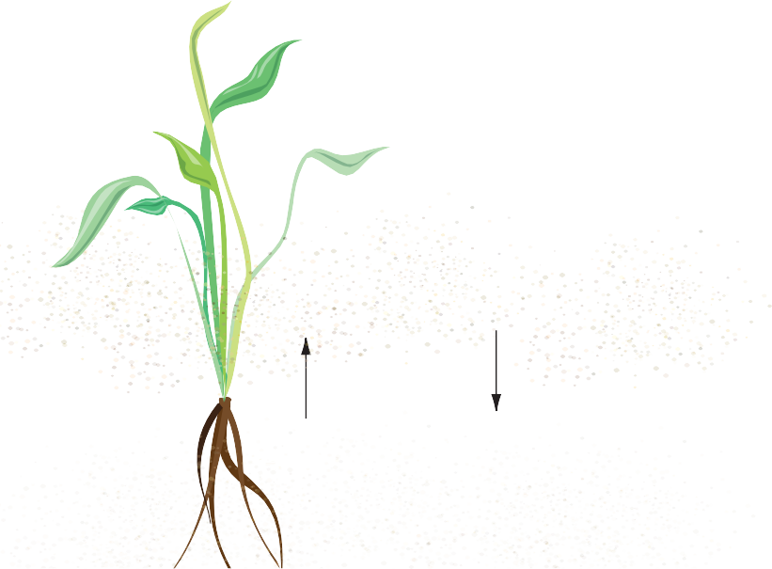Habitats
sunlight

water level

algae
fine particles trapped on plant stems
decomposition of organic material
nutrients stored in sediments
plants take up nutrients
nutrients released from sediments
sediments
Wetlands form complex communities where diverse species interact with each other and the environment.
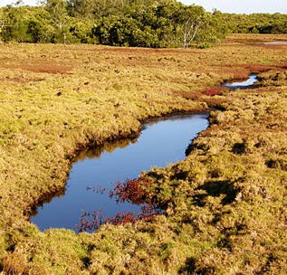
Wetlands are used by animals for a range of activities, for example as nurseries for fish, birds, mammals, crayfish, frogs, turtles, snakes and insects. Plants are lush and dense providing good cover for the young. 20% of Australia’s bird species depend on wetlands for parts of their lifecycle.

Biological filter
Wetlands improve the quality of water that passes through them by acting as filters. As water passes through a wetland, bacteria, pesticides, nitrogen,
phosphorus and fertilisers are removed. Large wetlands with dense vegetation clean water best.
Nutrients enter wetlands as dissolved ions or particulate material from surface or groundwater discharge. Wetlands slow the flow of water so that sediment and particulate matter settle on the bottom. Plants also collect microbes and sediments on their stems. Microbes and plants help to filter and take up toxic substances that are bound to sediments or dissolved in the water. Heavy metals, organic material and even oil can be removed from water in this way.
Areas of deeper water provide the time necessary for finer material to settle, and for sunlight to kill bacteria. A nutrient rich environment combined with sunlight can promote an algal bloom. Whilst a bloom helps trap dissolved nutrients, it also depletes oxygen in the water and results in a release of toxins.
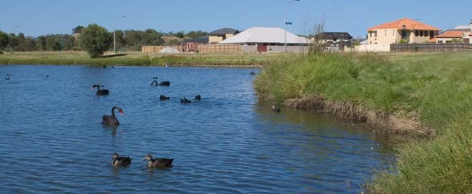

On the Swan coastal plain, Western Australia, it is estimated that between 70 and 80% of wetlands have been cleared, filled or developed and only around 15% retain high ecological values.

References

Historical use of wetlands
Wetland ecosystems are resilient to natural variability, but are extremely vulnerable to human intervention. Since European settlement, human activities have degraded many wetland environments. People have drained, filled and built over wetlands to allow for expansion of town sites.
Sewerage and chemicals, such as pesticides, have found their way into water and sediments in wetlands. This can have a knock-on effect for local animals. Sedimentation and uptake of toxic materials by plants cleans water but concentrates toxins in plants. When these plants are eaten, toxins move
up the food chain, becoming more concentrated. This can lead to loss of breeding potential or even death.

Department of Environment and Conservation (n.d.) Threats to Wetlands. Retrieved 30th August 2007, from http://www.naturebase.net/index2.php?option= com_co ntent&task=view&id= 817&pop=1&page= 0&Itemid= 868
Department of Environment and Heritage. (2001). Australia State of the Environment 2001 - Inland Waters. Victoria: CSIRO Publishing. Pugh D (1987). Understanding Australia Habitats: Wetlands and Heaths Activity Book. Paddington NSW: Rainforest Publishing.
Water and Rivers Commission. (2001). Water Facts 16 – Living Wetlands: An Introduction to Wetlands. Western Australia: State Government of Western Australia. Wildfowl and Wetlands Trust. (1992). Wildfowl and Wetlands. Gloucester: Orchard and Inds
Ramsar Convention Secretariat. (2007). Wise use of wetlands: A Conceptual Framework for the wise use of wetlands (3rd edition). Switzerland: Ramsar Convention Secretariat

