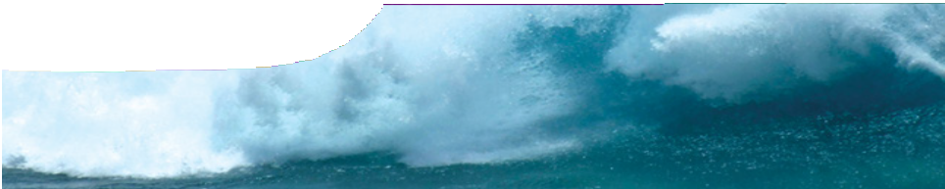
background sheet
Tsunami physics

What is a tsunami?
A tsunami is a series of waves that are caused by a disturbance (such as an undersea earthquake, a
volcanic eruption or a meteor strike). A disturbance that moves the water vertically (a sudden drop or
a sudden rise) can generate a tsunami, like ripples generated when a stone is thrown into a pond.

Tsunamis and water waves
Waves on a lake or ocean surface are usually generated by wind and have short wavelengths and short periods. Waves that a surfer might catch may have a wavelength of 150 m and a period of 10 s.
These are surface waves: the deeper you go, the weaker the effect of waves.
Tsunamis are very different from wind-waves. They are characterised by long wavelengths (e g 100 km) and long periods (e g 5 min).
Tsunamis move at speeds equal to the square root of the product of acceleration due to gravity (9.8 m s‑2)
9.8d

Effects of water depth
In deep water, tsunamis are barely noticeable. Satellite radar has revealed that the maximum wave height of the Boxing Day tsunami two hours after the earthquake was 60 cm(3). However, in shallow water, tsunamis change markedly. The wave slows to only tens of kilometres per hour but interference with the ocean floor increases wave height.
The speed of a tsunami is directly related to water depth, so as depth decreases, speed of the tsunami also decreases. Energy flux of a tsunami is dependent upon its speed and wave height, so in shallow water the height of the wave increases. A tsunami that can pass unnoticed out at sea will grow much higher as it approaches a coast (the ‘run-up’ effect).
The Boxing Day tsunami that struck Aceh reached a height of 24 m along the coastline and rose to 30 m in some places as it swept inland (4).

Coming ashore

and the depth of the water, v =
where d is
The rate at which energy is dissipated from a wave is

the ocean depth. For example, in the Pacific Ocean (which has an average depth of approximately 4000 m), a tsunami travels at about 700 km h-1 (200 m s‑1)(1).

How do earthquakes cause tsunamis?
Tsunamis are often formed when there is a large vertical displacement of Earth’s crust, particularly at boundaries of tectonic plates (fault lines). In the Pacific, denser oceanic plates slip under continental plates to cause a subduction earthquake. A sub- duction earthquake is a particularly effective generator of tsunamis. Vertical movement of
the crust displaces a large volume of water. As gravity acts to restore equilibrium, waves of water (tsunamis) race away from the epicentre.
inversely proportional to its wavelength, so tsunamis travel great distances (e g right around the globe) with limited energy loss(1).
In common with wind-generated waves, energy transfer occurs as tsunamis approach the shore. Some energy is transferred to reflected waves, and there are large conversions to heat and movement due to turbulence and friction between wave and seafloor. Yet tsunamis still reach land with enormous energy. They can erode beaches, undercut coastal vegetation and inundate low-lying land for great distances inland. Buildings can be destroyed and there is always the potential for significant loss of life.

- Bernard, E.N. (n.d.). National Oceanic & Atmospheric Administration (NOAA), U.S. Department of Commerce. Retrieved 14th June 2007, from http://www.tsunami.noaa.gov/tsunami_story.html
- Intergovernmental Oceanographic Commission (n.d.). Tsunami Information. Retrieved 2nd August 2007, from
http://www.ioc-tsunami.org/
- McKee, M. (2005). Radar satellites capture tsunami wave height.
NewScientist.com news service, 6th January 2005. Retrieved 2nd August 2007, from http://www.newscientist.com/article. ns?id= dn6854
- Paulson, T. (2005). New findings super-size our tsunami threat. Seattle Post, February 7th 2005. Retrieved 2nd August 2007, from http://seattlepi.nwsource.com/local/211012_ tsunamiscience07.html

  - and 2) are useful websites for general information on tsunamis.

ast0005 | Mechanical waves 1: Tsunami physics (background sheet) developed for the Department of Education WA
© The University of Western Australia 2008 for conditions of use see spice.wa.edu.au/usage version 1.3 reviewed July 2014 page 1 Licensed for NEALS

