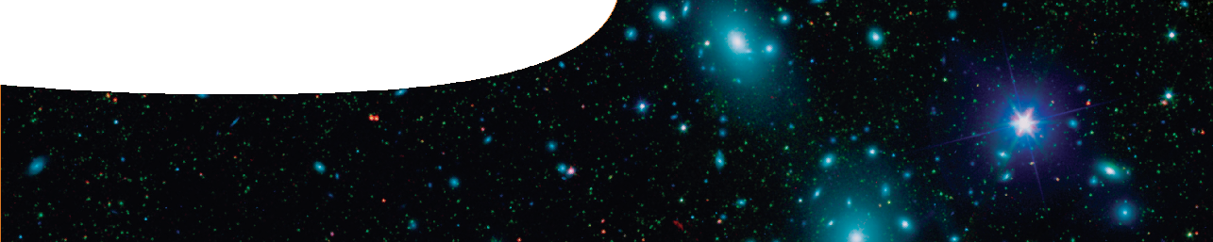
fact sheet
Timeline of the Universe

0 - 10-43 s undefined
KEY EVENTS
ERA
(K)
THE BIG BANG
TIME SINCE TEMPERATURE
Planck

10-43 - 10-35 s 1032
10-35 - 10-12 s 1027
10-12 - 10-6 s 1015

10-6 – 1 s 1013
1 – 10 s 1010
lepton
The Big Bang occurred and the Universe came into existence.
Current theories can’t describe the Universe during the time between the Big Bang and 10-43 s (Planck era) because the Universe was dominated by quantum gravitational effects, and we do not yet have a quantum theory of gravity
As the Universe expanded and cooled, gravity separated from the strong, electromagnetic and weak interactions (Grand Unified theory era).
inflation GUT
The strong interaction separated from the electromagnetic and weak forces causing the Universe to expand by a factor of 1025 in 10-32 s (inflation era). It ended when part of the energy was transformed into matter.
The electromagnetic interaction separated from the weak interaction, giving us the four fundamental interactions we know today.
Gravity began to control the expansion of the Universe.
quark
radiation-dominated era
Quarks, leptons and their anti-particles formed (quark era). Leptons separated into electrons, neutrinos and their anti-particles. The quark era ended when most matter and anti-matter particles annihilated each other, leaving a slight excess of matter to populate the future Universe.
The Universe had cooled sufficiently for quarks and anti-quarks to combine and form protons, neutrons and their anti-particles (hadron era).
hadron
Protons and anti-protons; neutrons and anti-neutrons annihilated each other leaving a slight excess of protons and neutrons.
The Universe had cooled to the point where no new lepton/anti-lepton pairs were created. Most leptons and anti-leptons annihilated each other (lepton era), leaving a slight excess of leptons (equal to the number of protons, making the net charge of the Universe zero)
Neutrinos and anti-neutrinos no longer interacted with protons and neutrons, so the Universe became transparent to neutrinos.

10 s onwards 1010 - 109

After the lepton era, the Universe was dominated by photons, which interacted with protons, electrons and eventually nuclei, and continued to do so for the next 300,000 years (radiation era).

3 – 20 min 109 The Universe cooled to the point where protons and neutrons began
photons
fusing to form helium and deuterium nuclei (nucleosynthesis), using up all spare neutrons. However, the temperature and density of the Universe soon fell to the point where fusion couldn’t continue.

300 000 –
380 000 yr
3 000
Hydrogen and helium nuclei captured electrons into orbits around them to form stable, neutral atoms.
Photons no longer interacted with charged particles, so the Universe became transparent to them. These photons are still evident today in the cosmic microwave background radiation (CMBR).
matter-dominated era

109 yr The first stars were formed 100–200 million years after the Big Bang. The first galaxies were formed 1 billion years after the Big Bang.
Heavy elements were created in supernova explosions.
8.4 x 109 yr The Sun and Solar System were formed.
13.7 x 109 yr 3 Humans appeared on Earth.

ast0703 | Cosmology 1: Timeline of the Universe (fact sheet) developed for the Department of Education WA
© The University of Western Australia 2011 for conditions of use see spice.wa.edu.au/usage page 1 Licensed for NEALS

