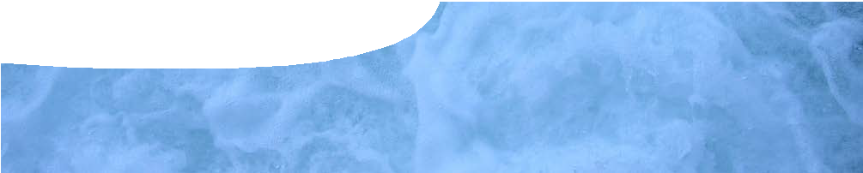
teachers guide
Soft drink science 1
Soft drink fountain

Components

 | NAME | DESCRIPTION | AUDIENCE
 | Soft drink fountain  teachers guide | This guide describes a teacher demonstration that may be used to engage students’ interest in the three states of matter, solutions and separation techniques. | teachers

Purpose
To Engage students’ interest in the science behind soft drinks. Students watch a teacher demonstration and think about the components of a soft drink, their properties and how to separate them. Through class discussion, students are introduced to the
ideas of solutions, states of matter and separation techniques.

Activity summary
Outcomes
Students:
- make observations;
- suggest ideas why adding a solid to soft drink releases gas; and
- brainstorm the ingredients of a soft drink.

ACTIVITY | POSSIBLE STRATEGY
The class goes outside for the teacher demonstration, Mentos-diet coke fountain, described below. | teacher demonstration
Teacher asks students some or all of the suggested questions from the teacher notes below. | class discussion

Mentos-diet coke fountain
It is advisable to do this experiment in a space outside the classroom. The teacher may also like to wear a lab coat. Ask students to stand at least 5 metres away.
In this experiment mentos are dropped into a bottle of diet coke to create an explosive fountain. This should only be performed as a teacher demonstration, not by students.
Equipment: 2 L bottle of diet coke
about 8 mentos mints piece of paper
piece of cardboard
- Put the bottle of diet coke on a flat surface.
- Roll up a piece of paper into a tube and put about eight mentos in it.
- Open the bottle of diet coke and put the piece of cardboard over the bottle opening. Position the tube of mentos, so they will fall into the bottle when the cardboard is removed.
- Pull away the cardboard, then move swiftly away.
SAFETY – DO NOT PUT THE CAP BACK ON THE BOTTLE ONCE THE MENTOS ARE ADDED.
Note: there are several good videos of this experiment on YouTube to show the class, if desired.

Technical requirements
The guide requires Adobe Reader (version 5 or later), which is a free download from www.adobe.com.

Acknowledgements
Designed and developed by the Centre for Learning Technology, The University of Western Australia.
Production team: Jan Dook, Alwyn Evans, Bob Fitzpatrick, Sally Harban, Dan Hutton, Emma Pointon, Jodie Ween, Michael Wheatley, with thanks to Wendy Sanderson and Charmaine White.

Suggested questions for class discussion
Some or all of the following questions may provide a basis for a class discussion about the demonstration, and elicit prior knowledge about concepts of states of matter, solutions and separation techniques. The answers are provided for teacher background, as students are not necessarily expected to provide this range or depth of answers.

QUESTION | SUGGESTED RESPONSE
What was released during the soft drink fountain? | a gas, carbon dioxide
What gas was it? | carbon dioxide
Where did the gas come from? | The carbonated water in the coke. Before the experiment, some of it can be seen as bubbles in the unopened bottle, and some is dissolved.
Where did the gas go? | Into the air, which is a mixture of gases.
How is gas stored in the soft drink, before the fountain? | It is dissolved. More gas dissolves under pressure so when the lid is removed the gas comes out of solution.
Why did adding mentos make gas bubble up out of the coke faster than usual? | The surface of mentos is bumpy which gives bubbles a surface to adhere to. This makes small bubbles join together to make big bubbles and come out faster.
What does the drink in the bottle look like before and after the gas is released? | Before release small bubbles can be seen in the bottle — afterwards there are no bubbles left.  (You may like to pass the bottle around the class after the demo. There will still be some flat coke in the bottom of the bottle.)
Would the drink taste the same with and without gas in it? Think about when you have drunk flat soft drink. | No. A flat drink is less acidic than a drink with bubbles in it.
Has a chemical reaction taken place or were chemicals separated? How can you tell? | There is no chemical reaction. Chemicals have just been separated. The solution left after the experiment looks the same as before, except that the bubbles have gone.
What senses can be used to make observations about the experiment? | sight — can see the explosion  hearing — can hear the explosion and fizzing taste — if you tasted the drink before and after  touch — if you get wet, or if you put your finger in before and after you could feel the bubbles
What are the ingredients in a soft drink? | water, sugar, carbon dioxide, flavourings, colourings

Associated SPICE resources
Soft drink science 1: Soft drink fountain may be used in conjunction with related SPICE resources.

DESCRIPTION | LEARNING PURPOSE
Soft drink science (overview)
This learning pathway shows how a number of SPICE resources can be combined to assist with teaching the topic of states of matter and solutions.
Soft drink science 1: Soft drink fountain  A teacher demonstration engages students’ interest in the three states of matter, solutions and separating techniques. | Engage
Soft drink science 2: Investigating soft drink  Students separate and investigate the components of soft drink through practical activities. | Explore
Soft drink science 3: States of matter  Students use worksheets and an interactive learning object to construct an explanation of the particle model of matter. | Explain
Soft drink science 4: Making soft drink  Students investigate solutions and use their knowledge to make a soft drink. | Explore
Soft drink science 5: Solutions  Students use worksheets and an interactive learning object to construct an explanation of separation techniques, using the particle model of matter. | Explain
Soft drink science 6: Separation techniques  A video about a forensic food scientist illustrates the importance of different separation techniques. Students perform their own practical investigation that involves separation techniques. | Elaborate

SPICE resources and copyright
All SPICE resources are available from the Centre for Learning Technology at The University of Western Australia (“UWA”). Selected SPICE resources are available through the websites of Australian State and Territory Education Authorities.
Copyright of SPICE Resources belongs to The University of Western Australia unless otherwise indicated.
Teachers and students at Australian schools are granted permission to reproduce, edit, recompile and include in derivative works the resources subject to conditions detailed at spice.wa.edu.au/usage.
All questions involving copyright and use should be directed to SPICE at UWA.
Web: spice.wa.edu.au Email: spice@uwa.edu.au Phone: (08) 6488 3917
Centre for Learning Technology (M016) The University of Western Australia
35 Stirling Highway
Crawley WA 6009

