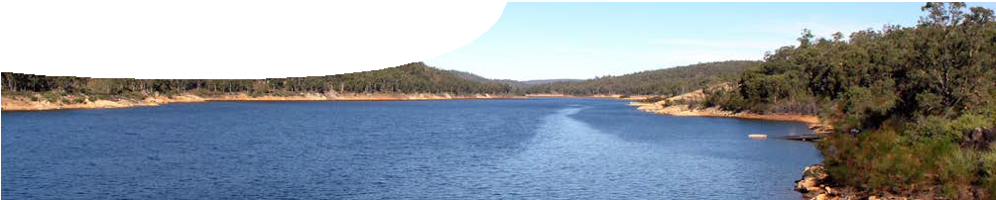teacher guide

Water 1:
Finding water

Components

 | NAME DESCRIPTION AUDIENCE
 | Finding water  teacher guide | This guide explains how to use a video to engage students in learning about ways to supply water to communities in Western Australia. | teachers
 | Water in Western Australia  background sheet | This sheet provides information about: current water sources in Western Australia; possible future water sources; and experimental water supply ideas trialled elsewhere. | teachers
 | Water everywhere  video | This cartoon shows a mixture of clever, inspired, practical and crazy ideas for water supply that have been tried or considered. It leads students to question how Western Australians can secure clean water for the future. | students

Purpose
To Engage students in thinking about where water they drink comes from.

Outcomes
Students:
- understand there are a range of alternative ideas for water supply that may or may not be successful;
- understand unique climate conditions in WA have always required careful management of water sources;
- realise people in WA need to use less water and recycle water we have; and
- classify alternative ideas for water supply into possible or impossible ideas.

Activity summary

ACTIVITY POSSIBLE STRATEGY
Students watch the video, Water everywhere. | whole class
Discuss. See Teacher notes below for key questions for students. | whole class

Teacher notes
This activity can follow viewing the video, Water everywhere:
- Provide two headings: ‘Possible ideas’ and ‘Impossible ideas’.
- Recall ideas shown in the video and classify them under these two headings.
- Which idea or ideas do students think are most likely to work? Why?

Suggested additional activity
Ask students to bring a copy of their family’s water invoice. From this they can calculate an average volume of water each person in their house uses daily. Students may be surprised how high this amount is.
They may also compare it with the average usage for Perth residents: 400 L per day.

Technical requirements
The teachers guide and background sheet require Adobe Reader (version 5 or later), which is a free download from www.adobe.com.
A modern browser (eg Internet Explorer 7 or later, Google Chrome, Safari 4.0+, Opera or Firefox) is required to view the video. This is a free download from www.apple.com/quicktime. A high quality MP4 version of the video is available on CD-ROM or download from the SPICE website.

Acknowledgements
Thanks to the Water Corporation of Western Australia.
Designed and developed by the Centre for Learning Technology, The University of Western Australia.
Production team: Designed and developed by the Centre for Learning Technology, The University of Western Australia. Production team: Anton Ball, Jan Dook, Alwyn Evans, Bob Fitzpatrick, Sally Harban, Dan Hutton, Paul Ricketts, Kate Vyvyan and Michael Wheatley, with thanks to Jenny Gull and Wendy Sanderson.
banner image: ‘Lake C Y O’Connor, Mundaring’ by SeanMack, GFDL, http://commons.wikimedia.org/wiki/ File:Lake_O%27Connor_SMC.jpg

SPICE resources and copyright
All SPICE resources are available from the Centre for Learning Technology at The University of Western Australia (“UWA”). Selected SPICE resources are available through the websites of Australian State and Territory Education Authorities.
Copyright of SPICE resources belongs to The University of Western Australia unless otherwise indicated.
Teachers and students at Australian and New Zealand schools are granted permission to reproduce, edit, recompile and include in derivative works the resources subject to conditions detailed at spice. wa.edu.au/usage.
All questions involving copyright and use should be directed to SPICE at UWA.
Web: spice.wa.edu.au Email: spice@uwa.edu.au Phone: (08) 6488 3917
Centre for Learning Technology (M016) The University of Western Australia
35 Stirling Highway
Crawley WA 6009

Associated SPICE resources
Water 1: Finding water may be used in conjunction with related SPICE resources to to teach the topic of water supplies in Western Australia.
DESCRIPTION LEARNING PURPOSE
Water (overview)
This learning pathway shows how a number of SPICE resources can be used in teaching students about how Western Australia secures its water supply.
Water 1: Finding water  A video shows a range of potential ideas for how water could be supplied to people living in Western Australia. | Engage
Water 2: Water sources  Students use an interactive learning object to explore water sources in a number of regions across Western Australia. | Explore
Water 3: Water supply  Students play a board game to investigate the economic, social and environmental factors that must be considered when planning a sustainable water supply. | Explain
Water 4: Recycling water  Students investigate the Water Corporation’s groundwater replenishment scheme by conducting background research, an experiment and a survey. | Elaborate

