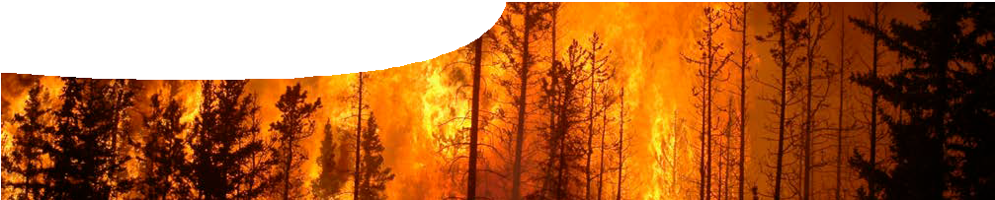
teacher guide

Bushfire science 1:
Fiery failures

Components

 | NAME | DESCRIPTION | AUDIENCE
 | Fiery failures  teacher guide | This guide explains how to introduce students to historical relationships between humans and fire. They question ways humans have sought to manage these situations. | teachers
 | Horrible environmental histories  video | A video shows four examples of environmental damage resulting from incautious or ill-informed human activity involving combustion: Greenland deforestation; acid rain in Europe; noxious products of lignite combustion in the former USSR; and fire suppression policies in 20th century USA. | students

Purpose
To Engage students in learning about relationships between fire, human activity and environment.

Activity summary
Outcomes
Students:
- understand combustion products affect the environment;
- understand many environmental disasters are the result of human actions;
- describe causes of past environmental disasters that are related to human actions; and
- discuss possible solutions to human-generated environmental problems.

ACTIVITY | POSSIBLE STRATEGY
Students watch the video, Horrible environmental histories. | whole class
Class discussion or small group activities about issues presented in the video. | whole class/small groups/individual

Teacher notes
Class discussion following the video may include the following questions:
- What issues surrounding the human use of fire were raised?
- Does the use of fire always have a negative impact on the environment?
- What measures could be taken to reduce or repair harmful environmental effects from fire?
- Do you know of other examples of harmful effects from human use of fire?
Alternatively students may work in groups or individually to produce a PMI chart. They create a table of Positives, Minuses and Interesting things they find out about human use of fire.

Technical requirements
The teachers guide requires Adobe Reader (version 5 or later), which is a free download from www.adobe. com. A modern browser (eg Internet Explorer 8 or later, Google Chrome, Safari 4.0+, Opera or Firefox) is required to view the video

Acknowledgements
Thanks to video presenter, Jeremy Rogers.
Designed and developed by the Centre for Learning Technology, The University of Western Australia.
Production team: Jan Dook, Alwyn Evans, Bob Fitzpatrick, Sally Harban, Dan Hutton, Paul Ricketts, Gemma Slater, Kate Vyvyan and Michael Wheatley, with thanks to Beate Ferbert-Booth, Jenny Gull and Wendy Sanderson.
banner image: ‘forest fire’ by Cameron Standberg.
CC-BY-2.0. commons.wikimedia.org/wiki/File:Fire-Forest. jpg

Associated SPICE resources
Bushfire science 1: Fiery failures may be used in conjunction with related SPICE resources to teach aspects of biodiversity and oxidation.

SPICE resources and copyright
All SPICE resources are available from the Centre for Learning Technology at The University of Western Australia (“UWA”). Selected SPICE resources are available through the websites of Australian State and Territory Education Authorities.
Copyright of SPICE Resources belongs to The University of Western Australia unless otherwise indicated.
Teachers and students at Australian and New Zealand schools are granted permission to reproduce, edit, recompile and include in derivative works the resources subject to conditions detailed at spice.wa.edu.au/usage.
All questions involving copyright and use should be directed to SPICE at UWA.
Web: spice.wa.edu.au Email: spice@uwa.edu.au Phone: (08) 6488 3917
Centre for Learning Technology (M016) The University of Western Australia
35 Stirling Highway
Crawley WA 6009

DESCRIPTION | LEARNING PURPOSE
Bushfires (overview)
Bushfires 1: Fiery failures  A lighthearted look at four environmental catastrophes through history brings out common connections with fire and combustion. | Engage
Bushfires 2: Exploring ecosystems  Students use sampling techniques to investigate a local ecosystem, and an interactive learning object to explore biodiversity in contrasting Western Australian ecosystems. | Explore
Bushfires 3: Oxidation  Students investigate combustion and other oxidation reactions. | Explore
Bushfires 4: Fire in Western Australia  Students use an interactive learning object to examine effects of fire on three Western Australian ecosystems. | Explain
Bushfires 5: Oxidation and combustion  Students use an interactive learning object to visualise oxidation reactions at a molecular level. | Explain
Bushfires 6: Fire stories  Students read three interactive stories about human use of fire and its consequences in different parts of Western Australia. | Elaborate

