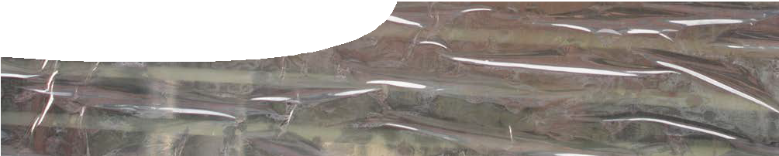
teachers guide
Soft drink science 3
States of matter

Components

 | NAME | DESCRIPTION | AUDIENCE
 | States of matter  teachers guide | This guide shows how a learning object and worksheet can be used to explain how the properties of the three states of matter are determined by their particulate structure. | teachers
 | Three states of matter  background sheet | This background information for teachers contains basic information about the three common states of matter. | teachers
 | States of matter explorer  learning object | The learning object shows differences in properties of solids, liquids and gases. Students see how particle structure and movement relate to properties of a substance and how substances change state. | students
 | Solids, liquids and gases  worksheet | This worksheet probes students’ understandings of animations in the learning object, States of matter explorer. | students

Purpose
To Explain the particle structure of the three states of matter. Students develop an understanding of how substances change state, and how substances with different particulate structures can be separated from each other.

Activity summary
Outcomes
Students:
- explain how the particle arrangement of each state of matter determines properties of a substance;
- understand that all particles are in motion, according to kinetic theory;
- identify some properties of solids, liquids and gases;
- describe what happens to particles in a substance when they change state; and
- explain how substances with different properties can be separated from each other.

ACTIVITY | POSSIBLE STRATEGY
Teacher may review information provided in the background sheet, Three states of matter.
Class goes outside for a ‘states of matter’ role play. See Teacher notes below for details. | whole class
Students work through the learning object, States of matter explorer, and complete the worksheet, Solids, liquids and gases as they go. See Teacher notes below. | individual or pairs
Discuss answers to questions. | whole class
Students write a rap or song about the three states of matter based on all that they have learnt. There are lots of good examples on YouTube that could be shown to the class for inspiration. | small groups

Teacher Notes

Role play
The class is taken to a roped off or marked out area outside. The students are to ‘act’ like the three states of matter. Begin with students as a ‘solid structure’ — they will need to stand in organised rows and shake on the spot. They can then ‘melt’ to form a ‘liquid’ — they will need to separate a bit and walk around each other slowly. They then ‘evaporate’ to form a ‘gas’ — this means they need to run in straight lines until they bump into the side of the marked off area, or someone else, then turn and run in a different direction.
It is important that students realise that the actual particles do not change when they change state, only the way they are organised and move.
The terms ‘condense’ and ‘freeze’ can be introduced to turn them back from gas to liquid and then liquid to solid. It could also be an opportunity to introduce the term ‘sublime’, where solid turns straight to gas.
Having introduced the terms and ideas to students, this activity may be built into a game where the teacher calls out instructions and students behave accordingly. (The slowest to respond each round is out until you have a winner.)

Using the learning object
Teachers may decide to stop the class after they have completed each question if students are unfamiliar with the particle model or cannot remember previous ideas about the states of matter and their properties.

Further research
Teachers may like to extend students by asking them to research some of the following interesting substances to classify them as solids, liquids or gases: silly putty, glass, plasticine, rubber, elastic, talcum powder, molasses, hair gel. How did they decide?

Technical requirements
The learning object requires Adobe Flash Player version 9 or later (this is a free download from www. adobe.com). It can be placed on a web or file-server and run either locally or remotely in a web browser.
The teachers guide and worksheet require Adobe Reader (version 5 or later), which is a free download from www.adobe.com. The worksheet is also available in Microsoft Word format.

Acknowledgements
Designed and developed by the Centre for Learning Technology, The University of Western Australia.
Production team: Jan Dook, Alwyn Evans, Bob Fitzpatrick, Sally Harban, Dan Hutton, Emma Pointon, Paul Ricketts, Jodie Ween, Michael Wheatley, with thanks to Wendy Sanderson and Charmaine White.

SPICE resources and copyright
All SPICE resources are available from the Centre for Learning Technology at The University of Western Australia (“UWA”). Selected SPICE resources are available through the websites of Australian State and Territory Education Authorities.
Copyright of SPICE Resources belongs to The University of Western Australia unless otherwise indicated.
Teachers and students at Australian schools are granted permission to reproduce, edit, recompile and include in derivative works the resources subject to conditions detailed at spice.wa.edu.au/usage.
All questions involving copyright and use should be directed to SPICE at UWA.
Web: spice.wa.edu.au Email: spice@uwa.edu.au Phone: (08) 6488 3917
Centre for Learning Technology (M016) The University of Western Australia
35 Stirling Highway
Crawley WA 6009

Associated SPICE resources
Soft drink science 3: States of matter may be used in conjunction with related SPICE resources.

DESCRIPTION | LEARNING PURPOSE
Soft drink science (overview)
This learning pathway shows how a number of SPICE resources can be combined to assist with teaching the topic of states of matter and solutions.
Soft drink science 1: Soft drink fountain  A teacher demonstration engages students’ interest in the three states of matter, solutions and separating techniques. | Engage
Soft drink science 2: Investigating soft drink  Students separate and investigate the components of soft drink through practical activities. | Explore
Soft drink science 3: States of matter  Students use worksheets and an interactive learning object to construct an explanation of the particle model of matter. | Explain
Soft drink science 4: Making soft drink  Students investigate solutions and use their knowledge to make a soft drink. | Explore
Soft drink science 5: Solutions  Students use worksheets and an interactive learning object to construct an explanation of separation techniques, using the particle model of matter. | Explain
Soft drink science 6: Separation techniques  A video about a forensic food scientist illustrates the importance of different separation techniques. Students perform their own practical investigation that involves separation techniques. | Elaborate

