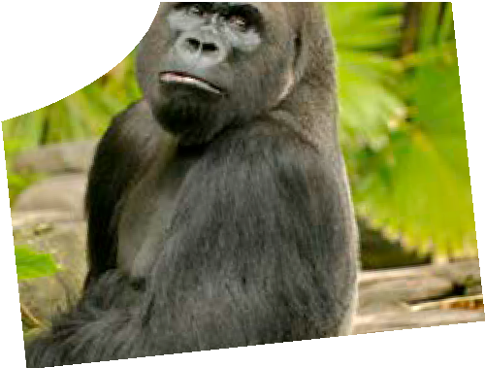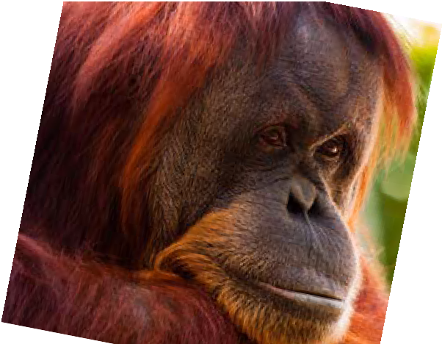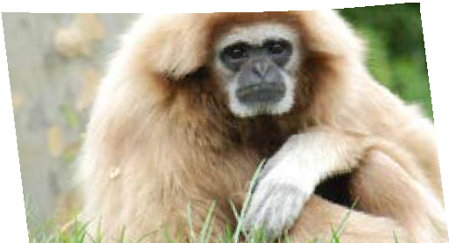
teachers guide
ce for evolution 2:
Primates
Molecular eviden

Components

 | NAME | DESCRIPTION | AUDIENCE
 | Primates  teachers guide | The guide explains how the learning objects can build students’ understanding of the way anatomical evidence is used to determine evolutionary relationships. | teachers
 | Primate trends  learning object | This learning object enables students to explore the anatomy of five primate skulls and make conclusions about primate relatedness. | students
 | Virtual zoo  learning object | This learning object contains video footage of four primates in captivity. After viewing it, students may make physiological and behavioural observations. | students
 | Primate relations  worksheet | This two-part worksheet collates information from both learning objects to explore evolutionary evidence of primate relatedness. | students

Purpose
To Explore how anatomical and behavioural evidence can be used to determine evolutionary relationships.

Outcomes
Students:
- identify selected areas of primate skulls;
- describe some anatomical features of skulls, and behavioural characteristics for selected primates;
- make observations of trends in primate skull characteristics; and
- make decisions about evolutionary relationships, using collected evidence.

Activity summary

ACTIVITY | POSSIBLE STRATEGY
Students use the learning object, Primate trends, to determine how primates may be related, then complete worksheet, Primate relations – Part 1: Primate trends. | individually or in pairs
Students visit Perth Zoo to observe gibbons and orang-utans. They may use the worksheet, Primate relations – Part 2: Virtual zoo, to record observations of four primates to help determine how primates may be related.  and/or  Students use the learning object, Virtual zoo, and use the worksheet, Primate relations – Part 2: Virtual zoo to make observations of four primates to help determine how primates may be related. | whole class, individuals or pairs

Using the learning objects

Primate trends
Primate trends enables students to view skulls one, two or four at a time. Using buttons under the View heading, students select a specific orientation for skulls they are viewing, then select buttons under Highlight to choose features of interest. Only relevant highlights are available for some views. The VR function (under the View heading) enables students to spin a skull, providing unique views of each skull.
The most practical way for students to work through this learning object is to compare four skulls at a time (Quad button), for each characteristic.
To begin, draw the scale bar in each skull’s section (bottom right-hand corner), to students’ attention. The scale indicates that skulls are different sizes, even though they are depicted as equal sizes in the learning object. Recognising this is important when considering relative cranial capacities as, for example, an average gorilla skull may be 2.5 times the size of an average gibbon skull. As they work, students enter required information into the table on worsheet, Primate relations – Part 1: Primate trends.
Each characteristic has parameters associated with it and students should take care to ensure skulls are rated correctly (according to their observations).

Virtual zoo
Virtual zoo provides video footage of four primates featured in this resource: orang-utans, gorillas, chimpanzees and gibbons. Four Australian Zoos are featured: Perth Zoo, Monarto Zoo, Melbourne Zoo and Taronga Zoo. Gorilla footage is the same for both Melbourne and Taronga zoos as each contributed footage to the combined video. Monarto and Taronga Zoos both contributes footage of chimpanzees.
Using this learning object students view movies for each primate, and enter observations into the worksheet, Primate relations – Part 2: Virtual zoo.
Students compare results from Primate trends and Virtual zoo to determine which primates are most closely related. Other resources in Molecular evidence for evolution will demonstrate more reliable methods of determining evolutionary relationships, through use of molecular techniques.

Technical requirements
Primate trends require a modern browser (eg Internet Explorer 7 or later, Google Chrome, Safari 4.0+, Opera or Firefox). Virtual zoo requires Internet Explorer 9+, Google Chrome, Safari 4.0+, Opera or Firefox). The learning objects can be placed on a web or file-server and run either locally or remotely in a web browser.
High quality versions of the learning objects are available on CD-ROM or download from the SPICE website.
The teachers guide and worksheet require Adobe Reader (version 5 or later), which is a free download from www.adobe.com. The worksheet is also available in Microsoft Word format.

Image credits

skulls
Chimpanzee, gorilla and gibbon skull images were obtained from the Digital Morphology Museum created by Kyoto University. Whilst every effort was made to match skulls with the zoo species featured in Virtual zoo, limitations of software and skull availability meant that compromises were necessary.
The species of gibbons featured in Virtual zoo are the Javan gibbon, Hylobates lar, and the white-cheeked gibbon, Nomascus leucogenys. The specimen featured in Primate trends is the agile gibbon, Hylobates agilis. The human skull is authentic and hooks are in place due to skull cap removal during autopsy.

male chimpanzee
‘PRICT No. 344, Pan Troglodytes’ by Digital Morphology Museum, KUPRI, Kyoto University, Japan, viewed August 2011, www.pri.kyoto-u.ac.jp/dmm/ WebGallery/dicom/dicom.html?ex_no=317

male gibbon
‘PRICT 275, Hylobates agilis’, by Digial Morphology Museum, KUPRI, Kyoto University, Japan, viewed August 2011, www.pri.kyoto-u.ac.jp/dmm/ WebGallery/dicom/dicomProperty.html?id=275

male gorilla
‘PRICT 317’, Gorilla gorilla’, by Digial Morphology Museum, KUPRI, Kyoto University, Japan, viewed August 2011, http://www.pri.kyoto-u.ac.jp/dmm/ WebGallery/dicom/dicomProperty.html?id=317

male orang-utan
‘PRICT 513, Pongo abelii’, by Digital Morphology Museum, KUPRI, Kyoto University, Japan, viewed November 2011, www.pri.kyoto-u.ac.jp/dmm/ WebGallery/dicom/dicomProperty.html?id=513

Virtual zoo
‘Close-up, chimp (Pan troglodytes) using stick to get termites, Gombe Stream National Park, Tanzania’ by Bill Wallauer / gettyimages.com.au, 82778606, used under licence, http://www.gettyimages.com.au/detail/ video/chimp-using-stick-to-get-termites-gombe- stream-stock-video-footage/82778606

Acknowledgements
Thank you to Assistant Professor Debra Judge and the School of Anatomy, Physiology and Human Biology and Dr James O’Shea and the School of Animal Biology at The University of Western Australia for the loan of the orang-utan skull (female).
Thank you to Associate Professor Julie Hill and the School of Anatomy, Physiology and Human Biology for the loan of the human skull (gender unknown).
Thank you to Dr Roger Price and Ms Janette Atkinson and the Department of Medical Technology and Physics at Sir Charles Gardner Hospital for their assistance in generating CT scans of the human and orang-utan skull.
Thank you to Associate Professor Paul Bourke and iVEC at The University of Western Australia for processing CT scans.

Thank you to Daniel Scarporolo and the Perth Zoo for their assistance in filming silvery and white-cheeked gibbon and orang-utans.
Thank you to Ben Gibson and Mark Williams and the Taronga Zoo for providing video footage of chimpanzees and gorillas.
Thank you to Judith Henke and the Melbourne zoo for providing footage of gorillas.
Thank you to Ruth Hall and Zoos South Australia for providing footage of chimpanzees.
Thank you to Claire Gaskin from Perth Zoo for her assistance in obtaining video footage.
Designed and developed by the Centre for Learning Technology, The University of Western Australia.
Production team: Anton Ball, Pauline Charman, Jan Dook, Alwyn Evans, Dan Hutton, Bec McKinney, Emma Pointon, Paul Ricketts, Jodie Ween and Michael Wheatley. Thanks to Bob Fitzpatrick, Jenny Gull, Beate Ferbert-Booth and Wendy Sanderson.

SPICE resources and copyright
All SPICE resources are available from the Centre for Learning Technology at The University of Western Australia (“UWA”). Selected SPICE resources are available through the websites of Australian State and Territory Education Authorities.
Copyright of SPICE Resources belongs to The University of Western Australia unless otherwise indicated.
Teachers and students at Australian and New Zealand schools are granted permission to reproduce, edit, recompile and include in derivative works the resources subject to conditions detailed at spice. wa.edu.au/usage.
All questions involving copyright and use should be directed to SPICE at UWA.
Web: spice.wa.edu.au Email: spice@uwa.edu.au Phone: (08) 6488 3917
Centre for Learning Technology (M016) The University of Western Australia
35 Stirling Highway
Crawley WA 6009

Associated SPICE resources
Molecular evidence for evolution 2: Primates may be used in conjunction with related SPICE resources to teach the topic of molecular evidence for evolution.

DESCRIPTION | LEARNING PURPOSE
Molecular evidence for evolution (overview)
Molecular evidence for evolution 1: Mammal evolution  A card game engages student interest in evidence used to determine evolutionary relationships between eutherians (placental mammals). | Engage
Molecular evidence for evolution 2: Primates  Students use interactive learning objects to explore how anatomical evidence may be used to determine relatedness. | Explore
Molecular evidence for evolution 3: Evolutionary trees  The use of molecular evidence to determine relatedness between species is explained. Students draw evolutionary trees to represent relatedness. | Explain
Molecular evidence for evolution 4: Viral evolution  Students use the Influenza Research Database to investigate virus evolution. This bioinformatics database is an authentic research tool used to compare genetic sequences of virus strains, and to construct cladograms to draw conclusions about their relatedness. | Elaborate

