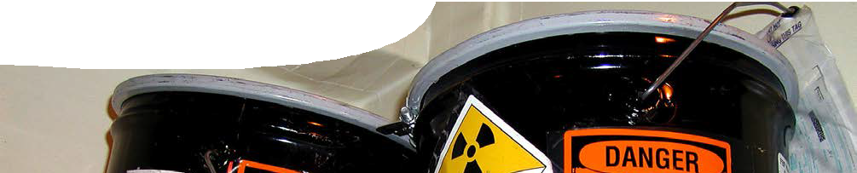
teacher guide
Radiation 2:
Nuclear radiation

Components

 | NAME | DESCRIPTION | AUDIENCE
 | Nuclear radiation  teacher guide | This guide describes three alternative ways for students to explore properties of alpha, beta and gamma radiation. | teachers
 | What is nuclear radiation?  background sheet | This background sheet contains information for teachers on different types of nuclear radiation, their properties and how radiation doses are measured. | teachers
 | Investigating nuclear radiation 1  procedure sheet | Students experiment with isotopes to determine the relative penetrative properties of three types of radiation. | students
 | Investigating nuclear radiation 2  worksheet | Students use second-hand data to analyse the penetration levels of various types of radiation. | students
 | Investigating nuclear radiation 3  worksheet | This provides a framework for student use of an interactive learning object, The alpha, beta and gamma of radiation. | students

Purpose
To Explore penetrative properties of alpha, beta and gamma radiation.

Activity summary
Outcomes
Students:
- describe penetrative properties of alpha, beta and gamma radiation; and
- analyse data to explain differences in penetrative properties of alpha, beta and gamma radiation.

ACTIVITY | POSSIBLE STRATEGY
A laboratory procedure with associated questions, Investigating nuclear radiation 1, may be used to explore and explain penetrative properties of nuclear radiation.  This activity provides opportunities to discuss differences in nature and properties of three types of radiation: alpha, beta and gamma. | Students perform an experiment and analyse data.  teacher-led explanation of characteristics of different types of radiation
If equipment for this laboratory activity is not available then two alternatives are provided:  - The worksheet, Investigating nuclear radiation 2, contains second- hand data that may be used to analyse penetrative properties of radiation; or  - an interactive learning object, The alpha, beta and gamma of radiation, may be used to take measurements and provide data for the worksheet, Investigating nuclear radiation 3. | student activity using a worksheet or learning object and worksheet

Technical requirements
The learning object, The alpha, beta and gamma of radiation, is published by Education Services Australia. It can be accessed through the Department of Education WA portal (K-12 Resources). It is also available through Scootle at https://www.scootle.edu.au/ec/viewMetadata. action?id=L45.
Adobe Flash Player version 8 or later is required to view the learning object. This is a free download from www.adobe.com.
The teacher guide, procedure sheet, worksheets and background sheet require Adobe Reader (version 5 or later), which is a free download from www.adobe.com. The worksheets and procedure sheet are also available in Microsoft Word format.

Teacher notes
Three alternatives are provided for this exploration of properties of nuclear radiation:
- Investigating nuclear radiation 1 describes a laboratory activity that uses sources of alpha, beta and gamma radiation.
- For schools that do not have access to this equipment, Investigating nuclear radiation 2 contains second-hand data that students may analyse.
- An interactive learning object, The alpha, beta and gamma of radiation, published by Education Services Australia provides a useful computer- based simulation of this activity. The ‘Your task’ screen embedded in the learning object may be replaced by the worksheet, Investigating nuclear radiation 3.

Associated SPICE resources
Nuclear reactions 2: Nuclear radiation may be used in conjunction with related SPICE resources to address the broader topic of nuclear physics.

DESCRIPTION | LEARNING PURPOSE
Nuclear reactions
This learning pathway shows how a number of SPICE resources can be combined to teach the topic of ionising radiation and nuclear reactions.
Nuclear reactions 1: Mines to medicine  Students express their opinions on a moral issue after viewing a film of demonstrators at a uranium mine and after a medical physicist explains why nuclear medicine is so important to diagnostic and therapeutic procedures. | Engage
Nuclear reactions 2: Nuclear radiation  Students investigate types and properties of radiation with particular attention to penetrative characteristics. | Explore 1
Nuclear reactions 3: Nuclear decay  Students manipulate variables in an interactive simulation to investigate connections between decay and half-life. An alternative procedure using dice is provided. | Explore 2
Nuclear reactions 4: Decay chains  In three separate interactive simulations, students experience modelling as an alternative way of exploring nuclear decay and half-life. | Explore 3
Nuclear reactions 5: Fission and fusion  Worked examples explain how to calculate mass defect and binding energy for fission and fusion reactions. The experimental ITER fusion reactor is also discussed. | Explain
Nuclear reactions 6: Nuclear medicine  Students explore applications of radioisotopes in medicine. | Elaborate 1
Nuclear reactions 7: Radioisotopes in research  Fact sheets illustrate the use of radioisotopes in research being undertaken at The University of Western Australia. | Elaborate 2

Acknowledgements
Developed by the Centre for Learning Technology, UWA. Production team: Bob Fitzpatrick, Jenny Gull, Paul Ricketts, Gary Thomas and Michael Wheatley.
banner image: ‘Radioactive HAZMAT labels on navy containers’ by US Navy. PD. en.wikipedia.org/wiki/ File:Radioactive_HAZMAT_labels_on_navy_containers.jpg

SPICE resources and copyright
All SPICE resources are available from the Centre for Learning Technology at The University of Western Australia (“UWA”). Selected SPICE resources are available through the websites of Australian State and Territory Education Authorities.
Copyright of SPICE Resources belongs to The University of Western Australia unless otherwise indicated.
Teachers and students at Australian and New Zealand schools are granted permission to reproduce, edit, recompile and include in derivative works the resources subject to conditions detailed at spice.wa.edu.au/usage.
All questions involving copyright and use should be directed to SPICE at UWA.
Web: spice.wa.edu.au Email: spice@uwa.edu.au Phone: (08) 6488 3917
Centre for Learning Technology (M016) The University of Western Australia
35 Stirling Highway
Crawley WA 6009

