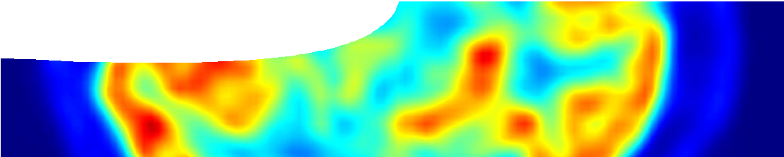
teacher guide
Nuclear reactions 6:
Nuclear medicine

Components

 | NAME DESCRIPTION AUDIENCE
 | Nuclear medicine  teachers guide | This guide shows how a video and comprehension worksheet may be used to elaborate on medical uses of radioisotopes. Safety procedures  followed by handlers of radioactive materials are emphasised. | teachers
 | Too hot to handle! Working safely with radioisotopes  video | The video shows a technician preparing, dispensing and administering radioactive iodine to a patient. | students
 | Medical uses of radioisotopes  worksheet | This worksheet contains information about radiotherapy and related questions. | students

Purpose
To Elaborate on uses of radioisotopes in medicine.

Activity summary
Outcomes
Students:
- explain principles observed when handling radioactive materials;
- describe monitoring devices used by handlers of radioactive materials;
- understand possible dangers of handling radioactive materials;
- understand how radioisotopes can be used in diagnostic and therapeutic situations; and
- describe the process of brachytherapy.

ACTIVITY POSSIBLE STRATEGY
View the video, Too hot to handle. | whole class discussion
Students read and study text on worksheet, Medical uses of radioisotopes. | read
Students answer questions on the worksheet. | write responses

Technical requirements
A modern browser (eg Internet Explorer 9 or later, Google Chrome, Safari 5.0+, Opera or Firefox) is required to view the video. A high quality MP4 version of the video is available by download from the SPICE website.
The guide and worksheet require Adobe Reader (version 5 or later), which is a free download from www.adobe.com. The worksheet is also available in Microsoft Word format.

Using the video
The video shows a physicist collecting, transporting and disposing of radioactive material. While doing so it is explained what safety protocols are in place to minimise exposure to radiation poisoning. The three main safety procedures (shielding, distance from source, and time exposed to source) are emphasised.
Discussion questions after viewing the video could include:
- What safety precautions are used by physicists when handling radioactive isotopes?
gloves are worn
lead container is used to store the isotope when not in use
tongs are used to transfer the isotope protective coat is worn
film badge (dosimeter) to detect radiation is worn transfer is dispensed behind a lead wall
patient is seated in a separate room to where the isotope is dispensed
quantity (volume) of isotope is carefully measured
- Would handling procedures for dealing with alpha emitters be different from handling gamma emitters?
There would be no difference in protocols, despite alpha radiation being less penetrating than gamma radiation (this is a very conservative approach).

Acknowledgements
Science experts: Simon Woodings (Radiation Oncology Medical Physicist) and Pat Barker (Senior Diagnostic Medical Physicist), Royal Perth Hospital.
Thanks to Dr David Causer, Royal Perth Hospital.
Designed and developed by the Centre for Learning Technology, The University of Western Australia.
Production team: Alwyn Evans, Bob Fitzpatrick, Paul Ricketts, Gary Thomas and Michael Wheatley, with thanks to Roger Dickinson, Jenny Gull and Wendy Sanderson.
banner image: ‘Transaxial slice of a human brain taken with positron emission tomography’ by Jens Langner. PD. en.wikipedia.org/wiki/File:PET-image.jpg

SPICE resources and copyright
All SPICE resources are available from the Centre for Learning Technology at The University of Western Australia (“UWA”). Selected SPICE resources are available through the websites of Australian State and Territory Education Authorities.
Copyright of SPICE Resources belongs to The University of Western Australia unless otherwise indicated.
Teachers and students at Australian and New Zealand schools are granted permission to reproduce, edit, recompile and include in derivative works the resources subject to conditions detailed at spice. wa.edu.au/usage.
All questions involving copyright and use should be directed to SPICE at UWA.
Web: spice.wa.edu.au Email: spice@uwa.edu.au Phone: (08) 6488 3917
Centre for Learning Technology (M016) The University of Western Australia
35 Stirling Highway
Crawley WA 6009

Associated SPICE resources

