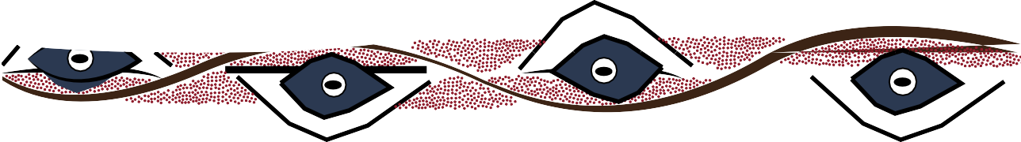
teacher guide
Feeding relationships 6:
Kimberley creations

Components

 | NAME | DESCRIPTION | AUDIENCE
 | Kimberley creations  teacher guide | This guide provides teachers with preparation strategies and materials required for students to complete the Kimberley art activities. | teachers
 | Stories in Aboriginal art  fact sheet | This fact sheet explains some key points to consider when creating an artwork based on techniques used in Aboriginal art. | students
 | Imagine, plan, create  worksheet | Students represent a feeding relationship that they have studied, by applying techniques used in Aboriginal art. | students

Purpose
This activity is designed to provide an opportunity for students to articulate and record understandings they have gained through studying feeding relationships in the Kimberley environment, by applying techniques used in Aboriginal art, to create an artwork that depicts their story.

Activity summary
Outcomes
Students:
- create their own artworks depicting scenarios about feeding relationships in the Kimberley;
- appreciate the place of art in Aboriginal culture;
- view and interpret some symbols used in Aboriginal paintings; and
- apply techniques used in Aboriginal artworks to create their own artwork.

ACTIVITY | POSSIBLE STRATEGY
Students read and discuss the fact sheet, Stories in Aboriginal art. | whole class/groups
Using the worksheet, Imagine, plan, create, students research Aboriginal art, write a story about feeding relationships in the Kimberley, and produce an artwork depicting their story. | group discussion  in pairs: research and discussion individually: complete artwork

Teacher notes
Prior to the activity, students need to study examples of Aboriginal art, and familiarise themselves with techniques used, and meanings of stories behind the artworks. During the study, they may draw up a chart of symbols in the public domain. Explain to students that as these are not sacred, anyone may use them
in paintings. Research guidelines are included in the worksheet.
If you/students have Aboriginal art prints/photos/ paintings it’s a good idea to bring them to class to discuss their meanings and techniques used.
When students have studied examples of artworks, their meanings and symbols used, it is important for them to understand the place of art in Aboriginal communities. Introduce them to aspects listed on the fact sheet, and encourage discussion.

After studying the fact sheet, students complete the worksheet. They may paint their pictures, or choose from media other than paint, including multimedia, and paste their description summaries on the back.
A class display of artworks created works well.

