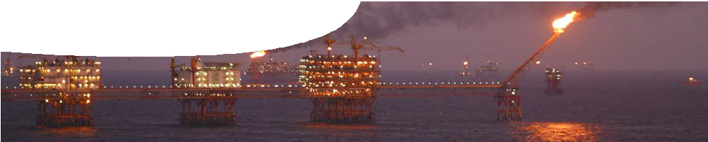
teacher guide
Hydrocarbon chemistry 4:
Hydrocarbon economy

Components

 | NAME | DESCRIPTION | AUDIENCE
 | Hydrocarbon economy  teacher guide | This resource draws links between properties of hydro- carbons and their intended use. It explores how the imbalance between what is naturally available in Australia, and what is required, is met by processing and import of hydrocarbons. | teachers
 | How is crude oil processed?  background sheet | This gives teachers some information about how crude oil is refined, including processes of fractional distillation and conversion. | teachers
 | Crude oil distillation  fact sheet | This introduces crude oil refining to students, focussing on the fractional distillation process. | students
 | Hydrocarbon glossary  fact sheet | This student reference defines selected terms used in the hydrocarbon industry. | students
 | Hydrocarbons in Australia  worksheet | A structured worksheet leads students through hydrocarbon production, use, import and export in Australia. | students

Purpose
To Elaborate on the role of hydrocarbons in Australia in fuel use, power generation and their part in creating export revenue.

Activity summary
Outcomes
Students understand that:
- a range of hydrocarbons are extracted in Australia;
- different hydrocarbons are required for different applications;
- extracted resources are processed to make useful hydrocarbons; and
- a global trade in hydrocarbons exists to match supply and demand.

ACTIVITY | POSSIBLE STRATEGY
Class discusses the question, ‘What hydrocarbons are extracted from natural deposits in Australia?’. | whole class
Continue discussion to include what hydrocarbons are used in domestic and industrial applications, and how these are sourced. | whole class
Distribute fact sheets, Crude oil distillation and Hydrocarbon glossary,  then complete worksheet, Hydrocarbons in Australia. | individual
Class may discuss points arising from worksheet, such as ‘How dependant is Australia on imported hydrocarbons?’. | whole class

Teacher notes?
This resource encourages students to consider social and economic values used in determining which fuels are used or produced locally, and which are part
of a global petroleum market. Further cultural and political values may be discussed during, or following, this activity.
Students may need to consider other sources of information to answer questions in the worksheet, Hydrocarbons in Australia

Technical requirements
A modern browser (eg Internet Explorer 9 or later, Google Chrome, Safari 5.0+, Opera or Firefox) is required to view the video. A high quality MP4 version of the video is available by download from the SPICE website.
The guide, worksheet, fact sheet and background sheet require Adobe Reader (version 5 or later), which is a free download from adobe.com. The worksheet is also provided in Microsoft Word format.

Acknowledgements
Original concept design: Don Marshall and Sally Harban (John Curtin College of the Arts).
Thanks to Stewart Gallagher, Shell Development (Australia) Propietary Limited.
Designed and developed by the Centre for Learning Technology, The University of Western Australia.
Production team: Bob Fitzpatrick, Jenny Gull and Michael Wheatley.
banner image: ‘An oil rig offshore Vungtau’ by Genghiskhanviet. Public Domain. commons.wikimedia.org/ wiki/File:An_oil_rig_offshore_Vungtau.jpg

Associated SPICE resources
SPICE resources and copyright
All SPICE resources are available from the Centre for Learning Technology at The University of Western Australia (“UWA”). Selected SPICE resources are available through the websites of Australian State and Territory Education Authorities.
Copyright of SPICE Resources belongs to The University of Western Australia unless otherwise indicated.
Teachers and students at Australian and New Zealand schools are granted permission to reproduce, edit, recompile and include in derivative works the resources subject to conditions detailed at spice. wa.edu.au/usage.
All questions involving copyright and use should be directed to SPICE at UWA.
Web: spice.wa.edu.au Email: spice@uwa.edu.au Phone: (08) 6488 3917
Centre for Learning Technology (M016) The University of Western Australia
35 Stirling Highway
Crawley WA 6009

Hydrocarbon chemistry 4: Hydrocarbon economy may be used in conjunction with related SPICE resources to address the broader topic of organic chemistry.

DESCRIPTION | LEARNING PURPOSE
Hydrocarbon chemistry
This learning pathway shows how a number of SPICE resources can be combined to teach the topic of organic chemistry.
Hydrocarbon chemistry 1: Coconut oil  This resource engages students in organic chemistry by showing them how fuel can be made from plants in a very basic home set-up. | Engage
Hydrocarbon chemistry 2: Biodiesel  This resource further explores biodiesel production as students make their own biodiesel and compare its properties with those of other fuels. | Explore
Hydrocarbon chemistry 3: Naming hydrocarbons  This resource explains to students how hydrocarbons can be drawn and systematically named. | Explain
Hydrocarbon chemistry 4: Hydrocarbon economy  Australia uses a wide range of hydrocarbons for domestic and industrial purposes. How is this range supplied from available sources? | Elaborate

