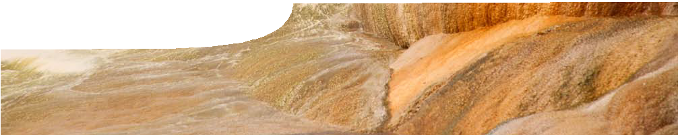
teachers guide
Geothermal energy 1:
Heat beneath your feet

Components

 | NAME | DESCRIPTION | AUDIENCE
 | Heat beneath your feet  teachers guide | This guide shows how to engage students’ interest in latent and specific heat by examining how geothermal energy is used in Western Australia. | teachers
 | Heat beneath your feet  video | The video shows how geothermal energy is used in Perth to heat swimming pools. Ideas of how geothermal energy could be used in the future are also raised. | students

Purpose
To Engage students’ interest in specific heat and latent heat by examining uses of geothermal energy in Perth, surveying community awareness of geothermal energy and looking at how it can be developed for future use.

Activity summary
Outcomes
Students:
- identify geothermal hot water as a viable alternative source of energy for Western Australia;
- formulate opinions about the viability of using geothermal energy in Western Australia;
- identify areas of energy use where geothermal energy may be substituted in the future; and
- appreciate that geothermal energy is a relevant, abundant, alternative source of energy, present in large quantities in the Perth Basin.

ACTIVITY | POSSIBLE STRATEGY
Show the video, Heat beneath your feet. | whole class
Students discuss focus questions. | in groups, individually or teacher-led discussion

Using the video
Play the video, Heat beneath your feet. The following questions may be used to encourage discussion in relation to the intended outcomes:
- Do you think people in Perth are well informed about the use of geothermal energy?
- How does geothermal energy compare with energy produced by fossil fuels, when carbon emissions are considered?
- In what situations can geothermal energy be used, in addition to heating swimming pools?
- Would you consider geothermal energy to be a sustainable source of energy?
- Do you think the claim that geothermal energy can be used to air-condition an entire university campus is reasonable?
- Water is used to transfer heat in many situations, not just in Perth, where a vast supply of hot water exists. Why do you think this is?

- The Perth sedimentary basin is up to 10 km deep. Why do you think bores to access hot water only need to go down 1 km?
- How is hot water able to move through rock?

Technical requirements
The video, Heat beneath your feet, is provided in two formats: on a standard DVD-video disk and as a QuickTime movie. QuickTime version 7 or later is required to view the movie. This is a free download from www.apple.com/quicktime.
The teacher guide requires Adobe Reader (version 5 or later), which is a free download from www.adobe. com.

Associated SPICE resources
Geothermal energy 1: Heat beneath your feet may be used in conjunction with related SPICE resources to investigate specific heat and latent heat.

DESCRIPTION | LEARNING PURPOSE
Geothermal energy (overview)
This learning pathway shows how a number of SPICE resources can be combined to assist with teaching the topics of specific heat and latent heat.
Geothermal energy 1: Heat beneath your feet  A video engages student interest in recent developments and future possibilities for the use of geothermal energy. | Engage
Geothermal energy 2: Specific heat capacity  Students investigate the specific heat capacity of water in laboratory and problem- solving activities. | Explore
Geothermal energy 3: Heating a pool  Students’ understanding of specific heat is developed through data analysis in the context of heating swimming pools using geothermal energy. | Explain
Geothermal energy 4: Sustainable energy sources  Students reinforce and deepen their understanding of specific heat and geothermal energy through problem-solving activities. | Elaborate
Geothermal energy 5: Latent heat  Students investigate latent heat through practical and problem-solving activities. | Explore
Geothermal energy 6: Using geothermal energy  Students use an interactive learning object to develop an understanding of how latent heat is used in a number of devices. | Explain
Geothermal energy 7: The geothermal alternative  Students use concepts developed throughout this sequence to analyse two case studies that involve use of geothermal energy. | Elaborate

Acknowledgements
Thanks to Professor Klaus Regenauer-Lieb, Director, Western Australian Geothermal Centre of Excellence.
Designed and developed by the Centre for Learning Technology, The University of Western Australia.
Production team: Anton Ball, Leanne Bartoll, Jan Dook, Alwyn Evans, Bob Fitzpatrick, Dan Hutton, Emma Pointon, Paul Ricketts, Gary Thomas, Jodie Ween and Michael Wheatley, with thanks to Pauline Charman, Jenny Gull, Wendy Sanderson and Charmaine White.

Video credits
- ‘California – oil pumps’ by C G P Grey, used by permission. www.flickr.com/photos/52890443@ N02/4889462844/
- ‘Hot spring at Hveravellir’ by Boris Sigurbjornsson, CC-by-2.0. commons.wikimedia.org/wiki/File:Hot_ spring_at_Hveravellir.jpg
- ‘Champagne pool’ by Antoine Hubert, CC-by-2.0. www.flickr.com/photos/33753516@N00/253022446/
- ‘Arenal’ by Scott Robinson, used by permission. www.flickr.com/photos/84617037@N00/131620637/
- ‘Gas well video footage’ courtesy of Channel Nine, Perth.
- ‘Mycom chiller’ by Mike Ono, used by permission. www.mayekawa.com.
- ‘Drill rig’ by Greenrock Energy Ltd, used by permission.
music
- ‘Kai’ courtesy of Neotnas, CC-BY-ND-3.0. freemusicarchive.org/music/Neotnas/
- ‘Decisions’ and ‘Killing time’ courtesy of Kevin MacLeod, Incompetech, creative industries, CC-
BY-3.0. incompetech.com/m/c/royalty-free/
banner image
- ‘Mammoth Hot Springs’ by Matthias Kabel, GFDL, commons.wikimedia.org/wiki/File:Mammoth_Hot_ springs_02.jpg

SPICE resources and copyright
All SPICE resources are available from the Centre for Learning Technology at The University of Western Australia (“UWA”). Selected SPICE resources are available through the websites of Australian State and Territory Education Authorities.
Copyright of SPICE Resources belongs to The University of Western Australia unless otherwise indicated.
Teachers and students at Australian schools are granted permission to reproduce, edit, recompile and include in derivative works the resources subject to conditions detailed at spice.wa.edu.au/usage.
All questions involving copyright and use should be directed to SPICE at UWA.
Web: spice.wa.edu.au Email: spice@uwa.edu.au Phone: (08) 6488 3917
Centre for Learning Technology (M016) The University of Western Australia
35 Stirling Highway
Crawley WA 6009

