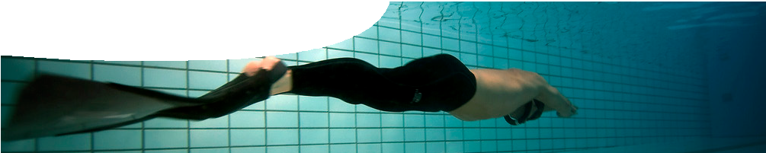
teachers guide
Adaptations 6
Freediving

Components
William Trubridge underwater glide, photo by Jayhem

 | NAME | DESCRIPTION | AUDIENCE
 | Freediving  teachers guide | Human freediving provides a context for comparing acclimatisation and adaptation. | teachers
 | Problems with pressure  background sheet | This background sheet for teachers provides information on problems of pressure when diving to depth. It includes freediving, scuba diving, and adaptations of diving animals. | teachers
 | Vertical Blue  video | This video shows world champion freediver, William Trubridge, complete an 88-metre dive. | students
 | Dangers of diving  worksheet | This three-part worksheet allows students to investigate diving abilities of freedivers, risks of diving to depth associated with pressure; and adaptations of the Weddell seal that enable it to cope with pressure at depth. | students

Purpose
To Elaborate on students’ knowledge of adaptations of air-breathing, diving animals by investigating potential hazards of diving to depth associated with pressure.

Activity summary
Outcomes
Students:
- distinguish between acclimatisation and adaptation;
- appreciate that human diving ability is restricted by structure and physiology;
- understand risks of diving associated with pressure, particularly behaviour of gases under pressure; and
- recognise structural, physiological and behavioural adaptations that enable diving animals to cope with pressure.

ACTIVITY | POSSIBLE STRATEGY
Teacher introduces the video, Vertical Blue, which features an 88 m dive by current freediving world champion, William Trubridge. | whole class or individually if resources available
Teachers distribute the three-part worksheet, Dangers of diving. The worksheet can be completed as a whole, or in parts. | individually or in small groups  completed as part of class discussion, class activity, or homework

Teachers notes
The video, Vertical Blue, depicts world champion freediver William Trubridge completing an 88 m dive.
William Trubridge currently holds the world record at 101 m in the category ‘constant weight without
fins’. In this discipline the diver competes without any assistance.

Encourage students to consider the abilities of a professional freediver in light of what they have learned regarding adaptations. The video provides an ideal opportunity to consider differences between adaptation and acclimatisation, either as a group discussion or in conjunction with part 1 of the worksheet, Dangers of diving.
To explore freediving further we recommend the websites www.verticalblue.net and www. aidainternational.org

Technical requirements
The teachers guide requires Adobe Reader (version 5 or later), which is a free download from www.adobe. com.
QuickTime version 7 or later is required to view the video. This is a free download from www.apple.com/ quicktime. A high quality MP4 version is available on CD-ROM or download from the SPICE website.

Acknowledgements
Thanks to William Trubridge, Vertical Blue (www.verticalblue. net), for providing use of his video.
Designed and developed by the Centre for Learning Technology, The University of Western Australia. Production team: Jan Dook, Alwyn Evans, Jenny Gull, Dan Hutton, Jodie Ween and Michael Wheatley. Thanks to Pauline Charman, Bob Fitzpatrick, Wendy Sanderson and Charmaine White.

Associated SPICE resources
SPICE resources and copyright
All SPICE resources are available from the Centre for Learning Technology at The University of Western Australia (“UWA”). Selected SPICE resources are available through the websites of Australian State and Territory Education Authorities.
Copyright of SPICE Resources belongs to The University of Western Australia unless otherwise indicated.
Teachers and students at Australian schools are granted permission to reproduce, edit, recompile and include in derivative works the resources subject to conditions detailed at spice.wa.edu.au/usage.
All questions involving copyright and use should be directed to SPICE at UWA.
Web: spice.wa.edu.au Email: spice@uwa.edu.au Phone: (08) 6488 3917
Centre for Learning Technology (M016) The University of Western Australia
35 Stirling Highway
Crawley WA 6009

Adaptations 6: Freediving may be used in conjunction with related SPICE resources to study structural, physiological and behavioural adaptations.

DESCRIPTION | LEARNING PURPOSE
Adaptations (overview)
This learning pathway shows how a number of SPICE resources can be combined to teach the concept of adaptations in plants and animals.
Adaptations 1: Defining adaptations  An interactive quiz encourages students to differentiate between different types of adaptation: structural, behavioural or physiological. | Engage
Adaptations 2: Emperor penguins  Students conduct experiments to model structural, physiological and behavioural adaptations of emperor penguins. | Explore
Adaptations 3: Barrow Island marsupials  Students use a learning object to investigate adaptations of four marsupials that live on Barrow Island. | Explain
Adaptations 4: Samphires  A profile diagram of a lake provides students with an opportunity to determine which species of samphire would be mostly likely to survive in particular locations. | Explain
Adaptations 5: Diving adaptations  Students use a learning object to compare and contrast physiological, structural and behavioural adaptations of air-breathing diving animals. | Explain
Adaptations 6: Freediving  Students watch a video of a human freediver and consider differences between acclimatisation and adaptation. Students review risks of diving associated with pressure. | Elaborate

