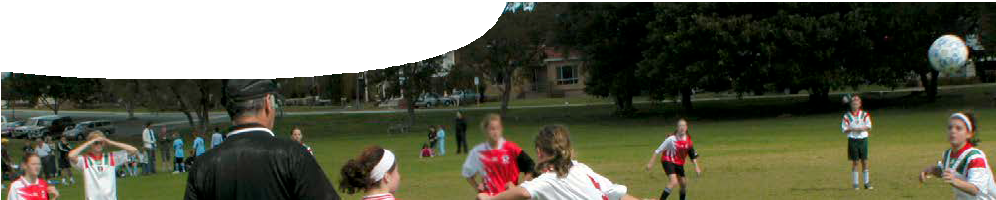
teachers guide
Forces 4:
Forces in the human body

Components

 | NAME | DESCRIPTION | AUDIENCE
 | Forces in the human body  teachers guide | This guide contains strategies that provide opportunities for students to apply their understandings of unbalanced forces to situations that affect the human body. | teachers
 | Forces in the human body  video | A video shows how an understanding of forces can be used to diagnose and provide solutions to medical issues. | students

Purpose
This resource provides students with opportunities to Elaborate on their understandings of balanced and unbalanced forces, by applying their knowledge to new contexts.

Activity summary
Outcomes
Students:
- understand that multiple forces on an object can be combined into a single force that has the same effect;
- develop an understanding that forces can be used to protect us from damaging effects of large unbalanced forces; and
- appreciate regulations about wearing seatbelts or safety helmets are based on scientific understandings of forces and motion.

ACTIVITY | POSSIBLE STRATEGY
Review students’ knowledge of forces and motion, including:  - balanced and unbalanced forces, and  - effects of forces on motion. | whole class discussion
Students watch the video, Forces in the human body, and answer questions, in the ‘Information for teachers’ section below.  This may take the form of a research project or a class/group discussion. | working individually, small groups or whole class
Teacher allocates a follow-up task to each group:  - design and construct a capsule to protect an egg in a 2 m fall; or  - plan and conduct your own investigation into how bicycle helmets, car seat belts, air bags or baby capsules protect occupants in the event of a collision. | small groups
Students present to the class features of their egg capsule and why it was successful/unsuccessful.  Or, students explain to class how bicycle helmets, car seat belts, air bags or baby capsules protect occupants from effects of large forces in a collision. | whole class

In small groups, students undertake either a design exercise or an investigation.

Design exercise
Students design a capsule to protect an egg in a 2 metre fall. To complete the task, students:
- design and construct a capsule from commonly available materials, such as: paper, cardboard, bubble wrap, drinking straws, adhesive tape …;
- test and modify their capsule design, as required, to ensure it meets its purpose;
- demonstrate to the class the success (or otherwise) of their design;
- describe (verbally, orally or visually) design features of their capsule; and
- apply their knowledge of forces to evaluate and explain the effectiveness of their design.

Investigation
Students plan and conduct an investigation into how bicycle helmets, car seat belts, air bags or baby capsules protect people from effects of large forces in a collision. To complete the task, students:
- select one of the above safety devices and research how it protects users from effects of large forces;
- explain (verbally, orally or visually) how the device minimises force on users;
- design and construct a model of the safety device, from commonly available materials, such as: paper, cardboard, bubble wrap, drinking straws, adhesive tape …;
- plan and conduct an investigation of their design; and
- evaluate the effectiveness of their design.

Technical requirements
The teachers guide requires Adobe Reader (version 5 or later), which is a free download from www. adobe.com.
QuickTime version 7 or later is required to view the video. This is a free download from www.apple.com/ quicktime. A high quality MP4 version with subtitles is available on CD-ROM or download from the SPICE website.

Acknowledgements
Thanks to Associate Professor Jacquie Alderson and Siobhán Reid (School of Sport Science, Exercise and Health, The University of Western Australia) and Noula Gibson (physiotherapist, Princess Margaret Hospital).
Designed and developed by the Centre for Learning Technology, The University of Western Australia.
Production team: Graham Baker, Jan Dook, Alwyn Evans, Jenny Gull, Paul Ricketts and Michael Wheatley, with thanks to Pauline Charman, Roger Dickinson, Bob Fitzpatrick and Wendy Sanderson.

SPICE resources and copyright
All SPICE resources are available from the Centre for Learning Technology at The University of Western Australia (“UWA”). Selected SPICE resources are available through the websites of Australian State and Territory Education Authorities.
Copyright of SPICE Resources belongs to The University of Western Australia unless otherwise indicated.
Teachers and students at Australian and New Zealand schools are granted permission to reproduce, edit, recompile and include in derivative works the resources subject to conditions detailed at spice.wa.edu.au/usage.
All questions involving copyright and use should be directed to SPICE at UWA.
Web: spice.wa.edu.au Email: spice@uwa.edu.au Phone: (08) 6488 3917
Centre for Learning Technology (M016) The University of Western Australia
35 Stirling Highway
Crawley WA 6009

Associated SPICE resources
Forces 4: Forces in the human body may be used in conjunction with related SPICE resources to address the broader topic of forces and motion.

DESCRIPTION | LEARNING PURPOSE
Forces (overview)
This learning pathway shows how a number of SPICE resources can be used to teach concepts of balanced forces, unbalanced forces and motion.
Forces 1: Introduction to force  A video stimulates students’ interest in learning about forces and motion, and elicits prior knowledge and misconceptions. | Engage
Forces 2: Investigating forces  Practical activities provide opportunities for students to explore effects of forces on the motion of objects, including those falling in Earth’s gravity. | Explore
Forces 3: Balanced and unbalanced forces  An interactive learning object enables students to explain and predict effects of balanced and unbalanced forces on objects. | Explain
Forces 4: Forces in the human body  Students apply their understanding of forces and motion to new contexts, such as: forces in the human body or designing and testing the effectiveness of a safety capsule to protect passengers in motor vehicle collisions. | Elaborate

