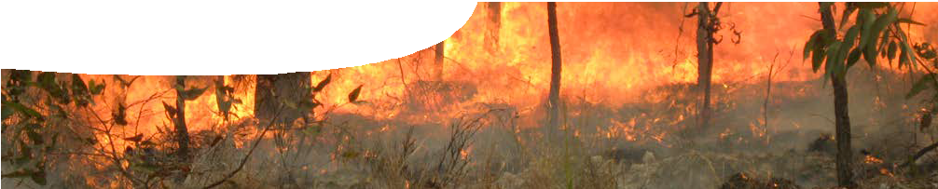
teacher guide
Bushfire science 4:
Fire in Western Australia

Components

 | NAME | DESCRIPTION | AUDIENCE
 | Fire in Western Australia  teacher guide | This guide describes how to use a learning object and video to explain impacts of fire on species in three different ecosystems. | teachers
 | Looking at bushfires  learning object | Students use this learning object to explain the impact of frequency, intensity and patchiness of fire on a variety of plant and animal species in the Kimberley, Western Desert and South West of Western Australia. | students
 | Effects of fire  worksheet | Students analyse data from the learning object, Looking at bushfires, to develop explanations of fire impacts in different ecosystems. | students

Purpose
To Explain impacts of fire on a range of plant and animal species in different regions of Western Australia.

Activity summary
Outcomes
Students:
- understand fire is an integral feature of Australian ecosystems;
- understand different ecosystems have different needs in regards to fire;
- explain seasonality and intensity of fire is important in many ecosystems in order to avoid devastating wildfires;
- understand frequency of fire is important for maintaining biodiversity in an ecosystem;
- understand patch burning enables flora and fauna to have refuge and supports maintenance of biodiversity; and
- analyse data presented in a graphical form to make judgements regarding appropriate frequency, season, intensity and mosaic burning in different ecosystems in order to maintain biodiversity.

ACTIVITY | POSSIBLE STRATEGY
Students work through the learning object, Looking at bushfires. | small groups or individuals
Students answer questions on the worksheet, Effects of fire. | Individuals or in pairs

Teacher notes
Students use the learning object, Looking at bushfires, and worksheet, Effects of fire, to understand, through data analysis, how fire affects three different ecosystems. Each ecosystem is examined to see how severity and frequency of
fire events affects plants and key animals. Further information is explored in relation to the strategy of patch burning in order to maintain biodiversity. The learning object is rich in data and challenges students to develop their own explanation of how fire impacts ecosystems.
Sustainable fire management
Sustainable fire management is based upon scientific principles aimed at conserving biodiversity whilst providing an acceptable level of protection for human life and property.
Fire is one of many complex environmental factors within an ecosystem and as such it influences the plant and animal biodiversity. Conversely, the nature of vegetation, both living and accumulations of dead material, landforms, climate and human interaction can influence the nature of fire in a landscape.
The learning object, Effects of fire, provides information about effects of different fire frequencies and severity on plant and animal communities within three study areas.
These two variables (fire frequency and fire severity) have been chosen to simplify the study of changes within these ecosystems. Other factors, such as topography, climate, soil types, time of year and previous fire histories, will influence effects of fire in an ecosystem. For example, areas that are moist all year round may provide refuge for plants that are unable to cope with frequent high intensity fires. Repeated fires that occur before plants that
re-establish from seed have flowered and developed seed may threaten the future of those plants.
For further information about guiding scientific principles for development of fire management plans for various bushfire regions (together with associated bio-regions, such as the North Kimberley or Desert), see:
http://webadmin.communitycreative.com.au/ uploads/rangelands/misc%20documents/Fire%20 Forum/RangelandsFireGuidingPrinciples_Aug15_ lowres.pdf

Technical requirements
The teacher guide and worksheet require Adobe Reader (version 5 or later), which is a free download from www.adobe.com. The worksheet is also provided in Microsoft Word format.
The learning object requires a modern browser (eg Internet Explorer 9 or later, Google Chrome, Safari
4.0+, Opera or Firefox). It can be placed on a web or file-server and run either locally or remotely in a web browser

Acknowledgements
Thanks to Corrin Everitt (Department of Parks and Wildlife), Erin Coates (Fremantle Arts Centre) and Channel 9 Perth.
Designed and developed by the Centre for Learning Technology, The University of Western Australia.
Production team: Designed and developed by the Centre for Learning Technology, The University of Western Australia. Production team: Sally Harban, Bob Fitzpatrick, Jan Dook, Gemma Slater, Anton Ball, Alwyn Evans, Dan Hutton, Paul Ricketts and Michael Wheatley, with thanks to Jenny Gull and Wendy Sanderson.

Extract from Waru (fire) video used by permission
Director: Kim Mahood
Filming: Dave Wells and Fiona Walsh Editor: Erin Coates
Translation: Desmond Taylor
Producer: Erin Coates, Fremantle Arts Centre
Footage contained in this video was shot during Martu ranger trips to care for country in the Western Desert.
Special thanks to Muuki Taylor, Wokka Taylor, Nancy Taylor, the staff at Kanyirninpa Jukurrpa and CSIRO for assisting with the content of this video.
The project was supported by BHP Billiton, Fremantle Arts Centre, the City of Fremantle and Martumili Artists, the Shire of East Pilbara.

SPICE resources and copyright
All SPICE resources are available from the Centre for Learning Technology at The University of Western Australia (“UWA”). Selected SPICE resources are available through the websites of Australian State and Territory Education Authorities.
Copyright of SPICE Resources belongs to The University of Western Australia unless otherwise indicated.
Teachers and students at Australian and New Zealand schools are granted permission to reproduce, edit, recompile and include in derivative works the resources subject to conditions detailed at spice. wa.edu.au/usage.
All questions involving copyright and use should be directed to SPICE at UWA.
Web: spice.wa.edu.au Email: spice@uwa.edu.au Phone: (08) 6488 3917
Centre for Learning Technology (M016) The University of Western Australia
35 Stirling Highway
Crawley WA 6009

Associated SPICE resources
Bushfire science 3: Oxidation may be used in conjunction with related SPICE resources to teach aspects of biodiversity and oxidation.

DESCRIPTION | LEARNING PURPOSE
Bushfires (overview)
Bushfires 1: Fiery failures  A lighthearted look at four environmental catastrophes through history brings out common connections with fire and combustion. | Engage
Bushfires 2: Exploring ecosystems  Students use sampling techniques to investigate a local ecosystem, and an interactive learning object to explore biodiversity in contrasting Western Australian ecosystems. | Explore
Bushfires 3: Oxidation  Students investigate combustion and other oxidation reactions. | Explore
Bushfires 4: Fire in Western Australia  Students use an interactive learning object to examine effects of fire on three Western Australian ecosystems. | Explain
Bushfires 5: Oxidation and combustion  Students use an interactive learning object to visualise oxidation reactions at a molecular level. | Explain
Bushfires 6: Fire stories  Students read three interactive stories about human use of fire and its consequences in different parts of Western Australia. | Elaborate

