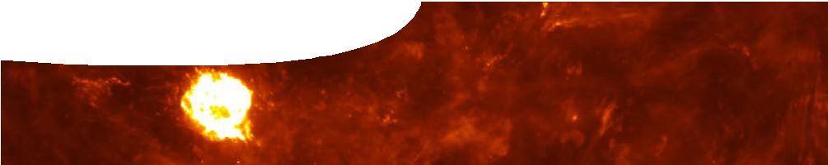
teachers guide
Measuring the Universe 4:
Cosmic distance ladder

Components

 | NAME | DESCRIPTION | AUDIENCE
 | Cosmic distance ladder  teachers guide | The guide includes information about how to use the factsheets and worksheet contained within this resource. | teachers
 | Explanation of the cosmic distance ladder  background sheet | Four rungs on the cosmic distance ladder are explained in detail: stellar parallax; Cepheid variables; Type 1a supernovae; and cosmological red-shift. | teachers
 | Climbing the cosmic distance ladder  fact sheet | This fact sheet shows the scales on which different measurement techniques operate. Collectively, these techniques are known as the cosmic distance ladder. | students
 | Death of a star  fact sheet | Certain types of supernovae are instrumental in measurements across the Universe. This fact sheet explains how supernovae form. | students
 | Travelling the Universe  worksheet | How big is the Solar System? How far away are the stars? This worksheet explores distances in the Universe through a practical activity and questions. | students

Purpose
To extend students understanding of how astronomers use a variety of techniques to measure the Universe, and construct a scale known as the cosmic distance ladder.

Activity summary
Outcomes
Students:
- describe how astronomers use a variety of extra- terrestrial objects to build the cosmic distance ladder;
- describe how astronomers use direct and indirect measurement techniques to build the cosmic distance ladder;
- explain the progressive steps of the cosmic distance ladder; and
- use a scale to build a model of the solar system, and perform calculations involving astronomical units.

ACTIVITY POSSIBLE STRATEGY
Distribute the fact sheets, Climbing the cosmic distance ladder and Death of a star. Record, on a placemat, information under the headings ‘direct measurement’, ‘indirect measurement’, ‘Cepheid variables’ and ‘supernovae’. | Students work in groups on a placemat activity.
Distribute the worksheet, Travelling the Universe. In part one of the worksheet, students construct a model of the Solar System that  addresses the size of the Solar System, and relative sizes of planets and the Sun. | whole class discussion and activity
Part two of the worksheet contains more challenging questions that relate to concepts explored in the fact sheets, and calculations using astronomical units. | individual or pairs

Technical requirements
The teachers guide, fact sheets, background sheet and worksheet require Adobe Reader which is a free download from www.adobe.com. The worksheet is also provided in Microsoft Word format.

Acknowledgements
Designed and developed by the Centre for Learning Technology, The University of Western Australia.
Production team: Leanne Bartoll, Alwyn Evans, Bob Fitzpatrick, Paul Luckas, Jodie Ween and Michael Wheatley, with thanks to Roger Dickinson, Pauline Charman, Jenny Gull and Wendy Sanderson.

SPICE resources and copyright
All SPICE resources are available from the Centre for Learning Technology at The University of Western Australia (“UWA”). Selected SPICE resources are available through the websites of Australian State and Territory Education Authorities.
Copyright of SPICE Resources belongs to The University of Western Australia unless otherwise indicated.
Teachers and students at Australian schools are granted permission to reproduce, edit, recompile and include in derivative works the resources subject to conditions detailed at spice.wa.edu.au/usage.
All questions involving copyright and use should be directed to SPICE at UWA.
Web: spice.wa.edu.au Email: spice@uwa.edu.au Phone: (08) 6488 3917

Centre for Learning Technology (M016) The University of Western Australia
35 Stirling Highway
Crawley WA 6009

Associated SPICE resources
Measuring the Universe 4: Cosmic distance ladder may be used in conjunction with related SPICE resources to address the broader topic of tools used by astronomers to measure distances in the Universe.

DESCRIPTION | LEARNING PURPOSE
Measuring the Universe
This learning pathway shows how a number of SPICE resources can be combined to teach aspects of how astronomers measure distances in the Universe.
Measuring the Universe 1: Transient astronomy  A video describes mysterious gamma ray bursts, which were first observed in the sixties. | Engage
Measuring the Universe 2: Virtual observatory  Students use a learning object to simulate processes used by astronomers to discover supernovae. | Explore
Measuring the Universe 3: Distances in the Universe  A presentation and worksheet introduce different methods used by astronomers to measure distances in the Universe. | Explain
Measuring the Universe 4: The cosmic distance ladder  The cosmic distance ladder is the term used to describe the collection of techniques used by astronomers to measure distances in the Universe. Measurements established by one technique are used to calibrate techniques that measure greater distances. | Elaborate

