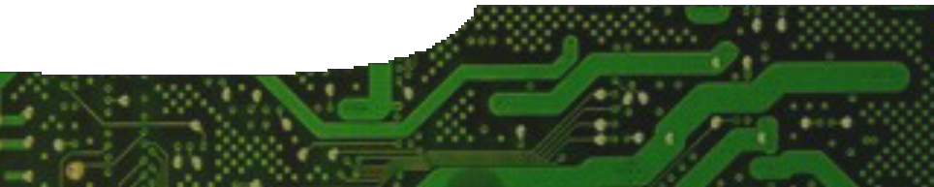
teacher guide

Electrical circuits 4:
Circuit rules

Components

 | NAME | DESCRIPTION | AUDIENCE
 | Circuit rules  teacher guide | This guide includes suggestions about how to use the worksheets to investigate Ohm’s law. | teachers
 | Circuit simulator  learning object | This learning object is an alternative to using practical procedures to explore resistance, potential difference and current in circuits. | students
 | Series and parallel  worksheet | This worksheet accompanies the learning object, Circuit simulator. | students
 | Circuit calculations  worksheet | This worksheet examines quantitative aspects of Ohm’s law (V = IR) and current in simple circuits. | students

Purpose
To extend the concept of electrical current to include quantitative aspects of Ohm’s law and rate of charge drift.

Activity summary
Outcomes
Students:
- use the formula I = q / t to solve problems associated with current;
- use V = I R to solve problems associated with Ohm’s law;
- manipulate components of an electrical circuit, read meters, and tabulate and analyse data;
- use rules for resistance to calculate total resistance in a circuit; and
- use data displayed in a learning object to explain relationships between potential difference, current and resistance in series and parallel circuits.

ACTIVITY POSSIBLE STRATEGY
The learning object, Circuit simulator, may be used to consolidate concepts of resistance in a circuit. Students may use it to obtain information about potential difference, current and resistance in series and parallel circuits. | individual or small group
Students complete the worksheet, Series and parallel, as they use the learning object. | individual
Alternatively, students complete an experiment to verify Ohm’s law. Laboratory manuals and websites have descriptions of suitable experiments. | small groups, or teacher demonstration
The worksheet, Circuit calculations, examines quantitative aspects of Ohm’s law and relationships between current and charge in simple circuits. | individual

Teacher notes
A procedure to verify Ohm’s law is a common experiment written up in many physics laboratory manuals and websites. Any version that is pitched at secondary level would be suitable for students to attempt, or for teachers to demonstrate.
The worksheet, Circuit calculations, need be used only if other sources of problems are not available. There are many problem books that students may use to practise using formulae for electrical work and power.
As an alternative, worksheets may be adapted and used for assessment.

Circuit simulator
- The lamp in the learning object has a resistance of
7.2 Ω. This value ignores any non-ohmic effects of the filament.
- The lamp is rated at 20 W. Its brightness varies depending on the current in the circuit.

Circuit calculations
The following rules relating to potential, current and resistance are important concepts that students encounter when completing the worksheet.
- At any node (junction) in an electrical circuit, the sum of currents flowing into a node is equal to the sum of currents flowing out of that node.
- The sum of electrical potential differences around any closed circuit is equal to the total potential in the circuit.
- The currents in branches of a parallel circuit are inversely proportional to the size of the resistances.
Circuit diagrams may be drawn to represent circuits students construct.

Technical requirements
The learning object requires a modern browser (eg Internet Explorer 9 or later, Google Chrome, Safari
4.0+, Opera or Firefox). It can be placed on a web or file-server and run either locally or remotely in a web browser.
The teacher guide and worksheets require Adobe Reader (version 5 or later), which is a free download from www.adobe.com. The worksheets are also provided in Microsoft Word format.

Acknowledgements
Designed and developed by the Centre for Learning Technology, The University of Western Australia.
Project team: Anton Ball, Alwyn Evans, Bob Fitzpatrick, Dan Hutton and Michael Wheatley.

SPICE resources and copyright
All SPICE resources are available from the Centre for Learning Technology at The University of Western Australia (“UWA”). Selected SPICE resources are available through the websites of Australian State and Territory Education Authorities.
Copyright of SPICE Resources belongs to The University of Western Australia unless otherwise indicated.
Teachers and students at Australian and New Zealand schools are granted permission to reproduce, edit, recompile and include in derivative works the resources subject to conditions detailed at spice. wa.edu.au/usage.
All questions involving copyright and use should be directed to SPICE at UWA.
Web: spice.wa.edu.au Email: spice@uwa.edu.au Phone: (08) 6488 3917
Centre for Learning Technology (M016) The University of Western Australia
35 Stirling Highway
Crawley WA 6009

Associated SPICE resources
Electrical circuits 4: Circuit rules may be used with related SPICE resources to address the broader topic of electricity.

DESCRIPTION | LEARNING PURPOSE
Electrical circuits (sequence overview)
This learning pathway shows how a number of SPICE resources can be combined to teach the topic of electricity.
Electrical circuits 1: Lightning  Students are engaged in the topic of electricity through observing and exploring lightning. | Engage
Electrical circuits 2: Static electricity  Students explore the effects of charge through a series of laboratory experiments. | Explore 1
Electrical circuits 3: Current electricity  Students construct circuits using simple electrical components. | Explore 2
Electrical circuits 4: Circuit rules  Students use an interactive learning object to record observations and derive rules for circuits. | Explain 1
Electrical circuits 5: Measuring electricity  Models and analogies are introduced to help students understand concepts around properties of electricity and how it is quantified. | Explain 2
Electrical circuits 6: Bioelectricity  Four fact sheets and a video provide examples of how electricity is used in living organisms, including humans. | Elaborate

