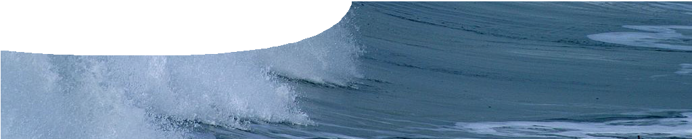
teachers guide
Buffers 4:
Buffering in the ocean

Components

 | NAME | DESCRIPTION | AUDIENCE
 | Buffering in the ocean  teachers guide | This guide shows how students can use their understanding of pH and buffering in the context of ocean acidification. | teachers
 | Researching ocean buffering  fact sheet | Students examine the work of two scientists, Robert King and Prof Malcolm McCulloch, involved in researching different aspects and consequences of ocean acidification. | students
 | Ocean acidification  worksheet | Students use their knowledge of buffers to interpret diagrams and answer questions about ocean acidification. | students
 | How does the ocean buffer?  procedure sheet | An experiment compares the buffering ability of tap water and seawater, under varying levels of carbon dioxide.  Discussion questions are included. | students

Purpose
To Elaborate on student understandings of buffering by examining ocean acidification and how rising levels of acidity may endanger marine life.

Activity summary
Outcomes
Students:
- understand that ocean buffering is a complex and open system,
- describe how sea water is buffered by the carbonic acid/hydrogencarbonate equilibrium,
- explain how an equilibrium shifts when changes are made to an environment,
- understand there is a limit beyond which buffers are no longer able to stabilise pH in a closed system, and
- apply their knowledge of buffering to real world situations.

ACTIVITY POSSIBLE STRATEGY
Students read the fact sheet, Researching ocean buffering, then complete a ‘3-2-1 summary’ (see Teachers notes below). Share responses as a class. | individual, then share with class
Students complete the worksheet, Ocean acidification, using the fact sheet, Researching ocean buffering, as a reference.  Discuss answers as a class. | individual, then share with class
Students complete the experiment outlined on the procedure sheet,  How does the ocean buffer? This can be spread over two lessons if needed. Students answer questions after each part, as well as discussion questions at the end of the worksheet. | small groups, then individuals
Discuss answers to questions. | whole class

Teachers notes
In the procedure, How does the ocean buffer?, a sample of seawater is required. It is possible to store a sealed sample of seawater in a fridge for months. Remove the lid, then allow the sample to come to room temperature and mix with air before using.
3-2-1 summary
In a 3-2-1 summary, students list: 3 things I learned today, 2 things I found interesting, and 1 question I still have.

