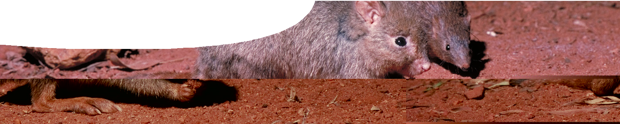
teachers guide
Adaptations 3:
Barrow Island marsupials

Components

 | NAME | DESCRIPTION | AUDIENCE
 | Barrow Island marsupials  teachers guide | This guide provides a framework to use the learning object, Barrow Island explorer, to investigate water  conserving adaptations of marsupial species living in an arid environment. | teachers
 | Barrow Island explorer  learning object | Students investigate behavioural and physiological adaptations of four marsupial species living on Barrow Island, which enable them to survive arid conditions. | students
 | Life in the dry  worksheet | Students record data from the learning object, and answer questions about the adaptations of Barrow Island marsupials. | students
 | Adaptations to an arid climate  background sheet | This background sheet for teachers describes regulation of body water by the kidney, and hormonal responses to varying water inputs. | teachers

Purpose
To Explain physiological and behavioural adaptations for water conservation in four species of marsupials living in arid conditions on Barrow Island.

Activity summary
Outcomes
Students:
- understand that strategies for water conservation vary between different marsupial species;
- identify physiological and behavioural adaptations relative to water conservation; and
- recognise that physiological and behavioural adaptations enable animals to survive in arid environments.

ACTIVITY | POSSIBLE STRATEGY
Students use the learning object, Barrow Island explorer.  As they work through the learning object, students answer questions on the worksheet, Life in the dry. | individually or in pairs
Students complete worksheet. | whole class discussion of answers

Teachers notes
The learning object enables students to examine
water-conserving adaptations of four marsupial species living on Barrow Island. An investigative component
is included that allows students to discover landscapes and climatic conditions on Barrow Island, through exploration of an interactive map.
Students record physiological and behavioural data, from the learning object, onto the worksheet and use this information to make decisions about conservation outcomes for each marsupial species.

Key conclusions students should reach when using the learning object and worksheet are that all four marsupials depend on adaptations to cope with the arid environment of Barrow Island.
Both burrowing bettongs and black-flanked rock wallabies rely principally on behavioural adaptations (nocturnal activity, use of burrows or caves) to avoid water loss. Euros and spectacled hare-wallabies have physiological adaptations to conserve water, with the spectacled-hare wallaby displaying remarkable physiological regulation of body water volumes.

Technical requirements
The learning object requires Adobe Flash (version 9 or later), which is a free download from adobe.com. The teachers guide, background sheet and worksheet require Adobe Reader (version 5 or later), which is a free download from www.adobe.com. The worksheet is also available in Microsoft Word format.

SPICE resources and copyright
All SPICE resources are available from the Centre for Learning Technology at The University of Western Australia (“UWA”). Selected SPICE resources are available through the websites of Australian State and Territory Education Authorities.
Copyright of SPICE Resources belongs to The University of Western Australia unless otherwise indicated.
Teachers and students at Australian schools are granted permission to reproduce, edit, recompile and include in derivative works the resources subject to conditions detailed at spice.wa.edu.au/usage.
All questions involving copyright and use should be directed to SPICE at UWA.
Web: spice.wa.edu.au Email: spice@uwa.edu.au Phone: (08) 6488 3917
Centre for Learning Technology (M016) The University of Western Australia
35 Stirling Highway
Crawley WA 6009

Acknowledgments
Barrow Island explorer
- video and images supplied by Chevron Australia
- ‘tidal flats’, ‘Biggada Creek’, ‘euro at seaside’, ‘mangroves’, ‘nodding donkey’, ‘perentie looking for shade’ and ‘euros seeking out shade’ by Amy Gluyas, All Rights Reserved, used by permission, www.flickr. com/photos/43652168@N00/
- ‘Triodia hummock grasslands at Karijini National Park, WA’, by Hesperian, CC-BY-SA-3.0, commons. wikimedia.org/wiki/File:Triodia_hummock_ grassland.jpg
- ‘perentie eating burrowing bettong’ by Don Bradshaw, All Rights Reserved, used by permission.
- climate data from Bureau of Meteorology, Australian Government, CC-BY-3.0, www.bom.gov.au/
- ‘Sometimes’ by Airtone, CC-BY-NC-Sampling + 1.0, CCMixter, ccmixter.org/files/airtone/23809
- ‘Babylon’, ‘Infados’ and ‘Night cave’ by Kevin MacLeod, CC-BY-3.0, incompetech.com
- ‘Snowgeese at Hagerman Wildlife Reserve’ by gurdonark, CC-BY-NC-3.0, dig.ccmixter.org/

Banner image: ‘Bettongs on Barrow Island’ by Chevron Australia, used by permission.

Thanks to Emeritus Professor Don Bradshaw (School of Animal Biology, UWA) and Chevron Australia.
Designed and developed by the Centre for Learning Technology, The University of Western Australia.
Production team: Anton Ball, Jan Dook, Alwyn Evans, Jenny Gull, Dan Hutton, Emma Pointon, Jodie Ween and Michael Wheatley, with thanks to Pauline Charman, Bob Fitzpatrick, Charmaine White and Wendy Sanderson.

Associated SPICE resources
Adaptations 3: Barrow Island marsupials may be used in conjunction with related SPICE resources to study structural, physiological and behavioural adaptations.

DESCRIPTION | LEARNING PURPOSE
Adaptations (overview)
This learning pathway shows how a number of SPICE resources can be combined to teach the concept of adaptations in plants and animals.
Adaptations 1: Defining adaptations  An interactive quiz encourages students to differentiate between different types of adaptation: structural, behavioural or physiological. | Engage
Adaptations 2: Emperor penguins  Students conduct experiments to model structural, physiological and behavioural adaptations of emperor penguins. | Explore
Adaptations 3: Barrow Island marsupials  Students use a learning object to investigate adaptations of four marsupials that live on Barrow Island. | Explain
Adaptations 4: Samphires  A profile diagram of a lake provides students with an opportunity to determine which species of samphire would be mostly likely to survive in particular locations. | Explain
Adaptations 5: Diving adaptations  Students use a learning object to compare and contrast physiological, structural and behavioural adaptations of air-breathing diving animals. | Explain
Adaptations 6: Freediving  Students watch a video of a human freediver and consider differences between acclimatisation and adaptation. Students review risks of diving associated with pressure. | Elaborate

