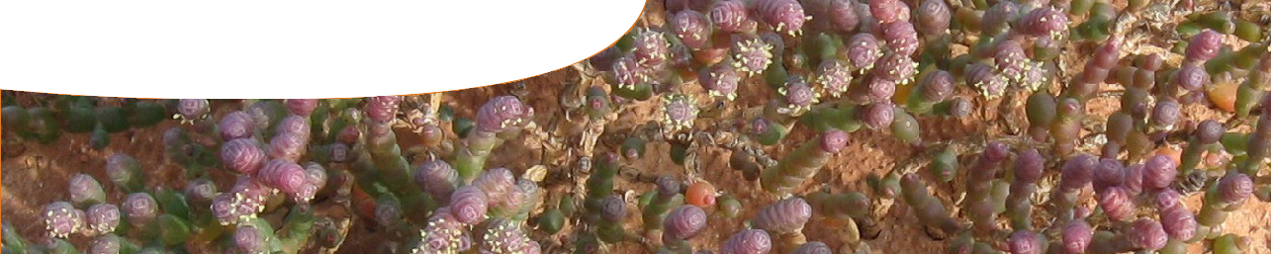
fact sheet
Surviving extremes

Samphires are succulent, salt-loving plants that grow in hostile environments, like coastal
estuaries, tidal flats, waterlogged saline land and shores of inland salt lakes. A key feature of many of these environments is salinity. Most plants are unable to survive in these environments, but samphires are equipped with adaptations that allow them to thrive.

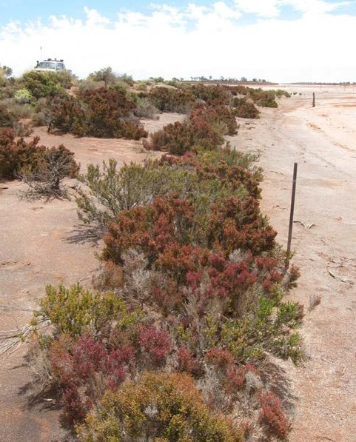
Mixed Tecticornia zonation, Bindy Datson (Actis Environmental Services)
Tecticornia mellaria, Bindy Datson (Actis Environmental Services)

In Australia, samphires are the dominant vegetation around inland saline lakes. Conditions around
these lakes vary. Zones differ in levels of salinity and range from waterlogged to dry sandy dunes. There can be a large variation in frequency and duration of water inundation in different zones. Each samphire species has unique adaptations that enable them to grow in preferred zones around inland lakes.

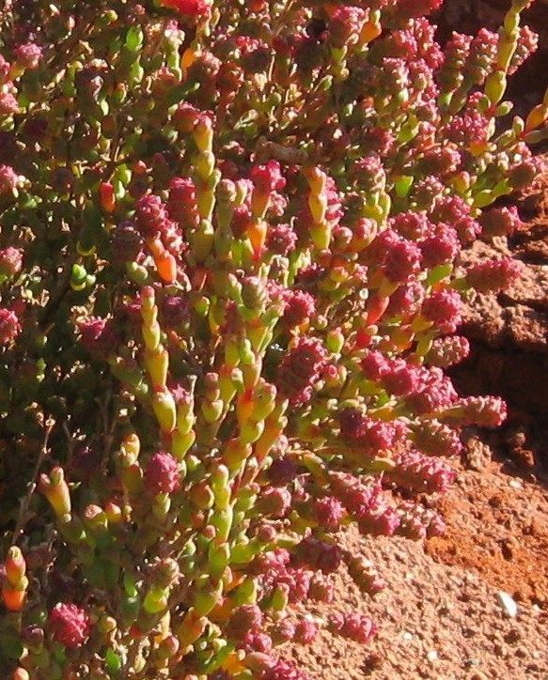
Tecticornia peltata, Bindy Datson (Actis Environmental Services)



And I’d like a side salad of samphire with that…
Young stems of coastal samphire are also known as sea asparagus. In Europe, samphires have been used as a food source for centuries. Rich in vitamins and minerals, it’s long been considered something of a health tonic. Even Henry VIII was partial to samphire, and his servants risked their lives to abseil down cliffs to collect it. Convicts on their way to Australia ate it pickled to prevent the dreaded scurvy.
Today, in some places, you’ll find samphire in supermarkets and on the menu of high-end restaurants where the juicy, nutritious succulent is served fresh, blanched or stir-fried.
© Becs Rivett, Laythetable.com

Effects of excess salt

All plants need salts to survive but too much salt can impede normal cellular functions.
- Salt affects osmosis

salt

soil
cell in root

no water flow
salt

soil
cell in root
Plant cells take up water via osmosis. Water is lost through leaves due to transpiration, which causes roots to draw
up more water from the soil. If water in the soil is highly saline, osmosis can cause loss of water from cells because concentration of ions in the water is higher than the concentration of ions in a plant. This damages root cells and will limit the amount of water that the plant can take up from the soil.
Plants also use energy trying to exclude harmful salts

from entering cells and also in pumping ions into central vacuoles of cells for safe storage.
Under normal conditions, osmosis results in a net flow of water from soil to cells in roots.
In saline conditions, there is no osmotic flow of water to plant cells.

- 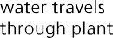Salt limits nutrient uptake
Plants take up water through their roots during transpiration. High levels of salt (ie sodium and chloride) in water inhibit uptake of other essential nutrients, such as potassium, from soil.
Enzymes control chemical reactions taking part in plant cells. High salt levels can also disturb action of enzymes resulting in stress for the plant.


How samphires cope with salt

- Vacuoles store salt
Vacuoles are spaces inside plant cells usually used for storage. Locking away excess salt in vacuoles counteracts osmotic effects of salinity so plants can take up water and nutrients.

- Succulent tissues store salt
Samphires accumulate salt in large succulent cells in their juicy stems. The stems are articulated. Salts can build up in older parts of the stem, which then fall off, effectively removing excess salt.
NOTE: Some other halophytic plants (plants that can grow in salty conditions) also possess salt bladders or salt glands to pump salts out of their leaves, but samphires are remarkably salt-tolerant even without these specialised mechanisms for salt removal.

Effects of drought

Plants need water for survival. Lack of water affects almost every physiological process in a plant.

Drought compromises photosynthesis

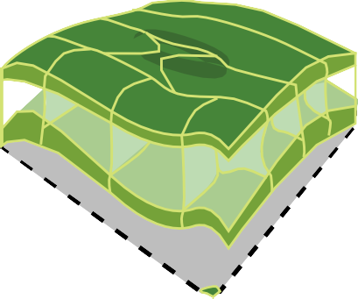Plants limit water loss during drought by closing leaf stomata and reducing transpiration. But this also reduces plants’ capacity to absorb carbon dioxide and photosynthesise, causing stress and limiting growth.
- Drought limits nutrient uptake
Plants need water for metabolism and transportation of nutrients. Restricted uptake of water reduces these capabilities leading to stress and lack of growth.
Carbon dioxide enters, and water and oxygen exit, through a leaf’s stomata.

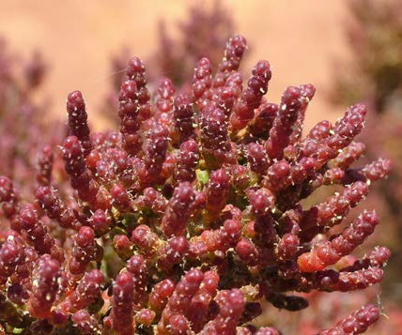
photosynthesis called C4 carbon fixation. This process requires a specialised arrangement of cells within their leaves, called Kranz anatomy. This arrangement uses more energy (ATP) but requires much less water. Water-saving occurs as C4 is a carbon-concentrating mechanism that enables
plants to function with stomata partially closed. All other samphires use C3 photosynthesis.
Tecticornia halocnemoides subsp. catenulata, Bindy Datson (Actis Environmental Services)
2. Using less water during photosynthesis
One samphire species uses a water-saving version of
How samphires cope with drought

1. Reduced surface area and increased water storage
Samphires lack true leaves. Instead they have a modified succulent stem. Reducing surface area of green photosynthetic tissues (ie having succulent stems rather than leaves) limits the amount of water lost during transpiration.
Samphires are able to store water in their stems.

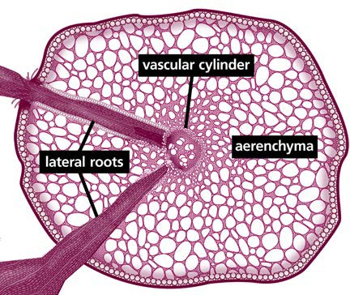

Effect of floods

All plants need water to survive but too much can be harmful.

Flooding restricts photosynthesis
Plants need light and carbon dioxide for photosynthesis, but underwater these are limited. Inability to photosynthesise adequately leads to stress from sugar ‘starvation’, slow growth, and eventually death.

Flooding limits oxygen uptake
Plants need oxygen for cellular respiration to provide energy for root growth and function. Waterlogged soils have very low levels of oxygen causing stress, lack of growth and potentially death. Furthermore, waterlogged soil can accumulate toxins, which can further damage roots.
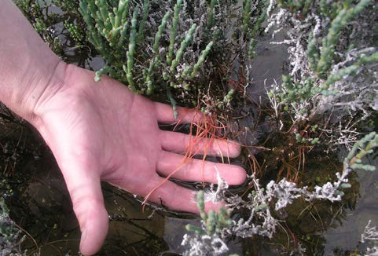
How samphires cope with flooding

- Adventitious roots
Some species of samphire grow adventitious roots when in flooded soils. Rather than growing out of normal roots, adventitious roots grow from the stem. Adventitious roots increase root biomass and have improved functioning in flooded conditions, as described below.

- Aerenchyma for gas exchange Some samphires have specialised intercellular gas-filled spaces in their roots, called
aerenchyma. These form hollow channels that
allow diffusion of oxygen down the roots, preventing oxygen stress under waterlogged conditions. That is, aerenchyma acts like a snorkel to provide oxygen so that roots can ‘breathe’.
adventitious roots on Tecticornia pergranulata, Bindy Datson (Actis Environmental Services)
- Photosynthetic roots
A few samphire species have chloroplasts in root cells of adventitious roots. These roots can photosynthesise. This adaptation allows a completely submerged plant to continue to
produce oxygen needed for respiration. Roots also contain enzymes needed for carbon fixation so that during the day they can make their own sugars.

