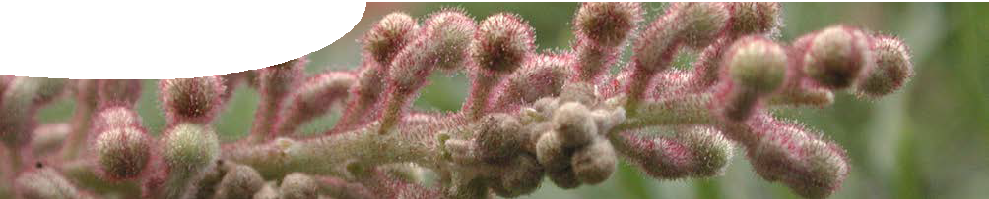
fact sheet
Super-sensitive plants

In the School of Plant Biology at The University of Western Australia, Dr Patrick Finnegan is studying the super-sensitivity to phosphate of some native Australian plants.
Phosphorus is one of the most limiting mineral nutrients to plant productivity worldwide. As a general rule, Australian soils are very low in phosphorus and many native Australian plants have evolved efficient mechanisms to take up phosphorus through root hairs.
Native Australian plants, such as Hakea prostrata and Grevillea crithmifolia, are super-efficient in extracting phosphate from the soil. This is unlike European crop plants that are poor at extracting naturally occurring phosphate and usually
require phosphate fertiliser to be added to the soil. The downside of super-efficient phosphate extraction is that native plants like Hakea prostrata can actually be poisoned if extra phosphate is added to the soil.

Why is this important?
If scientists understand how super-efficient plants take-up, use and store phosphate they may be able to apply that knowledge to develop crop plants that are less reliant on fertilisers. If crops become more phosphate- efficient, agriculture would be more sustainable and environmentally friendly.
This is an important area of research as non-renewable reserves of natural phosphate (such as phosphate rock) will eventually run out. Adding extra phosphate to soils via fertilisers is also expensive and can lead to problems such as algal blooms in waterways.

Use of radioisotopes
Patrick’s research focuses on the uptake and transfer mechanism of phosphate in native plants. To do this he has a choice of two radioactive isotopes of phosphorus, phosphorus-32 (32P) and phosphorus-33 (33P).
Both isotopes of phosphorus are beta-emitters. 33P is used in preference due to health and safety issues, as it is a weaker emitter than 32P. The half- life of 33P (3.5 weeks) is also longer than that of 32P (14.3 days).
In these experiments 33P is detected using liquid scintillation counting. This uses the characteristic spectral behaviour of beta emissions from 33P. The sample to be measured is placed in a vial containing a scintillant fluid. This is a mixture of fluorophores that absorb radioactivity from the sample and convert that energy to light which is detected by a counter. The counter registers the number of flashes per minute within the beta energy range.
An advantage of using radioactivity as a tag or tracer is that the molecule of interest is directly labelled, so that phosphorus can be traced. This means there minimal disturbance to the system and measurements are more realistic.

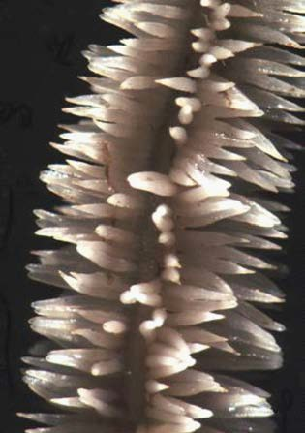
Photo: Patrick Finnegan
Root hairs on Hakea prostrata

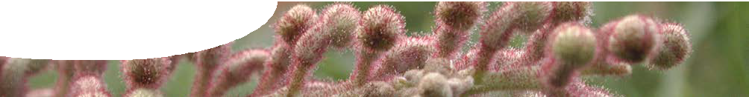
fact sheet
Super-sensitive plants

How is the radioisotope used?
33P is used to monitor how Hakea prostrata and Grevillea crithmifolia acquire phosphate. Plants are grown hydroponically (in a solution), which makes it easier to control nutrient addition. The radioisotope is added
to the hydroponic system and after a short period of time (minutes to a few hours) phosphate uptake by the plants is measured. The amount of radioisotope left in the fluid is also recorded.
To measure radioactive uptake, the plant is chopped into its component parts of roots and leaves etc. Various bits of plant are individually mashed up and put through a series of extractions to separate soluble and insoluble molecules. Scintillant is added to these extractions which are then put into the counter. The reason for separating soluble and insoluble fractions of the plant is to find out whether phosphorus remains as small molecule, or becomes incorporated into storage compounds within the plant.
Using these methods, Patrick traces the pathway of phosphate uptake in plants. 33P labelling of phosphate allows him to address questions such as ‘In what parts of a plant does phosphate travel?’ and ‘Where is phosphate stored in the plant?’.

Research results

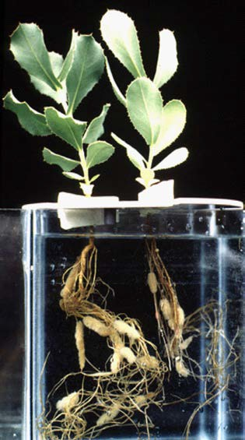
Photo: Patrick Finnegan

Research by Patrick’s collaborator, Professor Hans Lambers, has found that plants tolerant to phosphate fertiliser tend to keep phosphate in their roots. However, many Australian native plants that are super-sensitive to phosphate transport phosphate through the plant and into leaves, where it accumulates and may poison the plant.

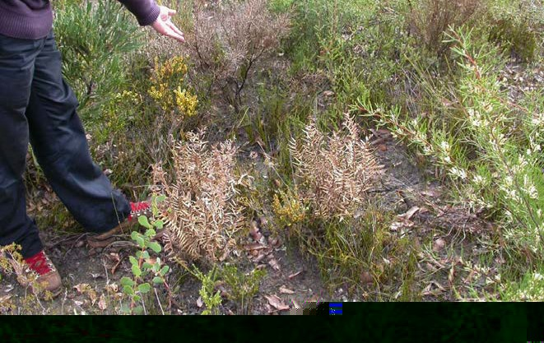
Plants affected by dieback
Photo: Professor Hans Lambers

A link between dieback and phosphorus
Whilst research is in its early days, it seems that there’s a link between phosphate uptake, its distribution and Phytophthora cinnamomi, a type of water mould that causes the deadly plant disease ‘dieback’. In species where phosphate is distributed throughout the whole plant, Phytophthora cinnamomi is lethal. The micro-organism has a reduced effect in plants where phosphate is stored in roots. Further proof of this link is that an analogue of phosphate, known as phosphite, reduces the impact of the disease when given as an alternative to phosphate.
Understanding processes and mechanisms involved in phosphate use by native plants may lead to a solution to dieback in our forests, as well as improved sustainability of our agricultural practices by reducing fertiliser use.

