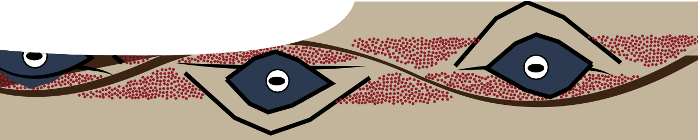
fact sheet
Stories in Aboriginal art

An aspect of Aboriginal art that is important to understand before commencing your painting, is the place of art in Aboriginal communities, and reasons the people create many of their paintings. Art has a central place in Aboriginal culture as it replaces the written word in recording most aspects of life.

Here are some points to discuss.
- Aboriginal art is different in various parts of our country. This is because different Language groups (groups of people who live in the same area and speak the same language) paint about their own cultures, and their spiritual beliefs linked to The Dreaming.

- For Aboriginal people, The Dreaming is the basis for all life, and is the focus for much of their art.

- Dreaming stories tell of creation of the world, including aspects like: landforms; watercourses; fire; animals and their features; stars and the heavens; and so on.

- Dreaming stories also teach each generation about aspects of life and culture, for example: relationships in communities; kinship; respect; laws; behaviour; hunting and gathering …

- Aboriginal paintings usually tell stories about the artist’s land and people, provide historical records, and many also pay homage to aspects of The Dreaming.

- We must be sensitive to, and respect, the spirituality and complexity of traditional Aboriginal art, as aspects may be sacred.

- Many symbols used in Aboriginal art are a way to record sacred/secret events and may only be used by the Language group to which the artist belongs – sometimes only the men, or in other cases only the women. These symbols may not be reproduced and used by non-Aboriginal people.

- Commonly recognised symbols, used in stories for Aboriginal children, depicting everyday events (eg tracking, campsites, water courses, bush tucker …), may be used in classrooms, and by the general public.

- Different Aboriginal groups may use similar symbols in a variety of ways (eg concentric circles and squares), but, if you use these general symbols, don’t paint them in the sacred ochre colours.

- If you’re in doubt about using particular symbols, your teacher may check with local Aboriginal Elders.

- More recent Aboriginal artworks are often a blend of traditional and contemporary techniques.

ast1037 | Feeding relationships 6: Stories in Aboriginal art (fact sheet) developed for the Department of Education WA
© The University of Western Australia 2012 for conditions of use see spice.wa.edu.au/usage version 1.1 revised November 2015 page 1 Licensed for NEALS

