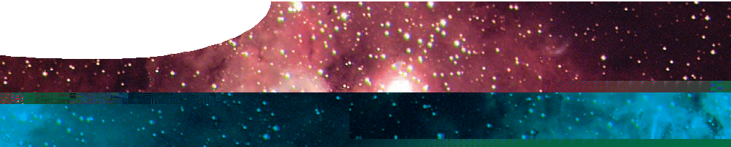
quick guide
Stellarium

Stellarium is an interactive planetarium program that allows you to explore the night sky at any location on Earth and at any time of the year. The following steps will help you find your way around the program.

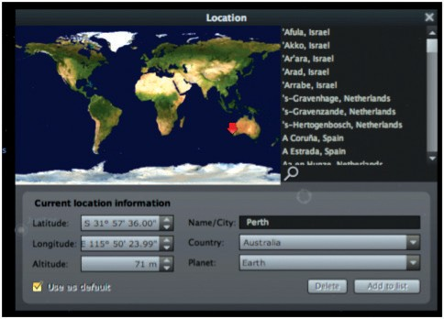
Set your location
Stellarium’s default location is Paris, France, but it can be reset to any location. To set it to your location, press F6 (or select the star icon in the left tool bar) to open the Location window.
Select your location by clicking on the map or by searching for a nearby city.
Alternatively, you may create a new location by manually entering your latitude, longitude and altitude.
Select Use as default.

Set the date and time
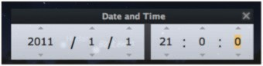
When Stellarium starts up it uses the date and time of your computer’s clock. However, you can set the date and time to any values you wish – past or future. To do this, press 7 to stop time, then F5 to display the date/ time panel. Use up/down arrows to set date and time to your chosen values, such as 1 January 2011, 21:00:00 (9.00 pm).
To return to the present date and time, press 8.

Set your viewing options
Select icons in the bottom toolbar or use the keyboard actions to add constellation lines (C), labels (V) and art forms (R); add the equatorial (E) grid; ‘see through’ the ground (G); show cardinal points (Q); remove the effect of daylight (A); add nebula and galaxy names (N); add planet names (P); and move a selected object to centre screen (spacebar).

Function keys may be used to customize appearance.

F1 | help | F4 | set sky and viewing options
F2 | configure Stellarium | F5 | set date and time
F3 | search for an object | F6 | set your location

Note: on Macintosh computers, press fn at the same time as the function key.

Look around
Click and drag the mouse, or use arrow keys, to look at different parts of the sky. Press A to turn off atmospheric effects (ie turn off daylight). Press N to show galaxies and nebulae and P to show planets.

Select an object
Click the left mouse button on an object to select it (the right mouse button deselects it). The spacebar centres an object on screen.
Information displayed for selected objects may include the type of object, its magnitude (brightness), location in the sky (RA/ DE or Az/Alt) and distance from Earth.
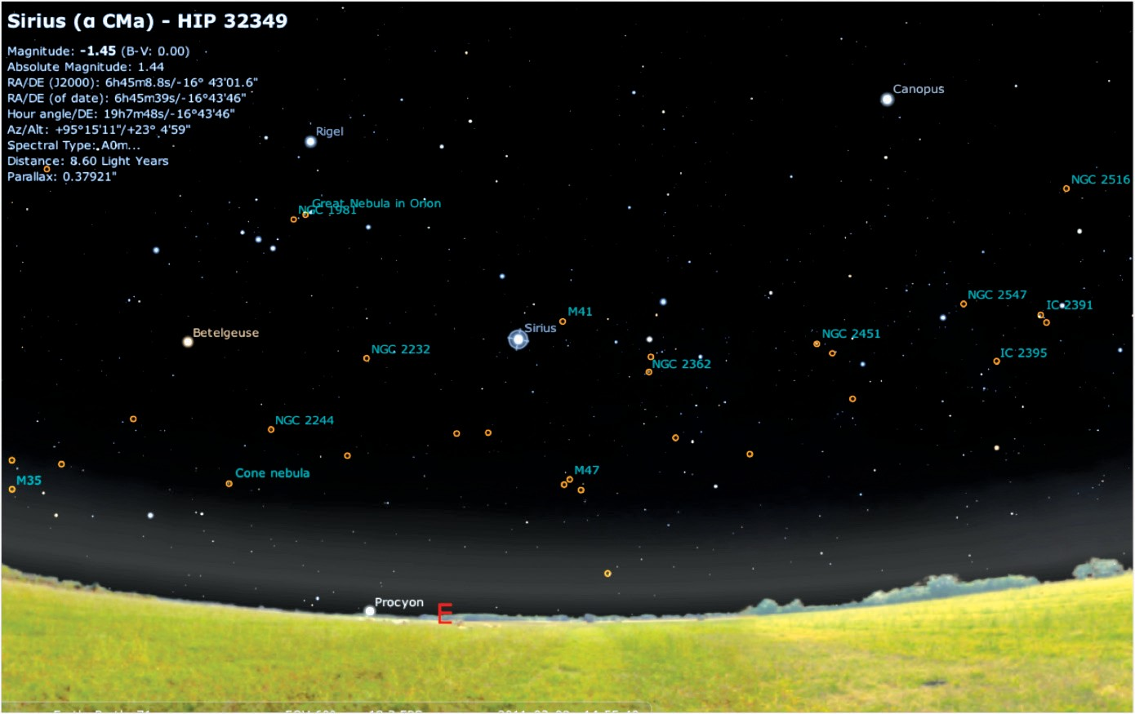

Search for an object by name
Press ctrl + F to open the search window, then type the name or catalogue number of a star, planet, constellation, galaxy or nebula. As you type, a list of matching objects appears. Press tab to select the next item in the list. Press return or select the magnifying glass icon to view the selected object.
If you chose an object that isn’t visible from your location, you’ll find yourself looking at the ground. Don’t despair! Stellarium enables you to see ‘through’ the Earth by pressing G. To try it, search for Polaris, the north pole star. To return to normal vision, press G and drag your mouse down the screen until you see the sky again.

Zoom in and out
Page up and page down keys can be used to zoom in or out by a small amount on a selected object. Forward slash ( / ) and back slash ( \ ) keys auto-zoom in or out to different levels, depending on the object selected.
Search for Saturn or Jupiter, then zoom in using either page up or forward slash keys.

Control time
The following keyboard actions allow you to control time.
- slows down time, and even lets it run backwards to see the past.
- resets time to the normal rate.
- speeds up time to see into the future.
8 resets the current date and time.
7 stops time.
Time control buttons are located on the tool bar at the bottom of the Stellarium screen.

Keyboard actions
Stellarium responds to the following keystrokes:

KEY | DESCRIPTION | KEY | DESCRIPTION
8 | sets time to now | V | shows constellation labels
J | slows down time | / | zooms in on selected object
K | sets normal time rate | \ | zooms out
L | speeds up time | page up/ down | zooms in/out
. | shows equator | ctrl + up/ down | zooms in/out
, | shows ecliptic | space | centres selected object
; | shows meridian | ctrl + G | selects home planet
A | adds/deletes daylight | left click | selects an object
B | shows constellation boundaries | right click | clears a selection
C | shows constellation lines | arrow keys  + left mouse drag | pan view around sky
E | shows equatorial grid | F1 | help window
F | adds/deletes fog | F2 | configuration window
G | adds/deletes the ground | F3 (or ctrl + F) | search window
N | shows nebulae | F4 | sky and viewing options window
P | shows planet names | F5 | date/time window
Q | shows cardinal points | F6 | location window
R | shows constellation art | F11 | sets full-screen mode
S | shows star names | ctrl + Q | quit
T | tracks an object | ctrl + S | save a screenshot

