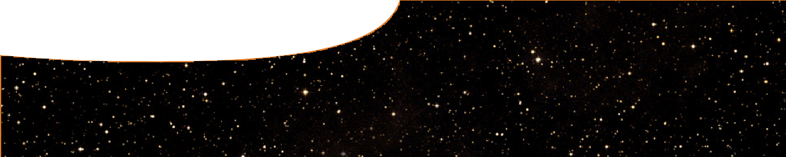
fact sheet
Searching for the origin of the Universe

Since time began …
Quarks were created a fraction of a second after the Big Bang.
Within a microsecond, they had joined together to form protons and neutrons and after another three minutes they had fused to form deuterium and helium nuclei. The Universe was awash with photons, which were continually being absorbed and emitted by freely moving electrons.
It wasn’t until about 370 000 years later that the Universe had expanded and cooled enough for electrons and protons to form stable atoms of hydrogen and helium. For the first time, photons could travel long
distances without interacting with matter and the Universe became transparent to light. Some of those photons – the afterglow of the Big Bang that we call cosmic background radiation – can still be observed today.
The first stars didn’t appear until approximately 400 million years after the Big Bang.

How big is the observable Universe?
The amount of the Universe we can observe is limited by the distance light has travelled in the time since the Universe became transparent to photons, plus the expansion of space during this time.
(billion light years)
50
0 10 20 30 40
Distance
Galaxy
x
Our position
Expansion of the Universe
in 13.7 billion years
Distance (billion light years)
50
40
Galaxy

0 10 20 30
x
Our position
Distance light travels
in 13.7 billion years
As the Universe is 13.7 billion years old, we might think that the most distant object we can see is
13.7 billion light years away.

However, this isn’t true, because in the 13.7 billion years it’s taken for light to reach us, the Universe has expanded. The distance to the most distant object is now about 46 billion light years, which is generally accepted as the size of the observable Universe.
The Universe wasn’t transparent to photons until 370 000 years after the Big Bang, so the electromagnetic spectrum doesn’t allow us to observe anything that happened before that time.

Searching for evidence
Around the world, three major scientific projects will soon join the search for new evidence about the origin of the Universe.
- The Square Kilometre Array (SKA) will search for radio waves emitted during the Big Bang. These waves will provide information on what the Universe was like after it had become transparent to electromagnetic radiation (370 000 years after the Big Bang);

- Gravitational wave detectors will search for gravitational waves emitted during the Big Bang. These waves will provide information on what the Universe was like a fraction of a second after the Big Bang; and

- The Large Hadron Collider will replicate conditions that existed during the Big Bang to determine what gives matter its mass.

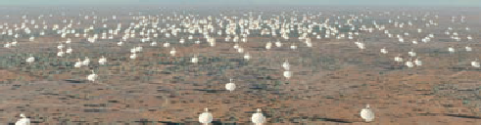
Swinburne Astronomy Productions and SKA Project development Office

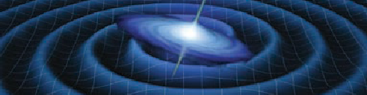
Gravitation waves. NASA/ESA


View of the LHC tunnel sector 3-4r. CERN



The Square Kilometre Array (SKA)
The Square Kilometre Array is a $3 billion international science project being developed by governments and scientific institutions from 19 different countries. The SKA will be a new generation radio telescope with a collecting area of about one square kilometre, giving it 50 times the sensitivity and 10,000 times the survey speed of today’s best radio telescopes.

The SKA will have three kinds of radio antenna: dishes, aperture array tiles and sparse aperture arrays.
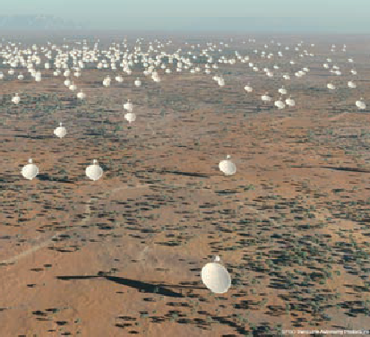

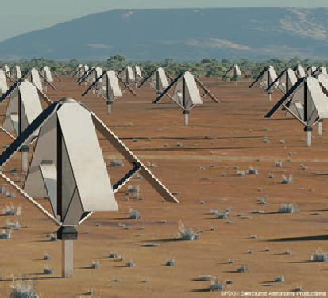
Images: Swinburne Astronomy Productions and SKA Project development Office

Viewed from above, the SKA will have a spiral shape, consisting of
- up to 3000 dishes, each 15 m in diameter and situated up to 3000 km from the central site, and
- fields of aperture array tiles and dipole arrays to sample the lower part of the frequency spectrum.
The SKA will give insights into the formation of the first stars
and galaxies formed after the Big Bang; how galaxies have since evolved; the role of magnetism in the Universe; the nature of gravity; and astrobiology (the study of the origin, evolution, distribution and future of life in the Universe).
The decision on whether to build the SKA in Western Australia
or South Africa will be made in 2012. In the meantime ASKAP, the Australian SKA Pathfinder project is already being constructed in the Murchison region of WA.
ASKAP will be a world-class radio telescope in its own right, as well as being a pathfinder instrument for the SKA.
ASKAP will eventually comprise an array of 36 dishes, each 12 m in diameter and providing high- resolution images across a wide field of view.

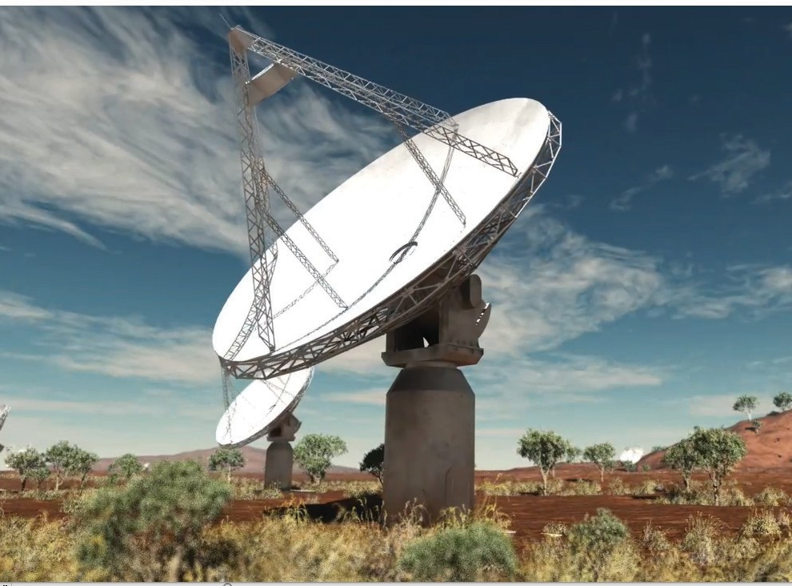
Artist’s impression of ASKAP at the Murchison radio-astronomy observatory
Credit: Swinburne Astronomy Productions. Design data provided by CSIRO.

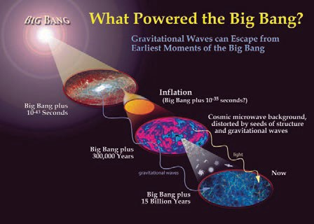
NASA

Gravitational waves
Einstein’s general theory of relativity predicts that gravitational waves are produced when large masses interact, such as when galaxies merge or when two black holes orbit each other.
Gravitational waves aren’t limited by the time it took for the Universe to become transparent to electromagnetic radiation. Using gravitational waves we may be able to observe the Universe as it was a fraction of a second after the Big Bang.

Gravitational wave detectors
Gravitational waves travel through space at the speed of light, passing directly through any object in their path and causing everything, including space itself, to alternately stretch and shrink in different directions.
Gravitational wave detectors are interferometers consisting of two arms up to 4 km long at right angles to each other. When a gravitational wave interacts with a detector, one arm stretches or contracts more than the other. This variation is detected as an interference pattern produced when two identical laser beams are superimposed.
Gravitational wave observatories have been built in the USA (LIGO), Japan (TAMA) and Europe (VIRGO). The Australian International Gravitational Observatory (AIGO) facility at Gingin currently operates a gravitational wave detector with arms 80 m long and plans to build one with arms 5 km long.
It is intended that AIGO will be linked with northern hemisphere interferometers to form a global network of gravitational wave detectors. This network will increase the sensitivity and resolution of the existing detectors and greatly improve their capacity to observe the Universe.

LISA: The future of gravitational wave research
Why study gravitational waves?
Astrophysicists currently use different parts of the electromagnetic spectrum to observe the Universe. Most of our current knowledge of the Universe has been built up from observations in the visible spectrum, supplemented by observations using
x-rays, ultraviolet, infrared, microwave and radio waves. Each part of the spectrum has contributed new information about the Universe.
Physicists expect gravitational waves to open up a new window on the first 370 000 years of the
Universe and provide new understanding of some of the most fundamental laws of physics.
In the near future, scientists plan to build the Laser Interferometer Space Antenna (LISA), made up of three spacecraft forming a giant interferometer with arms about 5 million kilometres long.
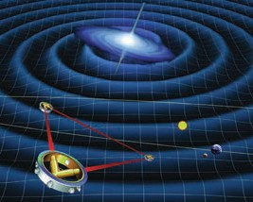
LISA will enable astrophysicists to observe the Universe as it was
a fraction of a second after the Big Bang. From this, they expect to learn more about how the Universe began, how
it evolved and what its

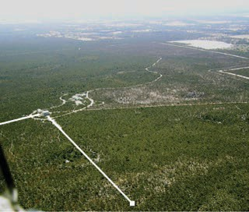
The planned long baseline gravitational wave detector, Gingin. Source: www.aigo.org.au

Gravitational wave detectors. Source: www.aigo.org.au

future might be.
Artist’s conception of LISA spacecraft ESA/NASA


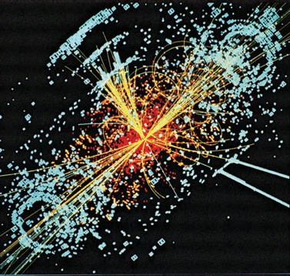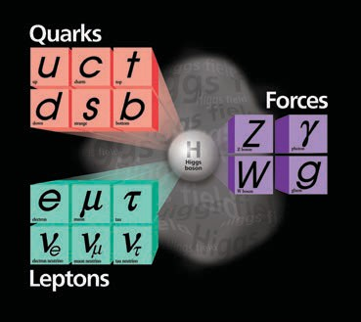

The Large Hadron Collider (LHC)
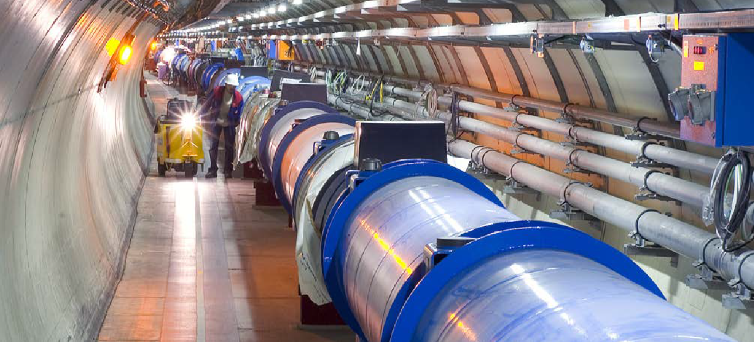
© CERN -AC-0510028 04, photograph: Maximilien Brice, http://public.web.cern.ch/public/en/lhc/lhc-en.html

Physicists once believed that mass and gravity were properties of matter itself. However, Einstein’s General theory of relativity says that gravity is a consequence of the distortion of space time by matter.
In the 1960s, British physicist Peter Higgs provided an explanation for why some fundamental particles acquire mass, and others do not. The explanation involves interactions with a particle called the Higgs boson. For example, photons, which don’t interact with the Higgs boson, have no mass.
In the 1970s, the Standard Model of particle physics was proposed as a single theory that brought together all of our understandings about sub-atomic particles and the interactions between them, except for gravity.
It introduced the idea that matter interacts with the Higgs boson. Observing the Higgs is an important test of the Standard Model. The LHC will be used to search for the elusive Higgs boson.
However, finding the Higgs boson is very tricky. Like most sub- atomic particles, it is unstable and only exists at extremely high energies, similar to those that existed in the Big Bang.

The LHC will attempt to replicate those conditions by accelerating twin beams of protons to 99.99% of the speed of light, then colliding them head-on.
If a Higgs boson is created, it will decay almost immediately, but it should leave a record of its creation and destruction. If its signature can’t be detected, it may be time for physicists to come up with a new model of particle physics!
For more information on the LHC, see the SPICE resource,
Matter and relativity 1: Quarks.

Right: A simulated event in the CMS detector, featuring the decay of a Higgs boson. credit: CERN

