
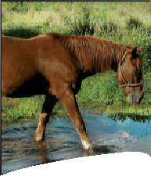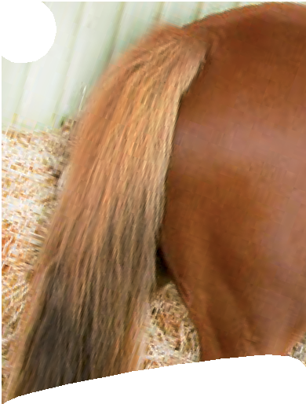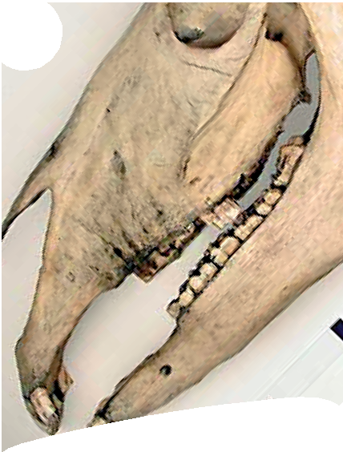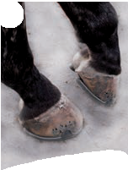
Teeth, tails and talons!
Rules of the game

Object of the game
The game cards show Australian animals and their features. The object of the game is to build sets of four related cards. A complete set contains an animal, its teeth, its tail and its talons or fins.
There are 48 cards, making up 12 sets.
One card from each category is needed to build a complete set. Cards are marked with a symbol and corresponding category letter.

A. an animal B. its teeth C. its tail D. its claws or fins

Example of a complete set:

hooves for high speeds and long distances

tail for protection and communication

teeth for grinding
Horse
Equus caballus
photo by Marnie Rawlinson, Cathy Accurso and Ken Walker © Museum Victoria

How to play the game
Teeth Tail Talons
Find
photo © Paul Ricketts
photo © Paul Ricketts
- Deal seven cards to each player.
- Turn the remaining cards face down in the centre; this is the draw deck.
- Turn the top card from the draw deck face up alongside it. This is the discard pile.
- The first player must pick up either the top card from the discard pile, or the top card from the draw deck. After picking up a card each player will have enough cards to build two sets.
- The first player checks to see if they can build a set of cards (an animal and three features of that animal).
- If the player has a set, they lay it down for all to view. Other players can challenge the choices.
- To complete this play, the first player discards a card onto the discard pile.
- Play continues in a clockwise direction. The second player can also pick up from the discard pile or the draw pile.
- Play continues around the group until a player has used all of their cards. This player is the winner.
- If the draw deck cards run out, the discard pile can be shuffled and used as the draw deck.
- There are four wild cards in the deck; these can be used to look through the discard pile and pick up any card needed. Play the wild card as your discard card. (Other players
cannot pick up a wild card from the discard pile.)

To find out if each set is right, or to resolve a group discussion, check
with your teacher, who has a matrix of features that
belong to each animal.
For a shorter game, the winner is the player who is first to build one complete set. Other players put down their cards and discuss which cards they needed to complete their sets.


Teeth, tails and talons
Featured animals

 | dingo  Canis lupus dingo | 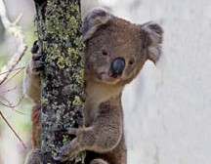 | koala  Phascolarctos cinereus
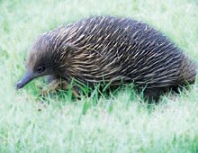 | short-beaked echidna  Tachyglossus aculeatus | 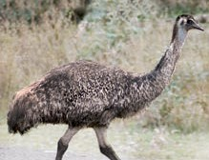 | emu  Dromaius novaehollandiae
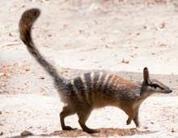 | numbat  Myrmecobius fasciatus |  | humpback whale  Megaptera novaeangliae
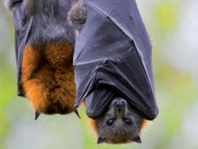 | grey-headed flying fox  Pteropus poliocephalus | 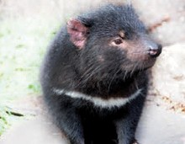 | Tasmanian devil  Sarcophilus harrisii
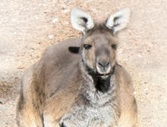 | western grey kangaroo  Macropus fuliginosus | 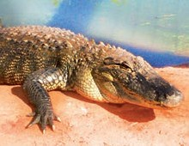 | saltwater crocodile  Crocodylus porosus
 | great white shark  Carcharodon carcharias | 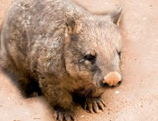 | common wombat  Vombatus ursinus

