fact sheet
RNA and gene regulation
Only 2% of the human genome is made up of protein-coding genes, the remaining 98% is made up of genetic sequences that are non-coding, or don’t encode protein. Many of these non-coding sequences play a role in regulating gene expression or are transcribed into non-coding RNA molecules. Others have no known function.
Scientists know that non-coding RNA molecules are involved in essential cellular processes, such as protein synthesis. Advances in biotechnology are beginning to uncover their important and diverse roles in regulating gene expression.

Coding RNA
Coding RNA contains a sequence, or code, that produces a specific protein when translated. The main type of coding RNA is messenger RNA (mRNA). During protein synthesis DNA is transcribed into mRNA that is further translated into an amino acid chain. This in turn folds to form a protein.

Non-coding RNA
All RNA molecules, coding and non-coding, are transcribed from DNA, but non-coding RNAs don’t progress into translation in the cytoplasm, they remain as RNA molecules.
RNA molecules are single-stranded chains of nucleotides. They can fold and form double-stranded regions, based on the rules of complementary base pairing.
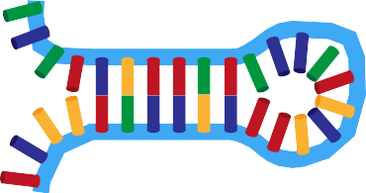Many non-coding RNA molecules have regulatory functions. Some of these molecules act as enzymes, while others interact with proteins and DNA complexes.

G U C C A C C A G G U G
Single-stranded RNA molecules fold to form three-dimensional double-stranded molecules.
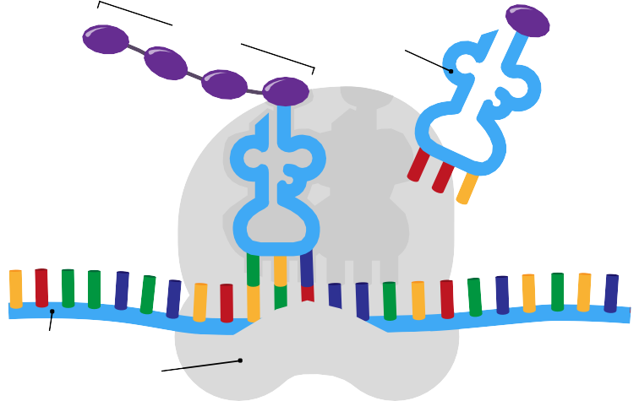
transfer RNA (tRNA) and ribosomal RNA (rRNA)
Non-coding RNA molecules play important roles in cellular processes. Both transfer RNA and ribosomal RNA are essential to protein synthesis, as both are involved in translation of mRNA into protein.
amino acid chain
tRNA
mRNA
ribosome
During translation of mRNA, tRNA carries amino acids to the ribosome.

small nuclear RNA (snRNA)
Short lengths of RNA found in the nucleus of eukaryotic cells, known as small nuclear RNA, are important in gene regulation. Some snRNAs are involved in splicing, forming complexes with protein molecules, known as spliceosomes. Spliceosomes trim mRNA of unwanted introns and exons before translation.

micro RNA (miRNA)
Other short lengths of RNA (on average only 22 base pairs in length) known as micro RNAs also play a role in regulating gene expression. miRNAs generally act in the cytoplasm, unlike snRNAs which are confined to the nucleus. These molecules silence gene expression by binding to mRNA and preventing translation, or causing degradation of mRNA.
Binding between miRNAs and mRNA is imperfect, as miRNAs only require a small core (seed) area to be complementary. Non-specific binding means a single miRNA molecule can target many different mRNAs and, conversely, many different miRNAs can target a single mRNA.

mRNA
G U C
A G G
U U A C
C A C G A C G U U A U G A C G A
U
A C A C G A C G U
miRNA
seed
5’
5’
G U A C A G C C A U G U C G
3’

The miRNA targets and binds to mRNA, binding is non-specific, only the seed area is complementary.

Cancer and miRNA
In some cancers miRNAs are overexpressed or underexpressed. Scientists believe they play an important role in disease development and progression.
Developing miRNA-based therapies is a new direction in cancer treatment. If miRNAs can be targeted to specific sets of genes or mRNA products, then cell growth may potentially be brought under control.
Table 1: Expression profiles show miRNAs in different types of cancer. Many miRNAs have higher expression levels than normal cells (overexpressed); or have lower expression levels than normal cells (underexpressed).

miRNA | EXPRESSION | TYPE OF CANCER
miR-15a | underexpressed | leukemia
miR-143 | underexpressed | colorectal
miR-155 | overexpressed | lymphoma
miR-21 | underexpressed | breast

Melanoma and miRNA
Researchers from Harry Perkins Institute of Medical Research in Perth, Western Australia, have found that miRNA molecule, miR-7-5p, is underexpressed in metastatic melanoma cells (those that have spread to other parts of the body), compared to primary melanoma cancer cells (those found in the original cancer).
Melanoma is difficult to treat when it spreads from the skin to other parts of the body, including major organs. Aiming to prevent the spread of cancer, the research team plans to identify how miRNAs may interfere with cancer cells’ ability to metastasise.
Non-coding RNA may not be translated into a protein, but these molecules have diverse functions and play important roles in protein synthesis and regulating gene expression. As research progresses, and biotechnological techniques are developed, new RNA molecules and their functions will continue to be discovered.

