fact sheet
Renewable energy vehicle
vehicles: the REV project at UWA
Electric

Since 2008, the Engineering faculty at The University of Western Australia (UWA) has been home to the renewable energy vehicle (REV) project. Researchers were motivated by the rising price of fuel, an uncertainty about future oil supply, and an abundance of sunshine, to develop an environmentally friendly electric vehicle powered by electricity generated from solar energy.
Electric vehicles use a battery to store energy as chemical energy. When the vehicle is switched on chemical energy is transformed into electrical energy that powers the motor and makes the vehicle move. Whenever energy is transferred or transformed some is wasted as heat, but very little energy is wasted as heat energy in an electric vehicle.
electricity
charging port
electric motor
rechargeable batteries
controller
inside an electric car

electricity grid battery electric motor electric motor car wheels
heat heat heat

energy flow through the renewable energy vehicle

electrical energy

chemical energy

electrical energy

kinetic energy
kinetic energy
heat

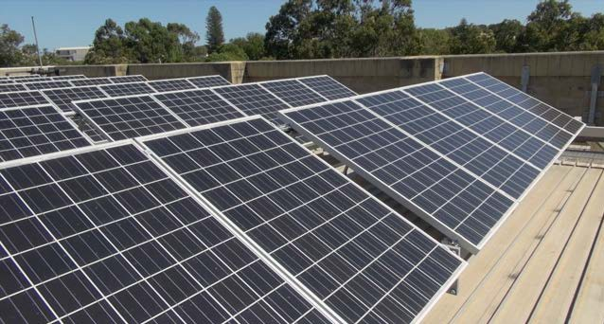
The first car to be converted to a plug-in REV by the project team was a Hyundai Getz. Electric drive motors, batteries and wiring were installed into the car which was charged with electricity from the state electricity supply grid. To offset this, and to meet their aim to develop
a renewable energy vehicle, UWA installed solar panels on the roof of the engineering building to feed electricity back into the grid.

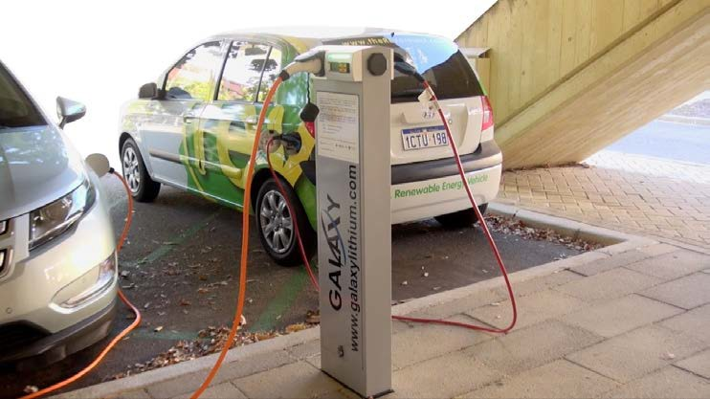
fact sheet
ELECTRIC
VEHICLE CHARGING STATION

In Perth, there’s an increasing network of fast-charge stations, from Fremantle to Midland.
Renewable energy vehicle

The REV Getz is housed at UWA. It takes about six hours to charge the battery to full capacity, using a purpose built charging station, at a cost of around $2.00 (2015 prices). When fully charged the car has a range of 100 km and a top speed of 125 km per hour. While this range seems small, the cost of going the same distance using a petrol-fuelled combustion engine Getz is about $7.00. The range of an electric vehicle depends on accessory use, such as air conditioning, and range must be carefully monitored while driving.
The REV project team have also converted a Lotus Elise and there are plans for more conversions, including an electric jet ski. You can find out more about the REV project at the project website, http://therevproject.com/
Energy gain in an electric vehicle: regenerative braking
In traditional cars, friction between brake pads and brake discs when brakes are applied stops the car. Braking generates a lot of heat and wear, which is why brakes are checked at every car service.
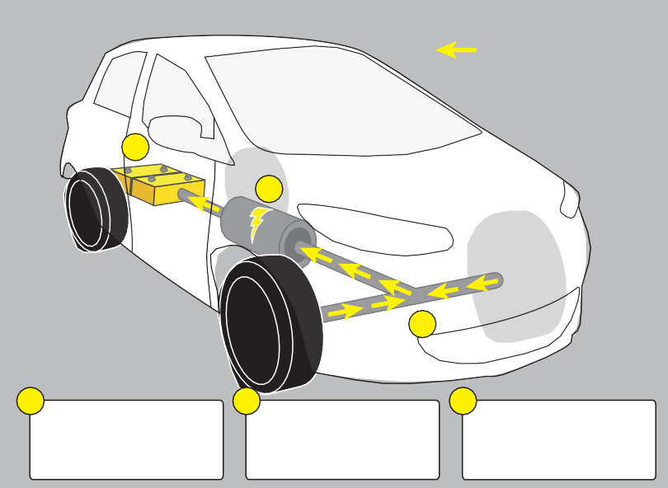In electric vehicles there’s an additional type of braking: regenerative braking. This transforms energy from a decelerating vehicle into electricity, which can be returned to the battery. This is particularly important in electric vehicles as it can extend the car’s range.
energy from generator
3
2
1
1
When the brakes are applied, The electric motor becomes a The electricity is transferred the kinetic energy from the generator, making electricity, to the batteries where it is wheels is transferred to the managed by the controller. stored.
electric motor.
2 3
When a driver of an electric vehicle takes their foot off the accelerator, or brakes gently, kinetic energy from the wheels transfers energy to the motor, which acts as a generator, producing electricity that flows back into the batteries. Regenerative braking is controlled by a computer that registers the force with which the driver brakes.
If braking happens suddenly, or with a large force, brake pads and discs are
used to slow the car down. In this case there’s no regeneration of electricity.

The drive motor acts as an electricity generator during regenerative braking.

