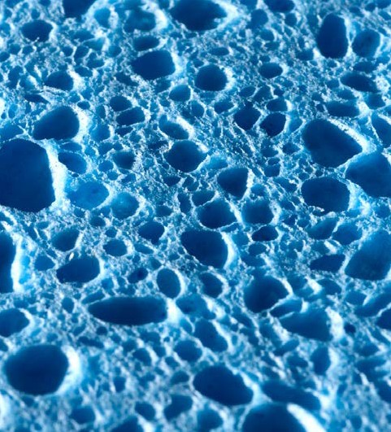
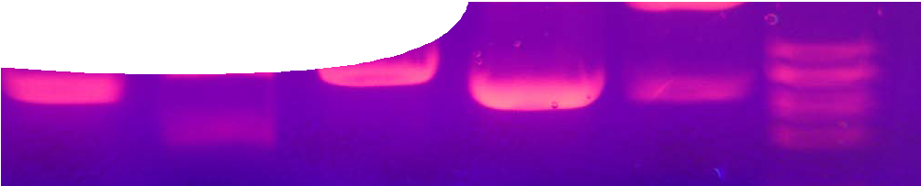Separating proteins
fact sheet
Protein visualisation
photo by Mnolf
Protein gel electrophoresis is a process used to separate and identify protein molecules in a sample. Protein gel electrophoresis causes molecules of a sample to separate as they pass, under the influence of an electric current, through a gel.

Like a sponge, gel contains microscopic, unevenly- sized pockets of space within a larger network of fibres. When an electric current is applied to the gel, negatively-charged protein molecules are attracted to the positively-charged terminal. Small molecules travel faster and further through the gel, while large molecules move slowly and cover less distance.

The end result is that proteins are distributed through the agar, based on size. Protein standards, which consist of a collection of proteins of known size, help identify what proteins are present. Dyeing
the sample makes proteins visible. Agar is like a sponge that contains a range of spaces through which particles move.

Protein gel electrophoresis

negative electrode

Load prepared food or tissue samples into wells in the agarose gel.

2.
1.
1.

test samples standard

3.

4.

loading wells

heavier proteins

proteins of the same size

lighter proteins

- Apply a voltage to move negatively- charged proteins through the gel, towards the positive electrode.

- Proteins separate by mass: large, heavy proteins do not get far through the agar as they can’t pass through microscopic gaps. Smaller, lighter proteins pass further through the gel, towards the positive electrode.

A standard that contains proteins of known size and weight is compared with test samples. Bands in the same horizontal position are likely to be the same size and therefore the same protein.
4.

positive electrode

fact sheet
Protein visualisation

electrophoresis proteins transferred from gel to membrane

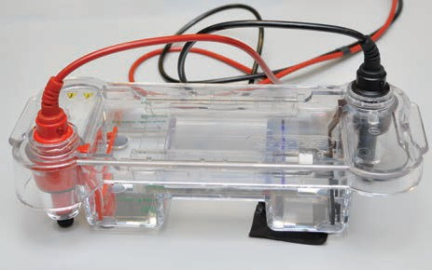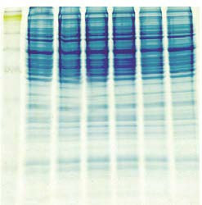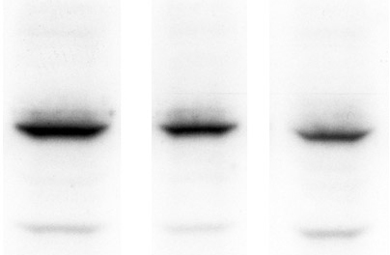photo by AJ Cann

Once you have a protein gel, how do you find out what’s on it? Mass spectrometry (which was used to measure quantities of proteins in the seminal fluid of bees in the video, The importance of proteins) and western blotting are both used to measure the amounts of different proteins in a tissue sample.

Western blotting involves taking proteins from a gel and transferring them to a membrane. The membrane is then washed with specific antibodies, that stick to target proteins, and a chemical marker added.
The marker emits light in a process called chemiluminescence: the stronger the light signal, the greater the amount of protein.

HIV diagnosis

Western blotting may be used for diagnostic purposes, for example identifying HIV. A sample of a patient’s blood is washed across a membrane impregnated with HIV proteins. If HIV antibodies are present in the blood they attach to the membrane. Once again, a light-producing reaction is used to visualise antibodies.

membrane probed (impregnated) with antibodies

secondary antibody (containing chemical marker)

primary antibody

antigen
(protein)

western blot

photo by AJ Cann

