fact sheet
Protein folding

Proteins are fundamental to life processes of almost every living cell, so when things go wrong consequences can be serious.
But what can go wrong in making proteins?
The first step in the process to make a protein is transcription. Part of a DNA strand is used to create a messenger RNA (mRNA) molecule that contains all the information needed to build a specific protein. During transcription, errors or mutations may creep in. If the sequence of codons in mRNA changes, a different protein may be built.

Potential transcription errors
For example, mRNA codon ‘AUU’ codes for isoleucine (Ile), while ‘AAU’ codes for asparagine (Asn). There is only one nucleotide difference between codons but properties of these two amino acids are quite different.
If hydrophobic (water-hating) isoleucine is exchanged for hydrophilic (water-loving) asparagine, it changes properties for that part of the protein molecule. As we’ll see, changing properties of part of a protein molecule can significantly alter the way it behaves.
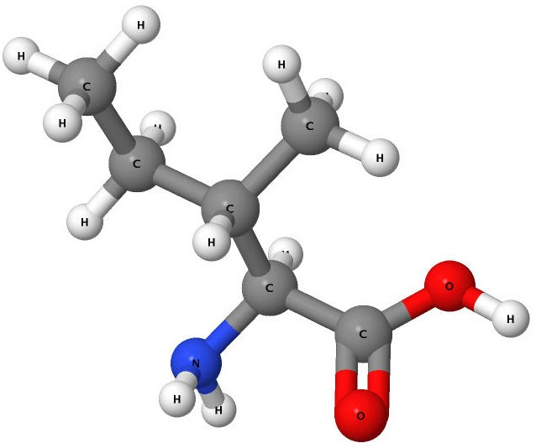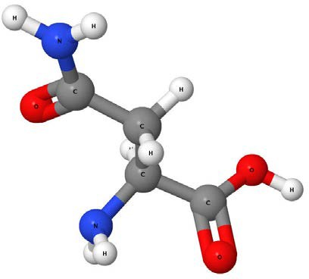
R group
R group

Figure 1: Isoleucine’s functional group –CH(CH3)CH2CH3 (highlighted) is hydrophobic (water-hating).
Figure 2: Asparagine’s functional group –CH2CONH2 (highlighted) is hydrophilic (water-loving).

Although proteins are often represented as a long, straight chain of amino acids, their real structure is quite different. The way they fold depends on interactions between amino acids in the chain.
Met
Ala
Leu
Trd
Met
Arg
Leu
Leu
Pro
Leu
Leu
Ala
Leu

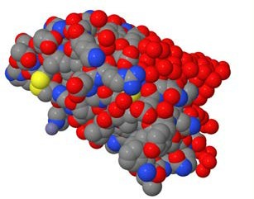
a)

b)

Figure 3: Two representations of insulin: a) part of the backbone chain naming constituent amino acids; and b) a 3-D model of the molecule. Which is more accurate?

As we’ve seen, the functional group of isoleucine is hydrophobic while that of asparagine is hydrophilic. Each amino acid has different properties that determine whether parts of the protein chain attract or repel each other.

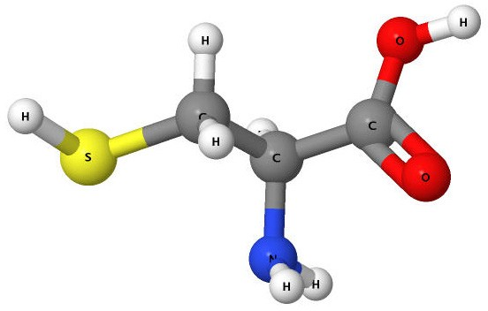
Cys
S

S
Cys

Figure 4: Amino acid cysteine has a functional group – CH2SH that includes a sulfur atom.
Figure 5: Interaction between two cysteine molecules forms a strong link through a sulfur-sulfur bond.

A wide range of different interactions, including: hydrogen, ionic and covalent bonds, as well as electrostatic attractions and repulsions are present in all protein molecules. The combination of all these interactions gives protein molecules their ultimate shape, which corresponds to the lowest possible energy state. The process of getting into this state is called ‘protein folding’.
For many proteins, their 3-dimensional shape is vital to their function. So, if something causes the shape to change then the protein may not function correctly.

Potential folding errors
Transcription may have proceeded smoothly, however as new proteins emerge from the ribosome they’re exposed to many different molecules in the cell’s cytoplasm. It is possible that inappropriate associations may occur, either between the new protein’s amino acids and those of other molecules, or between its own amino acids.
So-called ‘chaperone proteins’ or chaperonins try to protect proteins from making mistakes. They work to avoid problems such as aggregation or clumping of incompletely folded proteins. They also help newly made proteins fold into their correct 3-dimensional shape.
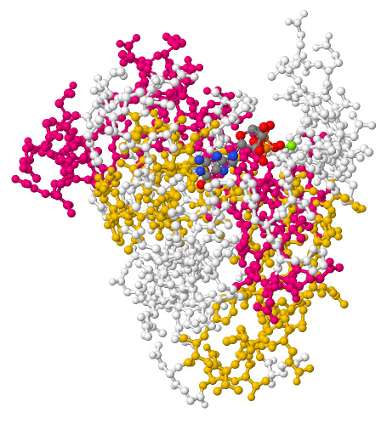
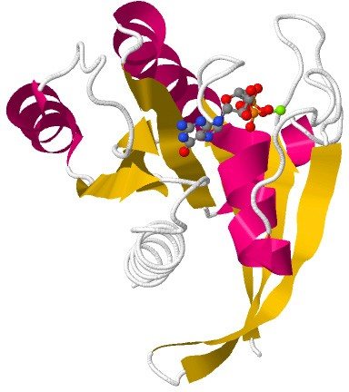At first sight the structure of proteins seems overwhelmingly complex, but certain broad patterns occur over and over again.
α-helix
ß-helix

Figure 6: It’s hard to see structure in a ‘ball-and-stick’ view of this protein (RAS).
Figure 7: A ‘cartoon’ view of RAS highlights two common structures found in proteins: α-helix and ß-sheet.

The α-helix and ß-sheet are two of the commonest structures found in proteins. Most proteins are composed of different proportions of both structures, although the α-helix predominates.

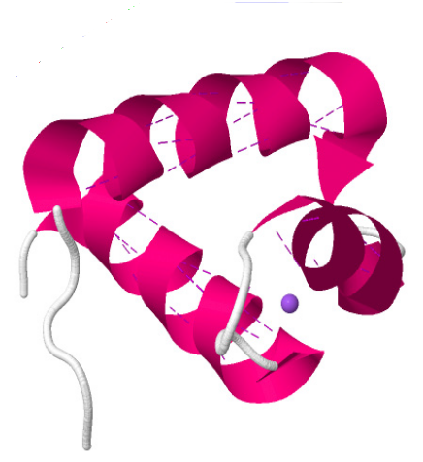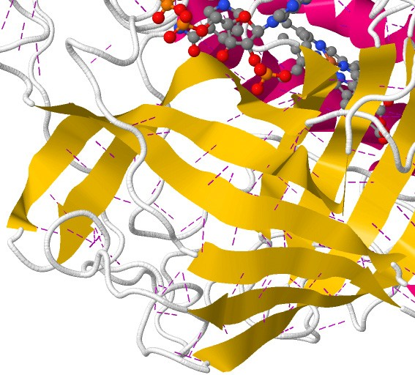

Figure 8: This protein (MYB) contains several α-helix elements. Dotted lines show hydrogen bonds between amino acids that help form a clockwise spiral structure.
Figure 9: This part of the catalase enzyme contains a concentration of ß-sheets. Again, hydrogen bonds are involved in setting up the repeating pattern.

Links between protein problems and disease
For proteins to perform properly they must assume the correct shape (also called conformation). Some diseases are associated with proteins that initially fold incorrectly. An example of this is cystic fibrosis which is caused by defective folding of a key membrane protein involved in chemical regulation of cells. Other diseases are caused by correctly folded proteins becoming abnormal. Alzheimer’s disease is an example of this condition. It causes amyloid deposits (clumps of insoluble protein material) to form in the brain.

The mad, bad world of prions
Transmissible spongiform encephalopathies (TSE) are a group of devastating diseases that affect animals and humans. These diseases have a number of things in common: they’re untreatable, fatal and caused by particular proteins known as prions.
Normal prion proteins are found in cells of animals and humans. They’re most common in the brain, where they anchor to cell membranes.
Prions can fold in two ways, referred to as PrPC (prion protein cellular form) and PrPSC (prion protein scrapies form). Although the two forms of prion protein contain exactly the same sequence of amino acids, their properties are quite different, because of different folding. PrPSC contains a greater proportion of ß-sheet structure.

 | NORMAL FORM: PrPC | ABNORMAL FORM: PrPSC
α-helix structure | 42% | 30%
ß-sheet structure | 3% | 43%
soluble in water | yes | no
digested by enzymes (proteases) | yes | no
forms amyloids (clumps of protein material) | no | yes
Table 1: Properties of normal and abnormal prions

TSE diseases
Like Alzheimer’s disease, TSE diseases cause clumps of protein material to accumulate in the brain, but there is a big difference between them. The name gives a hint about this difference. Prion is a word coined by Nobel Prize winner Stanley Prusiner that is short for PRoteinaceous INfectious particle. Prions are considered to be proteins, but they’re somehow able to infect cells and propagate, even though they contain no DNA or RNA.
It appears that a single misfolded prion molecule can cause correctly folded prions to flip over to the misfolded form. In a cascade reaction, more and more prions are converted in an irreversible process.
Scientists don’t actually know how prions do this, but they’re working hard to find out.
So how does an organism become infected with a prion disease?
There appears to be three main mechanisms: genetic; spontaneous; and exposure to contaminated material.
- Through genetic inheritance, an individual may have a greater tendency to create prions in the misfolded form.
- If you’re really unlucky, a normal prion protein may spontaneously change to the misfolded form (known as spontaneous conformational change).
- Or an organism may ingest or otherwise come in contact with material that contains misfolded proteins.
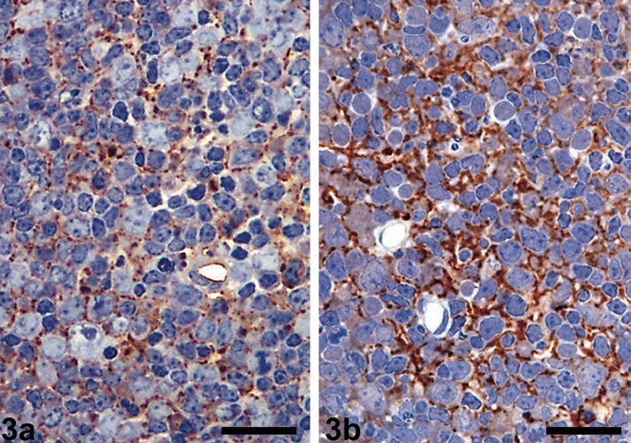Whatever the infection route, once an organism contains misfolded prions there is a risk they’ll multiply.
a
b
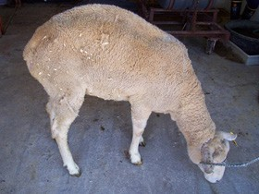
Figure 10: Scrapie-affected ewe with weight loss and hunched appearance

Prion diseases
The first recorded prion-related or TSE disease was scrapie in sheep. Prion diseases are now known to occur in other animals, and in humans where TSE is known as Creutzfeldt-Jakob disease (CJD).
In TSE diseases brain tissue degenerates as clumps (known as amyloids) of misfolded prion protein accumulate. Patients’ brains look sponge-like, they develop progressive dementia, have major coordination problems and their vision becomes blurred. TSE diseases are always fatal. Luckily, prion diseases are uncommon. About one person in a million is affected each year with sporadic CJD, so it’s unlikely you’ll ever come into contact with one.
Bovine spongiform encephalopathy (BSE) otherwise known as ‘mad cow disease’ was big news a few years ago. Some people who consumed beef from cows infected with BSE developed a variant of CJD. CJD
has also been transmitted through the use of cadaver- derived growth hormone, corneal transplantation and surgery using contaminated instruments. Prions aren’t ‘alive’, so standard sterilisation procedures that would destroy bacteria and viruses may not affect them. Most CJD cases, however, are believed to be spontaneous.
The cause for sporadic conversion is unknown.

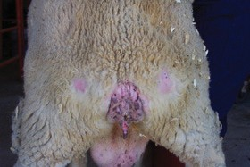

Figure 11: Same ewe as above with bare patches on rear end from scraping
Figure 12: Lymph nodes from (a) healthy and (b) infected sheep. Colouring with antibodies shows clear sign of scrapie prions in intracellular tissue of the infected sheep.
McGovern G, Jeffrey M (2007). Scrapie-specific pathology of sheep lymphoid tissues. PLoS ONE 2(12): e1304. doi:10.1371/journal.pone.0001304

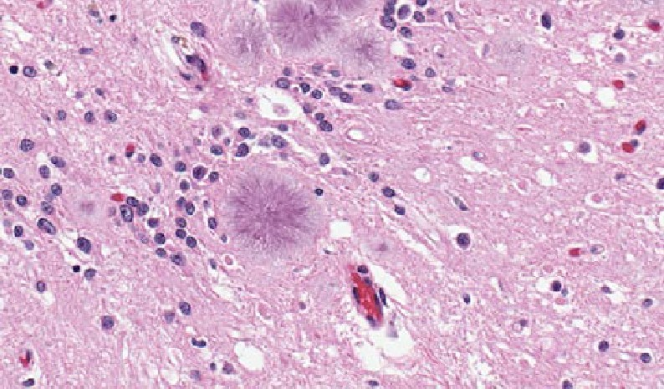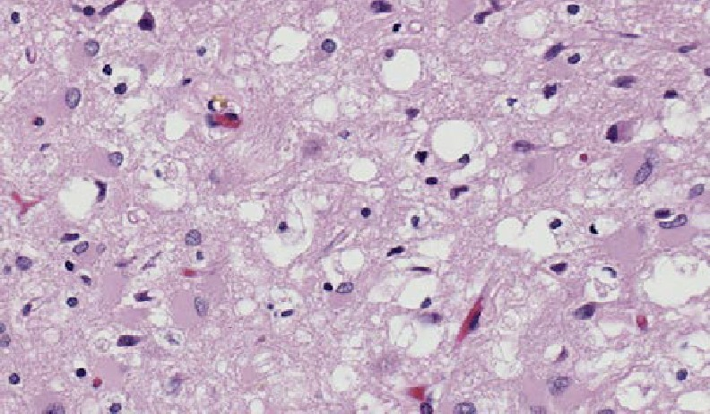

Figure 13: Brain tissue from a patient with Creutzfeldt- Jakob disease showing build up of amyloid plaques (radiating structures).
Center for Disease Control/Teresa Hammett, PD, phil.cdc.gov/phil/
Figure 14: Brain tissue from a patient with Creutzfeldt-Jakob disease showing spongelike character.
Center for Disease Control/Teresa Hammett, PD, phil.cdc.gov/phil/

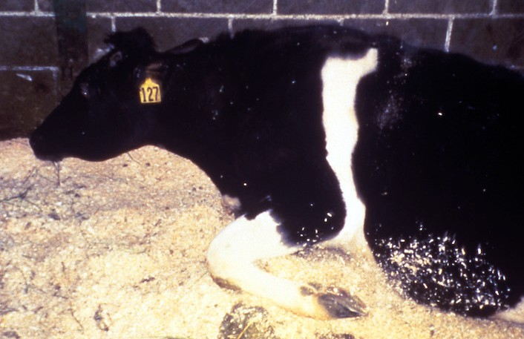Mad cow disease
…Bovine Spongiform Encephalopathy (BSE) is a disease of cattle. It was first recognised and defined in the United Kingdom in November 1986. Over the next few years the epidemic grew considerably and affected all parts of
the country but to different degrees. It reached its peak in 1992, when 36,680 cases were confirmed in Great Britain, and since then has shown a steady decline… (Department for Environment, Food and Rural Affairs, UK).
Behind these words lies an event that devastated the British agricultural sector and cost billions of pounds to eliminate. Even though four million cattle were

Figure 15: Cow affected by BSE.
Dr Art Davis, US Department of Agriculture (Animal and Plant Health Inspection Service), PD, phil.cdc.gov/phil/

slaughtered as a preventative measure, an estimated 500,000 infected animals entered the food chain. 170 people have died through contracting the human equivalent of BSE, Creutzfeldt-Jakob disease (CJD), mainly through consumption of BSE-infected beef.
Cows are herbivores, but the high cost of plant-derived protein in the UK meant many animals were fed ‘meat-and-bone meal (MBM)’ products. It’s presumed that these animal-derived products contained some misfolded prion protein, maybe from a scrapies-infected sheep. Further recycling of dead, infected animals exacerbated the epidemic.
A long incubation period for BSE, and scepticism that the disease could cross from cattle to humans led to wide exposure of the UK population to the disease. Even today, people who lived in the UK between 1980 and 1996, for six months or more, are ineligible to give blood in Australia because of the risk that they may carry prion disease.

Want to know more?
- CJD Support Network (nd). http://www.cjdsupport.net/
- Marchant, J. (2012). Prion diseases hide out in the spleen. Retrieved 9 May 2012 from http://www.nature.com/news/ prion-diseases-hide-out-in-the-spleen-1.9904
- Prusiner, S.B. (1998). Prions. Proc. Nat. Acad. Sciences U.S.A., 95(23), 13363–83. Retrieved 14 May 2012 from http://www.pnas.org/content/95/23/13363.full
- Reynaud, E. (2010). Protein misfolding and degenerative diseases. Nature Education 3(9):28, retrieved 9 May 2012 from http://www.nature.com/scitable/topicpage/protein-misfolding-and-degenerative-diseases-14434929

