**Appendix G: Pollen library**

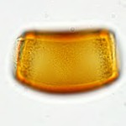Banksia

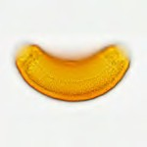Banksia

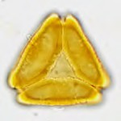Marri

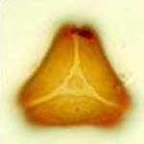Tuart

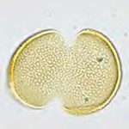Grass tree

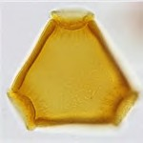Hakea

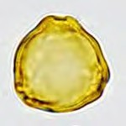Sheoak

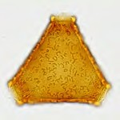Grevillea



|  |  |  |  |  |
| --- | --- | --- | --- | --- |
|  | |  |  | |
| ast1176 | Be a Bush Scientist (teacher guide)  © The University of Western Australia 2014 version 1.1 revised January 2015 | page 65 |  |  | developed for the Department of Education WA for conditions of use see spice.wa.edu.au/usage |