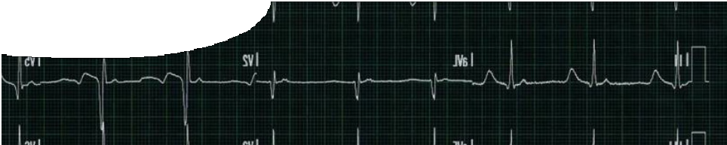
fact sheet
Pacemaker

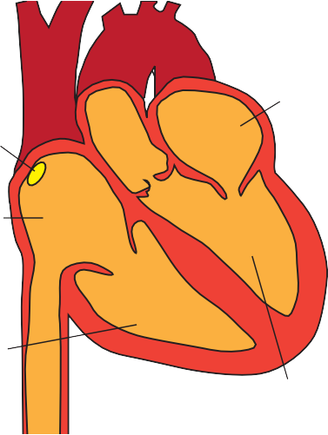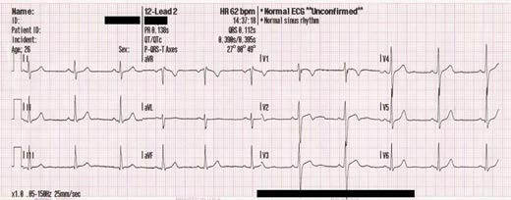Over the next 24 hours, your heart will beat 100 000 times, and every single heartbeat will be generated by an electrical impulse.

sinus node

right atrium

right ventricle

Electrocardiogram

left atrium

left ventricle

A natural pacemaker

Your heart is a powerful muscular pump with the important task of pushing blood around your body. Its rhythm (your heartbeat) is controlled by a small group of modified muscle cells called the sinus node.
The sinus node sits in the top right corner of your heart. It is your natural pacemaker. Cells in the sinus node don’t contract like normal muscle cells, but they do spontaneously generate an electrical impulse (also known as an action potential) that governs how often your heart beats.
The electrical impulse spreads down through your heart, triggering its muscle cells to contract. This wave of contraction squeezes the heart’s walls, forcing blood through its chambers and out around your body.

Doctors can detect the heart’s electrical impulse by performing an electrocardiogram (ECG). Electrodes, which pick up the heart’s electrical signals, are attached to a patient’s chest, arms and legs.
If doctors detect an abnormal heart rhythm
(known as an arrhythmia), they may suggest fitting an artificial pacemaker. This sends its own electrical signal to the heart, whenever it is needed, helping to control the rhythm.

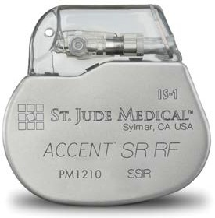
Speed control
At first, pacemakers were fitted in patients with a slow heart rate. The steady firing of an electrical impulse was used to increase their heart rate. Pacemakers are now used to manage a range of abnormal heart rhythms, whether slow, fast or irregular, and they tend to be reactive, stepping in only when needed.
Many modern pacemakers are also rate responsive. They contain multiple sensors to help them gauge the ‘correct’ heart rate, depending on whether a person is exercising or sitting still. To do this they may detect vibration, breathing rate and body temperature.
Some of the latest artificial implants combine pacemakers and defibrillators. Defibrillators can shock the heart during a life-threatening rhythm disturbance (cardiac arrest), as well as working like a pacemaker.

ast1403 | Electrical circuits 6: Pacemaker (fact sheet) developed for the Department of Education WA
© The University of Western Australia 2010 for conditions of use see spice.wa.edu.au/usage version 2.0 revised February 2015 page 1 Licensed for NEALS

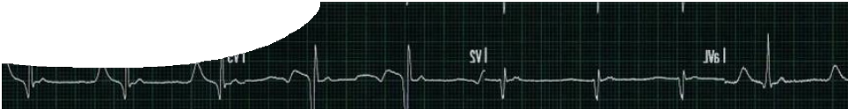
fact sheet
Pacemaker

Pacemaker structure
The first pacemakers of the 1950s were bulky external devices that relied on mains power. A patient had no choice but to live tethered to the wall socket, and a power cut could be fatal.
In response to this problem, an American, Earl Bakken, developed the first wearable battery-powered cardiac pacemaker.

Early portable external pacemaker (1958)

Prototype external pacemaker (1957)

First implanted pacemaker (1958)

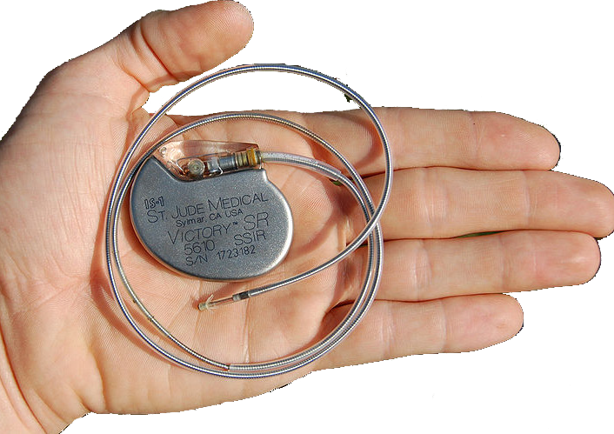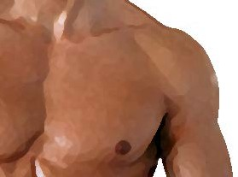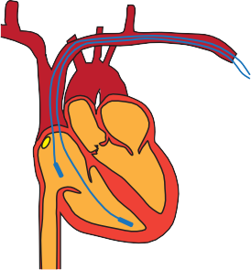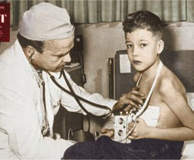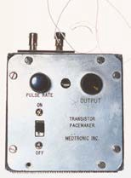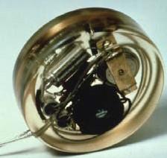Today’s electronic pacemakers sit inside a patient’s chest, are battery-operated, and smaller than a matchbox. These modern pacemakers consist of two sections: the leads and a 2.8 V battery-powered generator. The leads sit in the heart and detect its electrical activity.
They convey this information to the generator, which is a tiny computer. Depending on the data, the leads may transmit an electrical signal back to the heart, stimulating it to beat.
dual-chamber pacemaker

Implanting a pacemaker
Pacemakers are fitted, under local anaesthetic, in an operation that takes less than 45 minutes. The generator sits in a pocket of tissue cut under the patient’s collarbone, while the leads are fed through a vein into the heart, using real-time x-rays as a guide (this is called fluoroscopy). Depending on the heart condition, there may be between one and three leads.
- Pacemakers weigh between 20 and 50 g, and are smaller than an average matchbox.
- Some new pacemakers record the electrical rhythm of the heart. Doctors can download this information, giving them an extra aid in diagnosing problems.
- At rest, your heart beats between 60 and 100 times per minute.
- Your body contains around
5.6 L of blood.
- Machinery generating strong magnetic fields can interfere with pacemakers.
Finally, the doctor programs the pacemaker from outside the patient’s body, for example, setting the lower rate at which the pacemaker should ‘kick-in’. The same programming device is used during checkups to verify the amount of energy left in the battery (they usually last for 7–10 years). Some modern
pacemakers now incorporate wireless technology, so patients can do their check-up over the Internet. When the lithium battery gets low, the surgeon opens up the pocket and swaps the old generator with a new one, leaving the leads in place.

Current research
Scientists are investigating whether it’s possible to replace electronic pacemakers with ‘natural’ pacemakers, made from human stem cells.
Image credits
‘Accent™ RF Pacemaker’ image provided courtesy of St. Jude Medical, Inc.
’ECG trace’ by MoodyGroove. Public domain, en.wikipedia.org/wiki/File:12leadECG.jpg
‘Dr C Walton Lillehei and a child who was one of the first patients fitted with the ‘White Box’ 5900 external pacemaker’. Image courtesy of Saturday Evening Post.
‘Earl Bakken’s first external, battery operated, transistorized pacemaker prototype which he delivered to Dr. C. Walton Lillehei at the University of Minnesota to use in a laboratory animal (dog)’. Image courtesy of Medtronic, Inc.
‘First implanted pacemaker’ by Professor Marko Turina, University Hospital, Zurich. CC-BY-3.0, commons.wikimedia.org/wiki/File:First_pacemaker_(Siemens-Elema_1958).jpg
‘Hand holding an artificial pacemaker with electrode’ by Steven Fruitsmaak. GFDL, commons. wikimedia.org/wiki/File:St_Jude_Medical_pacemaker_in_hand.jpg

ast1403 | Electrical circuits 6: Pacemaker (fact sheet) developed for the Department of Education WA
© The University of Western Australia 2010 for conditions of use see spice.wa.edu.au/usage version 2.0 revised February 2015 page 2

