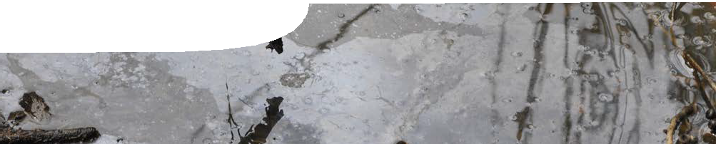
sequence overview
Redox reactions

ENGAGE
EXPLORE EXPLAI

Background
N ELABORATE
These SPICE resources may be drawn together into a learning pathway to develop students’ understanding of oxidation and reduction processes. The pathway is structured around a constructivist model based on the 5-Es where teachers may:
- Engage students’ interest in the concept of redox. Students watch a video about the occurrence of acidic soils resulting from the oxidation of sulfide compounds in wetland soils.
- Provide opportunities for students to Explore the chemical reactions of sulfide compounds. Students perform experiments and develop inferences about sulfide oxidation reactions.
- Explain the concept of redox in the context of reactions involved in the formation of sulfide compounds through reduction processes and their subsequent oxidation.
- Elaborate on the ideas presented through an investigation of redox reactions involved in bioremediation and application of these and other techniques to acid-sulfate affected environments.
- Evaluate students’ progress through the pathway.
The resource is designed for students studying year 11 chemistry, but may also be used with students in earlier years at the discretion of the teacher.

Learning resources
N ELABORATE

ENGAGE
EXPLORE EXPLAI

Redox reactions 1: Acid soils
Acid soils comprises a teachers guide and video.
This resource engages students in the chemistry associated with the problems caused by acid sulfate soils. See the teachers guide for detailed information on the purpose and use of this resource.

ENGAGE
EXPLORE EXPLAI

Redox reactions 2: Sulfide chemistry
Sulfide chemistry comprises a teachers guide and student procedure sheet with questions.
Students explore the chemistry of sulfide compounds through practical laboratory activities. See the teachers guide for detailed information on the purpose and use of this resource.

ENGAGE
N ELABORATE
EXPLORE EXPLAI

N ELABORATE
Redox reactions 3: Acid soils and redox
Acid soils and redox comprises a teachers guide, learning object and student worksheet.
This resource explains how sulfide-rich deposits are formed and how acidic solutions result from their exposure. See the teachers guide for detailed information on the purpose and use of this resource.

ENGAGE
EXPLORE EXPLAI

Redox reactions 4: Bioremediation
Bioremediation comprises a teachers guide, procedure sheet and student worksheet.
This resource shows how scientists endeavour to solve acid sulfate soil problems through a practical investigation and a case study activity. See the teachers guide for detailed information on the purpose and use of this resource.

Acknowledgements
N ELABORATE
Thanks to PhD students Talitha Santini and Bree Morgan (School of Earth and Environment, The University of Western Australia); Associate Professor Andrew Rate (School of Earth and Environment, The University of Western Australia); Gary Cass (Faculty of Natural and Agricultural Sciences, The University of Western Australia); and Ruth Kempton (Team Leader, Regional Technician Group, Department of Education WA)
Designed and developed by the Centre for Learning Technology, The University of Western Australia.
Production team: Bob Fitzpatrick, Anton Ball, Helen Billiald, Alwyn Evans, Sally Harban, Dan Hutton, Paul Ricketts, Gary Thomas and Michael Wheatley, with thanks to Pauline Charman, Jenny Gull, Wendy Sanderson and Charmaine White.

Banner image: ‘Spoonbill Lake’ by Paul Ricketts.

SPICE resources and copyright
All SPICE resources are available from the Centre for Learning Technology at The University of Western Australia (“UWA”). Selected SPICE resources are available through the websites of Australian State and Territory Education Authorities.
Copyright of SPICE Resources belongs to The University of Western Australia unless otherwise indicated.
Teachers and students at Australian schools are granted permission to reproduce, edit, recompile and include in derivative works the resources subject to conditions detailed at spice.wa.edu.au/usage.
All questions involving copyright and use should be directed to SPICE at UWA.
Web: spice.wa.edu.au Email: spice@uwa.edu.au Phone: (08) 6488 3917

Centre for Learning Technology (M016) The University of Western Australia
35 Stirling Highway
Crawley WA 6009

