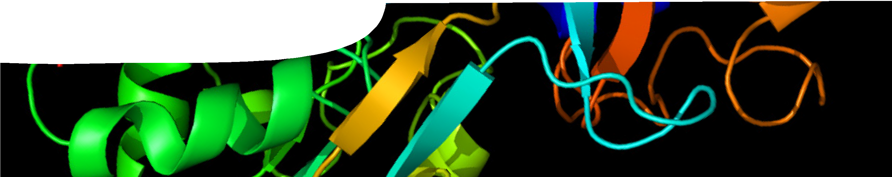
sequence overview
Proteins


EXPLAIN 1
ENGAGE
EXPLORE
ELABORATE
EXPLAIN 2

Background
These SPICE resources may be drawn together into a learning pathway to develop students’ understanding of proteins. The pathway is structured around a constructivist model based on the 5-Es where teachers may:
- Engage students’ interest in proteins and the diversity of their roles in living organisms;
- provide opportunities for students to Explore ways in which proteins are visualised through electrophoresis;
- Explain the structure of proteins and how they are made in the body;
- Elaborate on ideas presented though the context of a protein-related disease; and
- Evaluate students’ progress through the pathway.
The resource is designed for year 12 biology and human biology students, but may also be used with students in earlier years at the discretion of the teacher.

Learning resources

EXPLAIN 1
ENGAGE
EXPLORE
ELABORATE
EXPLAIN 2
Proteins 1: The importance of proteins
The importance of proteins comprises a teachers guide and video.
A video introduces students to the multiple and diverse role of proteins, and their importance to biological life. Research at The University of Western Australia on the reproduction of honeybees is featured. See the teachers guide for detailed information on the purpose and use of this resource.
EXPLAIN 1
ENGAGE
EXPLORE
ELABORATE
EXPLAIN 2
Proteins 2: Looking at proteins
Looking at proteins comprises a teachers guide, procedure sheet and fact sheet.
Students follow a procedure for visualising proteins using gel electrophoresis. See the teachers guide for detailed information on the purpose and use of this resource.

EXPLAIN 1
ENGAGE
EXPLORE
ELABORATE
EXPLAIN 2

Proteins 3: Protein molecules
Protein molecules comprises a teachers guide, interactive learning object and student worksheet.
An interactive learning object explains what proteins are, introduces amino acids and shows how they combine to form proteins. See the teachers guide for detailed information on the purpose and use of this resource.

EXPLAIN 1
ENGAGE
EXPLORE
ELABORATE
EXPLAIN 2

Proteins 4: Making proteins
Making proteins comprises a teachers guide, interactive learning object, student worksheet and fact sheet.
An interactive learning object explains how proteins are made. Students interact with the animation to ‘build’ part of a protein. See the teachers guide for detailed information on the purpose and use of this resource.


EXPLAIN 1
ENGAGE
EXPLORE
ELABORATE
EXPLAIN 2

Proteins 5: Defective proteins
Defective proteins comprises a teachers guide, two fact sheets and a student worksheet.
The importance of protein folding, and what happens when it goes wrong, are examined through the context of prion diseases. See the teachers guide for detailed information on the purpose and use of this resource.

Acknowledgements
Thanks to Professor Boris Baer (CIBER – Centre for Integrative Bee Research, UWA), Tiffany Bates (Apiary Manager, UWA), Dr Reza Zareie (Research Associate, Plant Energy Biology, ARC Centre of Excellence, UWA), Keren Muthsam (Animal Technician, Sheep and Native Animal Facility, UWA), Peter Cowl (Chief Technician, Native Animal Facility, UWA), Dr Malcom Lawson (Manager, Animal Care Services, UWA), Assistant Professor Liza Seubert (Pharmacy division, UWA), Warwick Mathews (After Hours Winery), Simon Harris (Talking Heads Hair Salon), Steve Garrett (Bio-Tek Australia) and Associate Professor Elizabeth Quail (School of Chemistry and Biochemistry, UWA), Kirsten Gottschalk and Alan Gull.
Designed and developed by the Centre for Learning Technology, The University of Western Australia.
Production team: Anton Ball, Helen Billiald, Pauline Charman, Jan Dook, Alwyn Evans, Sally Harban, Trevor Hutchison, Dan Hutton, Bec McKinney, Emma Pointon, Paul Ricketts, Jodie Ween, Michael Wheatley and Charmaine White. Thanks to Bob Fitzpatrick, Jenny Gull and Wendy Sanderson.
banner image: ‘Protein visualisation’ by Emw, CC-BY-SA-3.0, en.wikipedia.org/wiki/File:Protein_TF_PDB_1a8e.png

SPICE resources and copyright
All SPICE resources are available from the Centre for Learning Technology at The University of Western Australia (UWA). Selected SPICE resources are available through the websites of Australian State and Territory Education Authorities.
Copyright of SPICE Resources belongs to The University of Western Australia unless otherwise indicated.
Teachers and students at Australian schools are granted permission to reproduce, edit, recompile and include in derivative works the resources subject to conditions detailed at spice.wa.edu.au/usage.
All questions involving copyright and use should be directed to SPICE at UWA.
Web: spice.wa.edu.au Email: spice@uwa.edu.au Phone: (08) 6488 3917

Centre for Learning Technology (M016) The University of Western Australia
35 Stirling Highway
Crawley WA 6009

